Objective: This Document is to make the user to understand the flow of accounting in Oracle applications, in Purchasing, Manufacturing, Inventory, Order Management and Financial Modules Payables, Receivables, Cash management and General ledger and not to cover all scenarios and Business cycles. I have not covered few other modules like Fixed Assets, Projects, Treasury, Payroll, Encumbrance etc., in this Document which also generates accounting entries. This Does not cover the technical aspects like, Table, columns etc., for which you have standard diagnostics scripts which can be run and viewed for every activity.

Business Case: Parry Confectionery Ltd is Manufacturers of Coffee Bite, Caramilk, Coconut Punch, Lacto King, Orange Candy variety of Chocolates. The Chocolates Manufacturing Process is as follows

- Milk is Boiled to evaporate the Water content @100 Degree centigrade and it is called Boiled Milk
- Then to the boiled Milk, Sugar and Cocoa are added which has the water content. This is again boiled to evaporate all the water content to make it as Thick Liquid Milk called Condensed Milk
- Condensed Milk is allowed to be allowed to pass through a drier which takes all Water content and make it as dry chocolate.
- The dry chocolates are allowed to pass through a cutting machine which cuts the chocolates into different pieces of 5 grams, 10 grams, etc
- Then the pieces of chocolates are passed to a wrapper machine which wraps the chocolate and pass it on to a container
- Then the wrapped chocolates from the container are sent to a Packing machine which picks up chocolates and makes them as 500 grams, 1KG pack chocolate covers.
- Then the chocolates are placed in 10 kg, 20 Kg carton boxes and sent to Customers

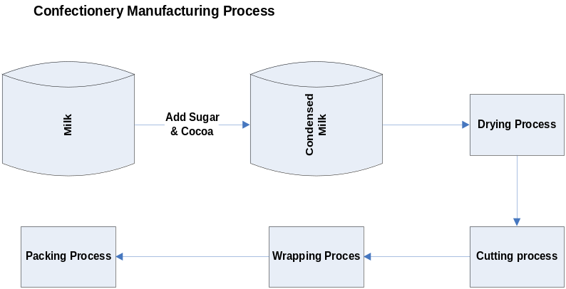

Key Points: I am using Vision Operations to explain the flow of accounting entries
Business Group: Vision Corporation
Set of Books: Vision Operations
Operating Unit: Vision Operations
Inventory Organization: Vision Operations (Master) V1, Seattle Manufacturing (Child) M1
Costing Method: Standard Costing

Disclaimer: This Document was created with my own assumptions to explain the concept of accounting and the names of the companies used in this article are only to explain the accounting concept with data assumptions and none of the Company is not responsible for the Data or the process information provided in this article.

Case Study

Parry Confectionery Ltd is Manufacturers of Caramilk, Lactoking and Coconut Punch Chocolates. Their Statement of Affairs as on 31-Oct-2007 is as follows

Balance sheet as on 31-Oct-2007

Liabilities | Amount in USD | Assets | Amount in USD
Share Capital | 50000 | Fixed Assets
Long term Loans |  | Building | 25000
8% Debentures | 50000 | Plant and Machinery | 75000
Loan from ICICI | 25000 | Investments | 20000
Current Liabilities |  | Current Assets
Sundry Creditors | 50000 | Inventory | 25000
 |  | Sundry Debtors | 20000
 |  | Bank | 7500
 |  | Cash | 2500
Total Liabilities | 175000 | Total Assets | 175000

During the period 01-Nov-2007 to 30-Nov-2007 following Transactions took place

- Purchased Inventory as follows
    - Milk 500 Ltrs @ 12USD per Ltr – 6000 USD
    - Sugar 500 Kgs @ 10USD per Kg – 5000 USD
    - Cocoa 500 Kgs @ 25 USD per Kg – 12500 USD
- Returned Materials to Supplier is 50 Ltrs of Milk
- Made Payment To Suppliers for Milk and Sugar
- During the month 7 kgs of Caramilk, 12 Kgs of Coffee Bite and 6 Kgs of Lackto King Chocolates the Discrete job is created
- The actual completed output of the Finished Goods Items are 5 Kgs of Caramilk, 10 Kgs of Coffeebite and 6 Kgs of Lactoking
- Sales Made during the Month is 5 Kgs of caramilk and, 10 Kgs of Coffee Bite and 4 Kgs of Lacto King
- Payment received from Customers only for Coffeebite
- Out of the Items sold 1 kg of Caramilk was spoiled for which the Customer has sent back the material
- One Kg of Lactoking was spoiled in Transit for which Customer need to be issued a Credit note as Material non-returnable
- During the month the company paid following expenses
  - Packing Material –100 Paid by Cash
  - Advertisement – 250 Paid by Bank to OrgMarg Company
- Company withdrew 1000 USD for Office use
- Interest Income received for the month is 100 USD
- Bank charges for the month is 5 USD
- Provision for Tax to be made 500 USD
- Employees Travel Expenses Provision to be made 300 USD

(M) Finished Goods (Lacto King, Caramilk, Coffee Bite)

Condensing Department
10 Hours @20 USD per Hr

Packing Department
1 Hours @ 50 USD per
Milk Sugar Cocoa

10 Ltrs @Rs10 5 Kgs @Rs10 4 Kgs @Rs25

The Standard cost of a Material Item is as follows

Cow Milk 100 USD +
Sugar 50 USD +
Cocoa 100 USD
--------------
Standard Cost 250 USD
=========

Manufacturing Cost of Chocolate is as follows

Purchase Standard Cost is 250 USD
Operations Cost
Condensing Dept Cost 200 USD
Packing Cost 50 USD
250 USD
--------------

Manufacturing Cost 500 USD
========

Selling Price

Coffee Bite 700 USD
Caramilk 650 USD
Lacto King 600 USD

Things to know: I hope all of you might have gone through my previous two accounting Materials and found it useful. But you should understand there are always challenges and advantages of using ERP system to generate the information and accounting transactions. We will discuss the details briefly here

Important Points:
- In the Manual or Legacy accounting systems, we will not have the concept of Intermediary accounting like Accruals etc.; This is a system requirement for it to perform the matching and meet the Standard accounting procedures accruals accounts need to be created.
- The Intermediary accounts like Accruals, Inter company Transfer account etc., must be defined as a Balance sheet account meaning either as an Asset or Liability. Why? The reason being if you define it as Revenue or Expense Account, then it will have the impact on Profit and Loss at the end of the period which is not correct. So keep it in mind whenever you define an Intermediary account it must be a Balance sheet account like Asset or Liability account type.
- The ERP system always follows perpetual system of Inventory which means the stock Receipt and Issues are accounted immediately and not using the Periodical Inventory system. To understand the difference between the two refer to the following URL
  - http://ccba.jsu.edu/accounting/PERPETUALPERIODICJE.HTML
  - http://ccba.jsu.edu/accounting/MAINMENU1.HTML
- The Confectionery Industry will fall under Process manufacturing or discrete Manufacturing might be a big debate, but for this exercise, I have explained only in discrete manufacturing and I have not considered the Normal losses etc., in the Process like Water evaporation Loss etc., in this exercise

Index

- Creation of Items, Item Costs and Bill of Material

- Loading of Opening Balances

- Transactions Creation

- Material Returned to Supplier

- Create Supplier Invoice and Make payment to Supplier

- Create Discrete Job for Coffeebite, Caramilk and Lactoking

- Create Sales Order, Book the Order, release and Ship confirm the Goods

- Payment received from Customers only for Coffeebite

- Out of the Items sold 1 kg of Caramilk was spoiled for which the Customer has sent back the material

- One Kg of Lactoking was spoiled in Transit for which Customer need to be issued a Credit note as Material non-returnable

- During the month the company paid following expenses
    - Packing Material –100 Paid by Cash
    - Advertisement – 250 Paid by Bank to Org Marg Company

- Company withdrew 1000 USD for Office use

- Interest Income received for the month is 100 USD

- Bank charges for the month is 5 USD

- Provision for Tax to be made 500 USD

- Employees Travel Expenses Provision to be made 300 USD

- Sub Ledger Entries Transfer to General Ledger

- Posting in General Ledger

- Running of Trial Balance, Profit and Loss Account and Balance Sheet

Introduction: The Opening Balance of Assets and Liabilities except the Receivables, Payables and Inventory will be loaded through a Journal in any Implementation. The Payables balances will be created from Accounts Payable and Receivables will be created from Accounts Receivables and Inventory will be created from Inventory module using cycle counting adjustment entries.

The Vision Instance will have certain transactions already created and those transactions will have the period end balances as Opening balance. Hence for this exercise ignore the Period beginning balance and period closing balance and ensure the Period do not contain any transactions.

Navigation Path
Oracle General Ledger
Others/ Requests
Parameter: Balancing Segment: Company
Period: Nov-07
Currency: USD

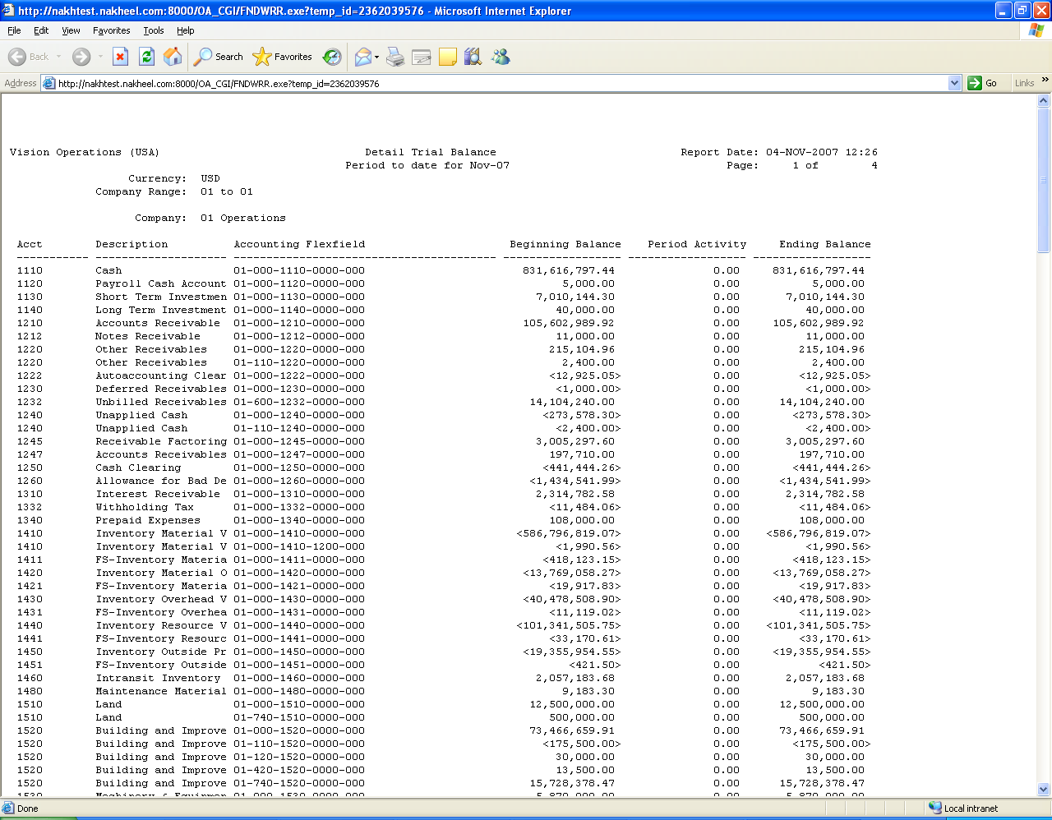

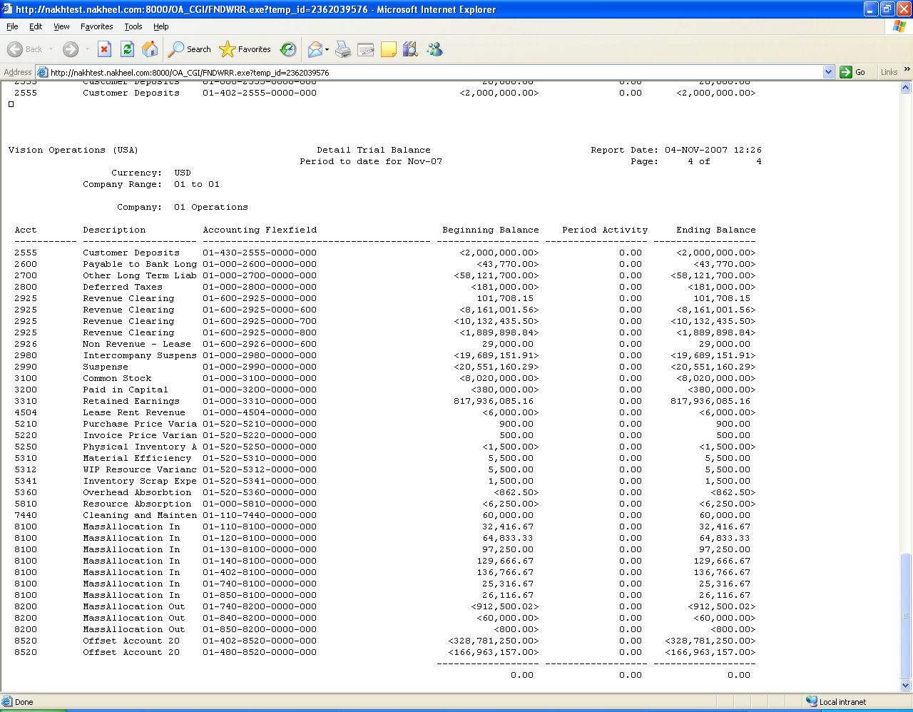

This clearly shows there are no transactions created for the period Nov-07

1. Creation of Item, Item Costs and Bill of Material (BOM)

I have explained in my Procure to Pay - Order to Cash - End to End Cycle Functional Documents in detailed steps on How to create an item, Item costs and Bill of Material in detail. So please replicate the same steps to get the cost of an Item

The Cost of the Item is as follows after we define the Item, Item costs, Resources, Departments, Routings and Bill of Material

Navigation path
Manufacturing Vision Operations
Choose Inventory Organization as M1 Seattle Manufacturing
Bill of Materials / Bill of Material
Query for Item Caramilk
Click on Tools Click on Roll up costs
Choose Cost type as Pending and Run the Report
View the concurrent Request when it is completed Normal

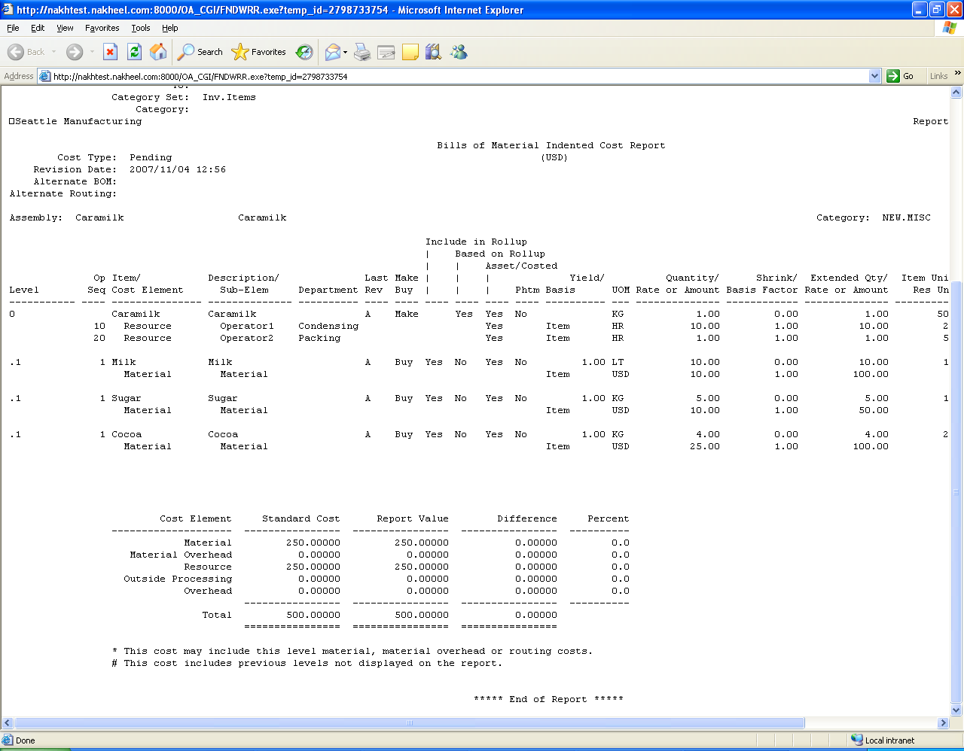

2. Loading of Opening Balances

The Opening Balances will be loaded through Journal as on 31-Oct-2007 as per the Balance sheet provided in the case study. The Asset and Liability balances are entered as it is and only for Receivables and Payables it is entered in Sub ledgers and transferred to GL and cleared the Clearing account instead of using Revenue and Expenses Account

Navigation Path
General Ledger Super User
Journals / Enter

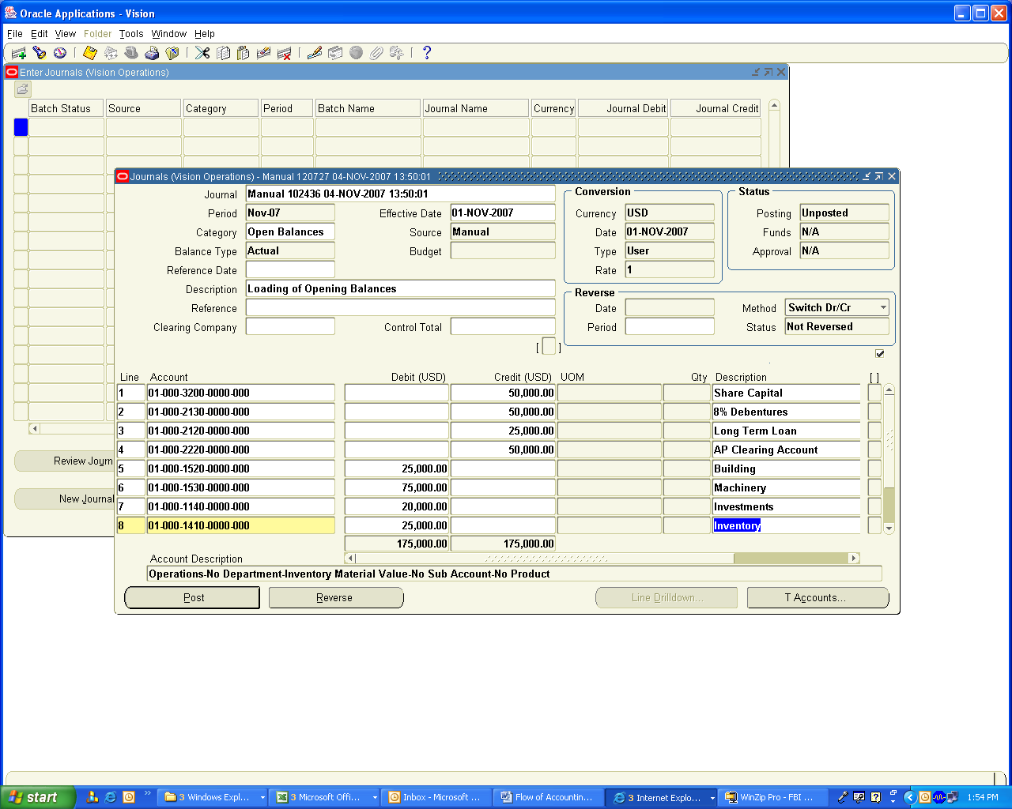

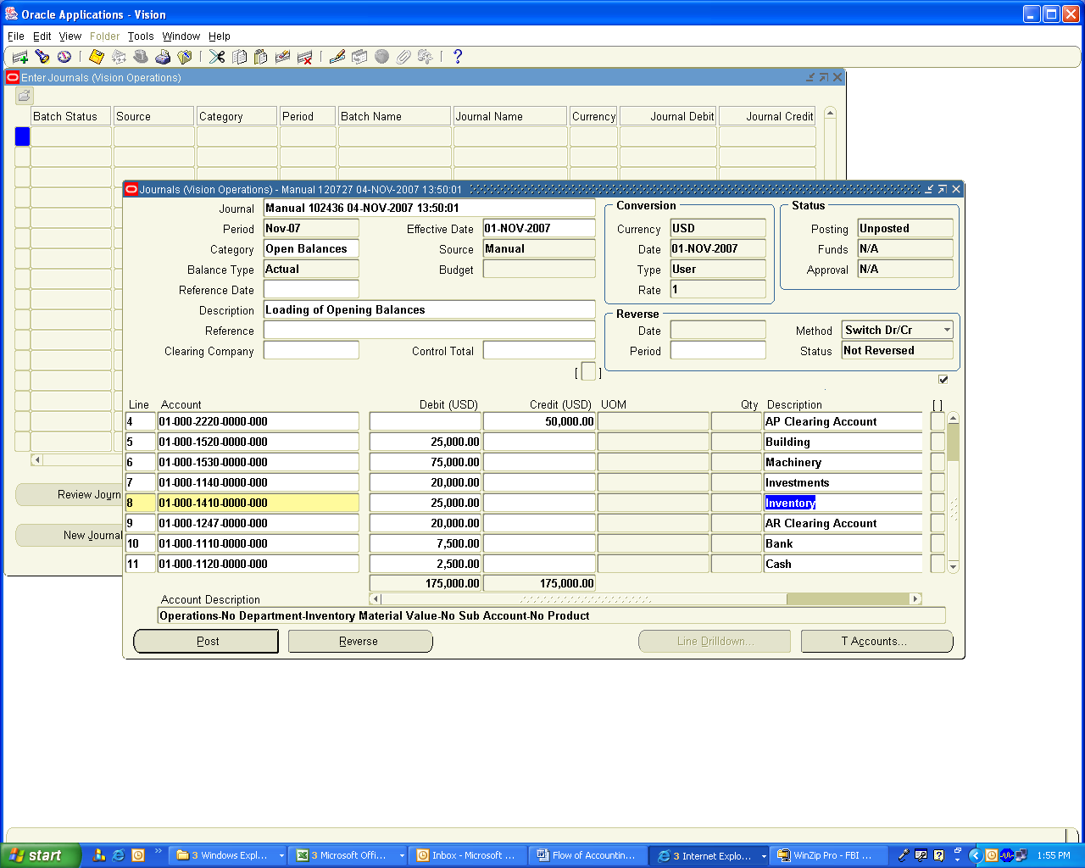

The Accounts Payables (Account code 2210) and Accounts Receivables (Account code 1210) have not been entered instead the Accounts Payables clearing Account (Account code 2220) and Accounts Receivables clearing Account (Account code 1247) to which the balances are created which will be knocked off by the entries created from the Sub Ledgers which will reflect the Open Invoices for Aging Purposes.

Navigation Path
Payables Vision operations
Invoices / Entry / Invoices

Create Invoices as per your individual supplier details and choose the GL Date in Distribution Lines as 1-Nov-2007 which is the Opening Balances Date and choose the distribution Line account as Accounts Payable Clearing Account.

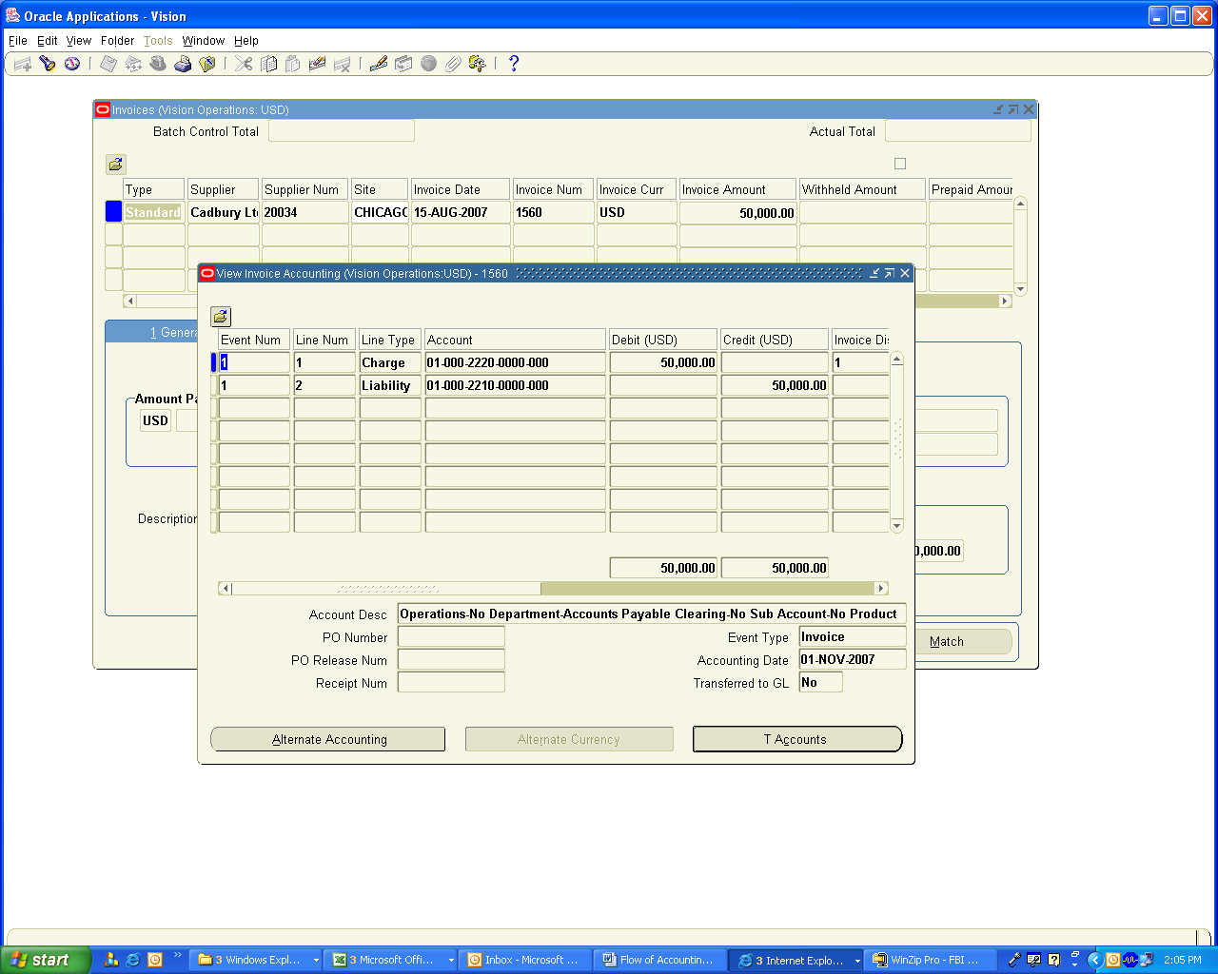

Now post the above Transactions to General Ledger

This will create unposted Journal Entry as follows

Accounts Payables clearing A/c Dr 50000
Accounts Payables A/c Cr 50000

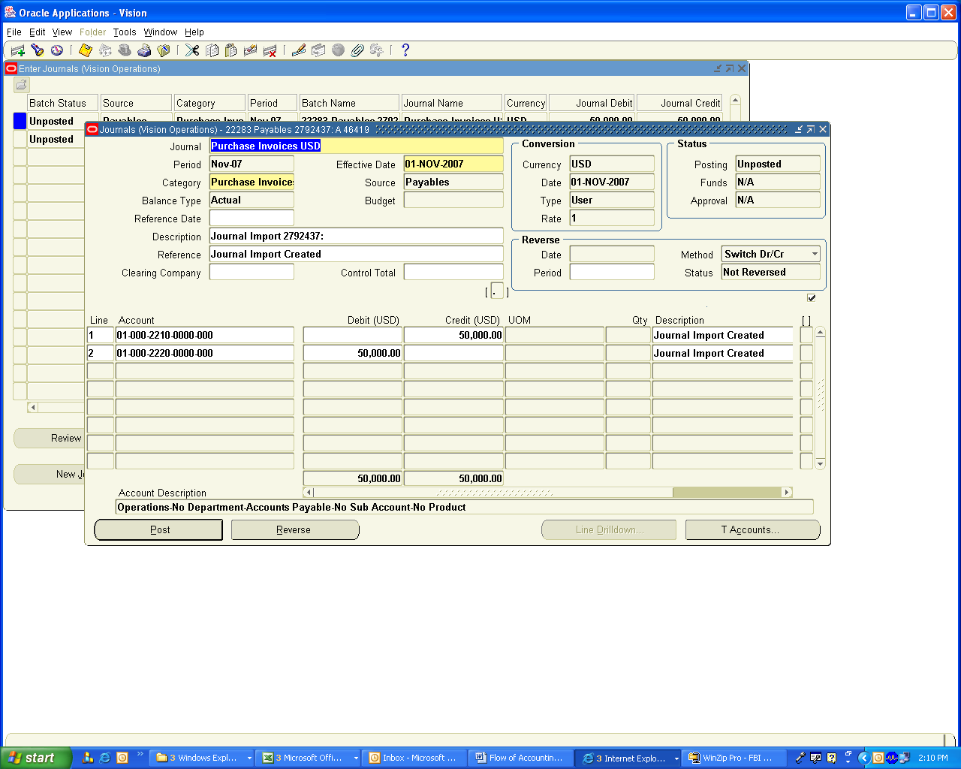

Navigation Path
Receivables, Vision Operations
Transactions

Create Invoices equivalent to your open balances with various dates and create a Transaction type of open Balances and attach in the revenue account Accounts Receivables Clearing Account (Account code 1247) and create an Invoice and save the Transaction and post the transactions to General Ledger

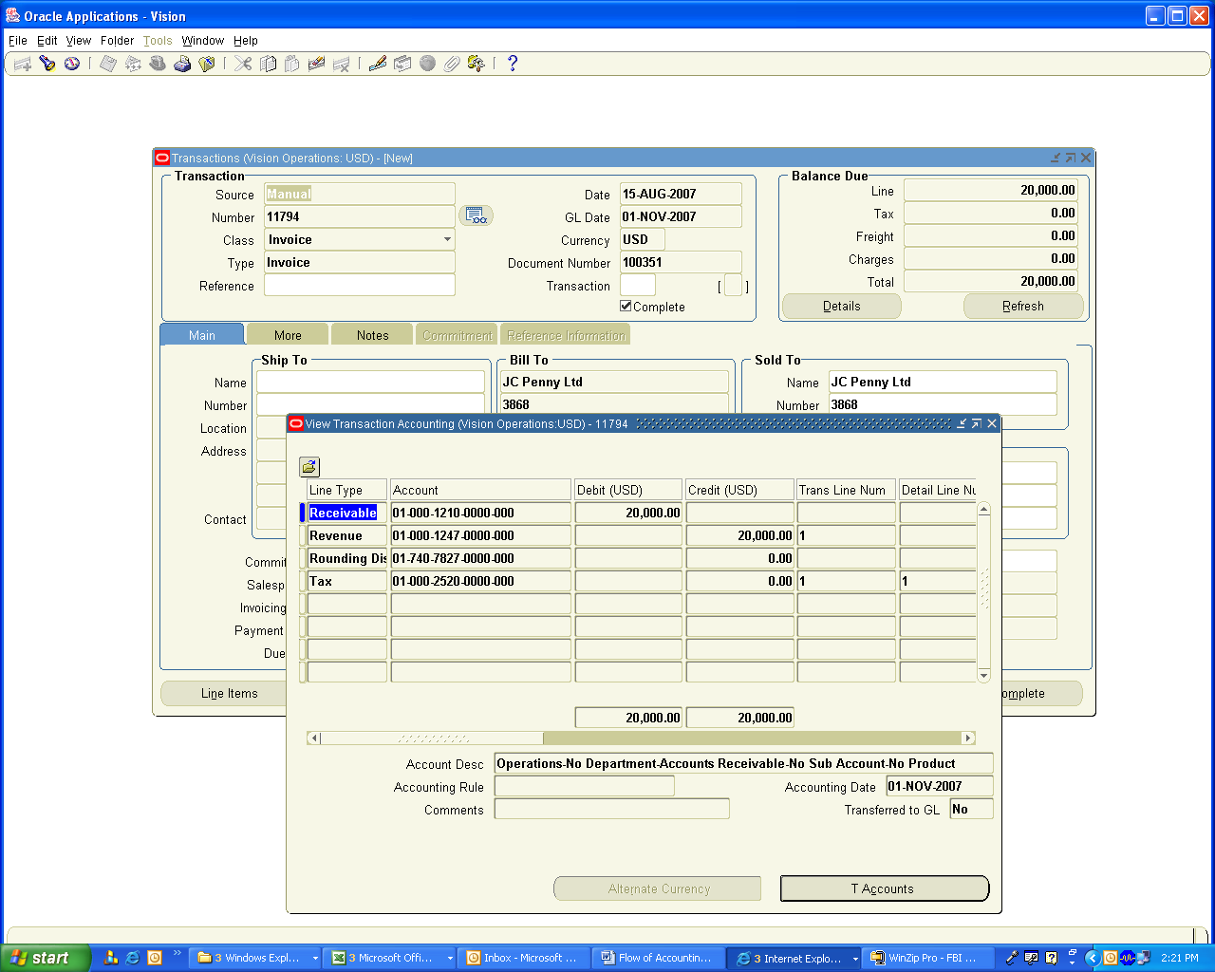

This will create following accounting entry

Accounts Receivables (1210) A/c Dr 20000
Accounts Receivables clearing (1247) A/c Cr 20000

The objective of doing this is to create Aging Reports in Receivables and Payables Module.

Run the Concurrent Program in Receivables

Navigation Path
Receivables, Vision Operations
Interfaces / General Ledger

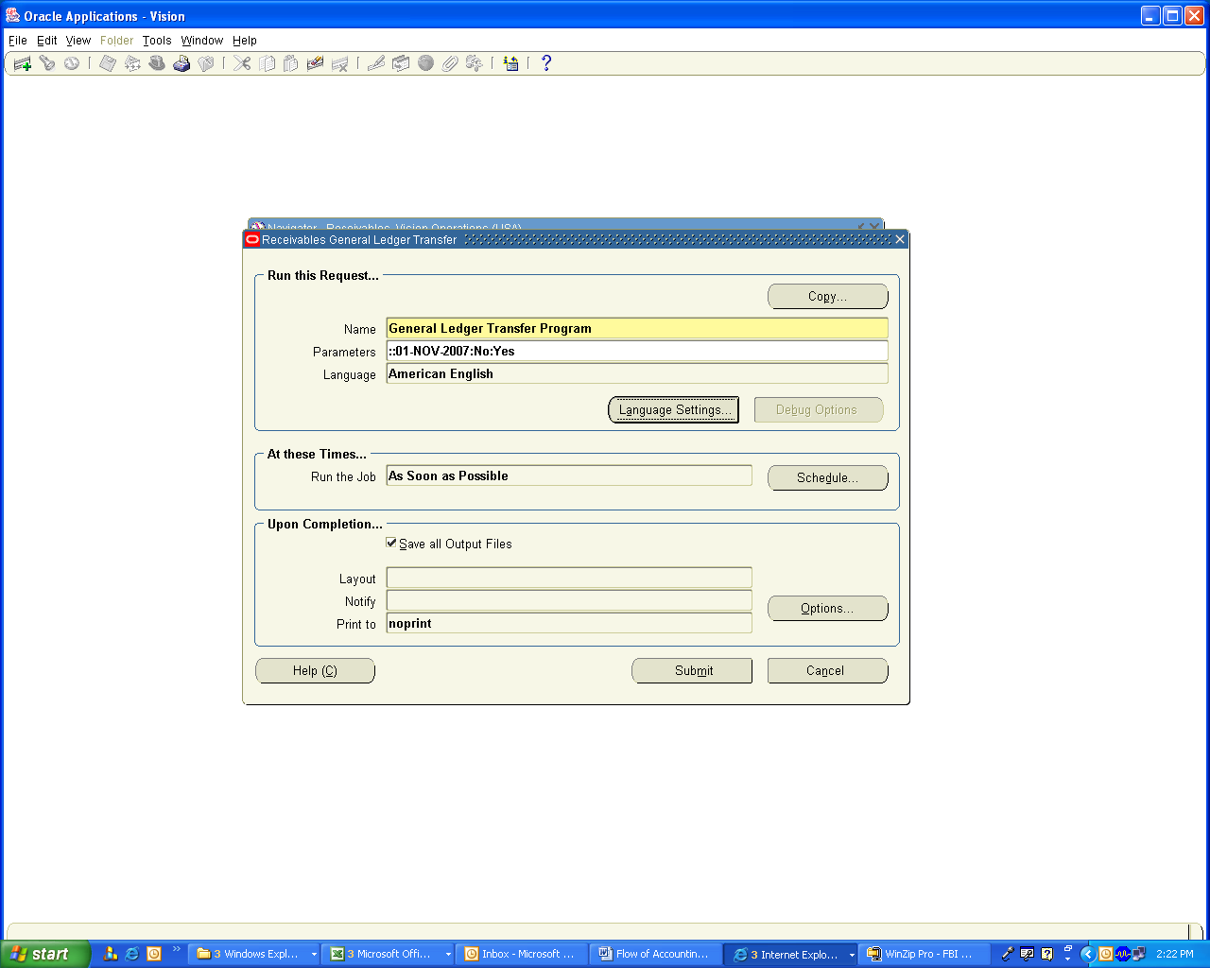

View the accounting Entries in General Ledger

Navigation Path
General Ledger, Vision Operations
Journals/ Enter / Journals

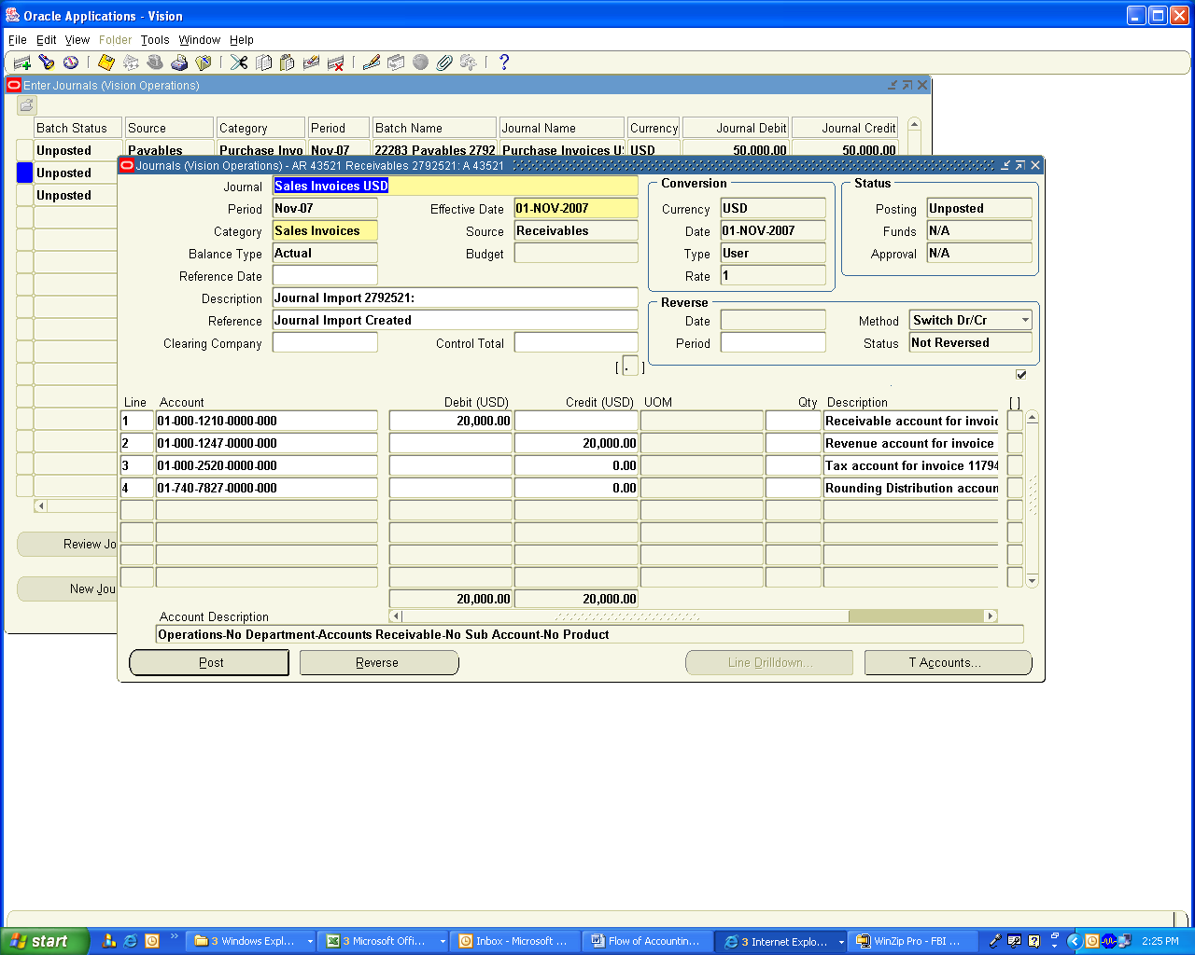

Review the Journals

Navigation Path
General Ledger, Vision Operations
Journals/ Enter / Journals

Query for Status Unposted and period Nov-07

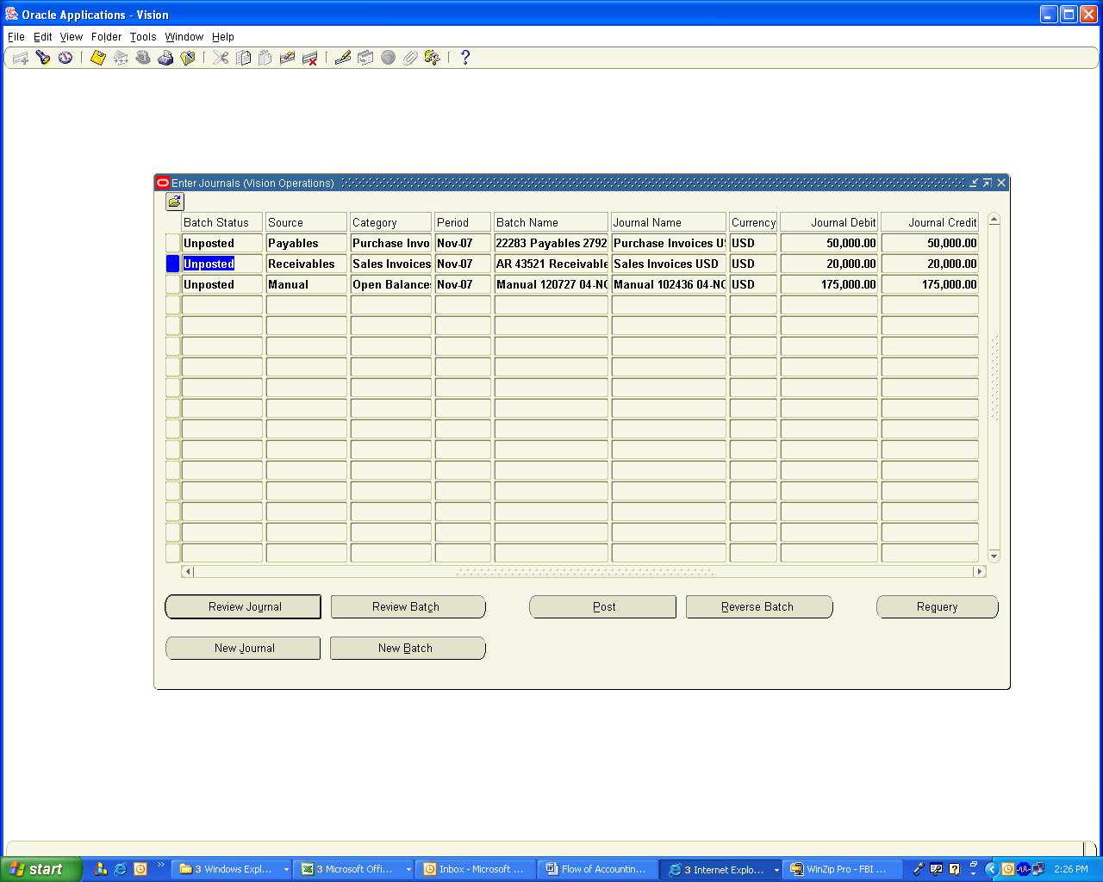

Post these Journals which completes the Opening Balances are ready

Note: This way we can load the opening Balances of Receivables and Payables. I have not covered Loading the opening Balances of Inventory which can be done using Miscellaneous Transactions or using Cycle counting adjustments.

Let us review the Trial Balance to view the opening balances of the Transactions created

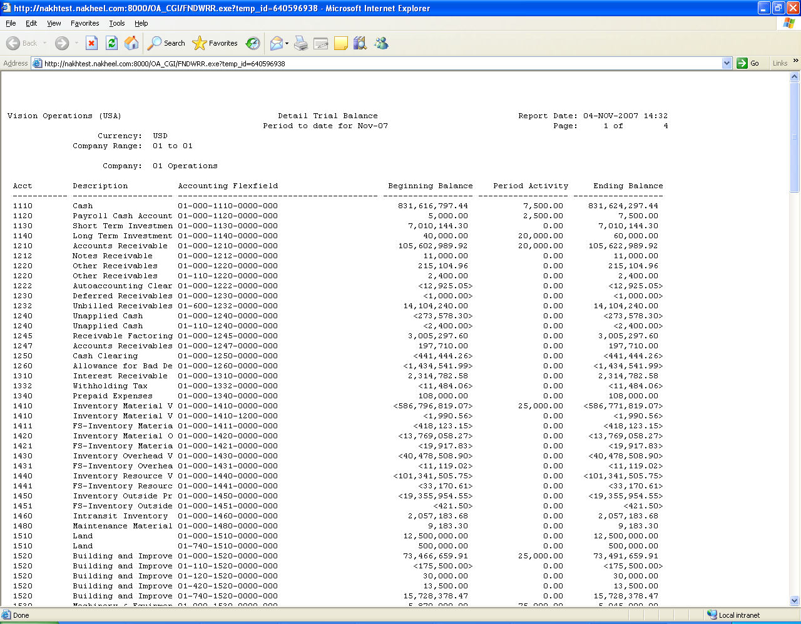

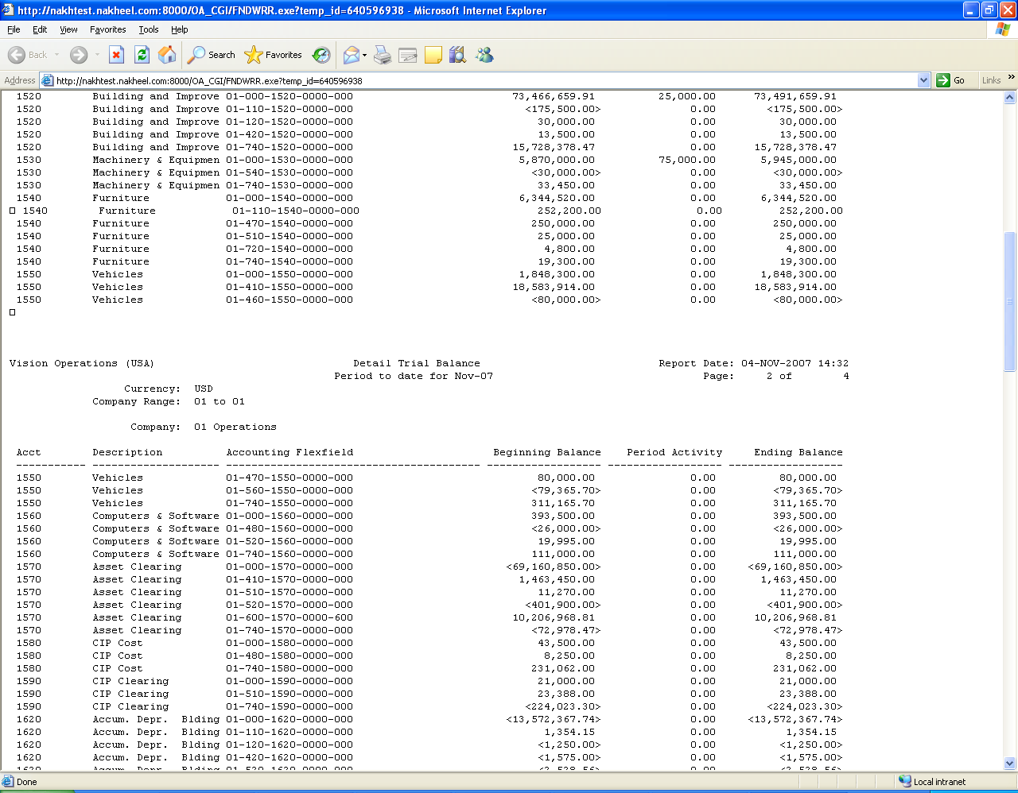

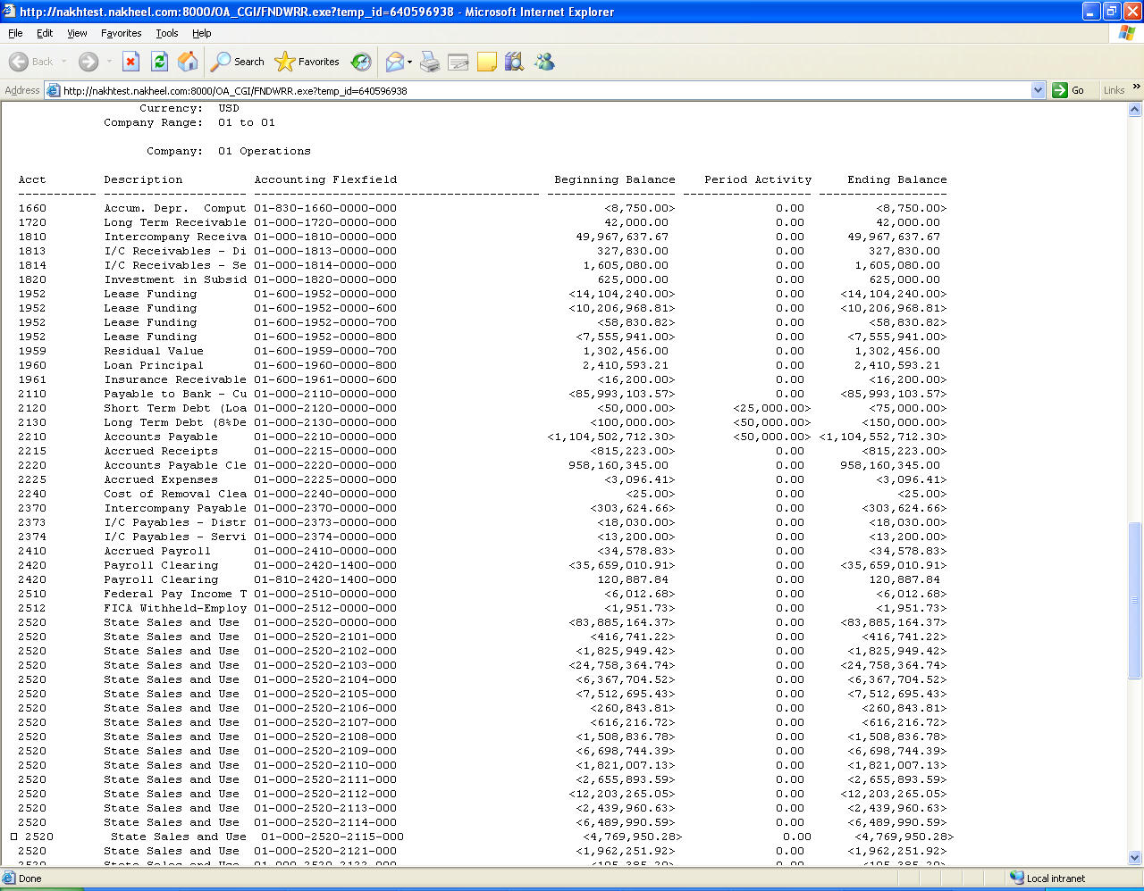

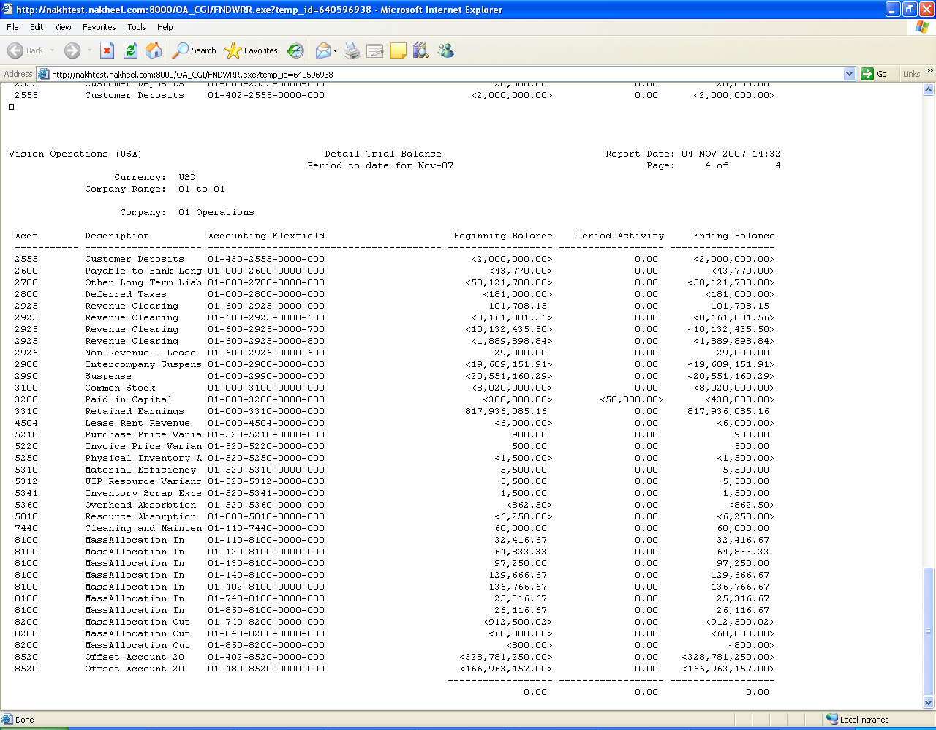

Let us View the Aging Reports in Payables and Receivables

Navigation Path
Payables, Vision Operations
Others/ Requests / Run
Single Request
Choose Invoice Aging Report

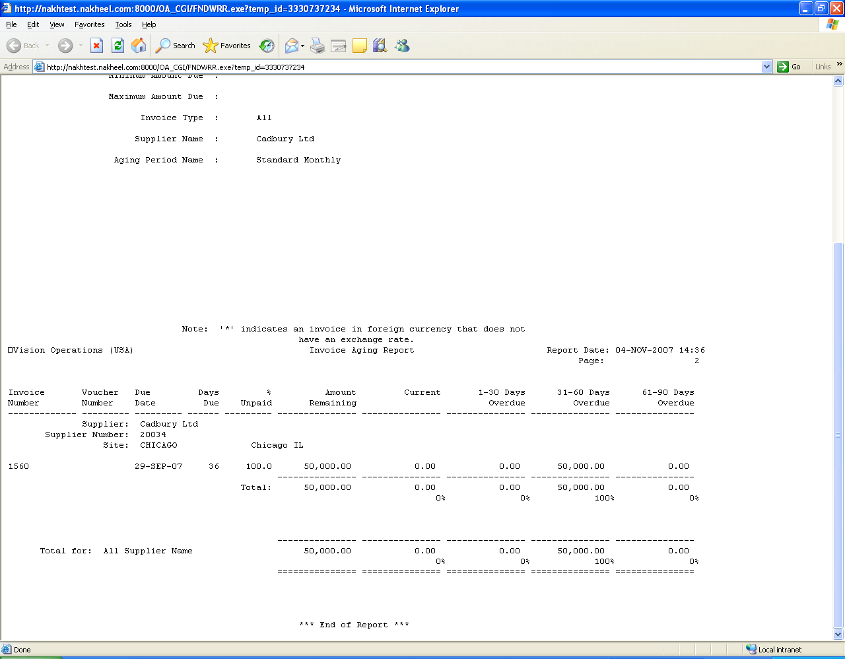

Aging Report in Receivables

Navigation Path
Receivables, Vision Operations
Reports / collections
Aging Report 4 Bucket

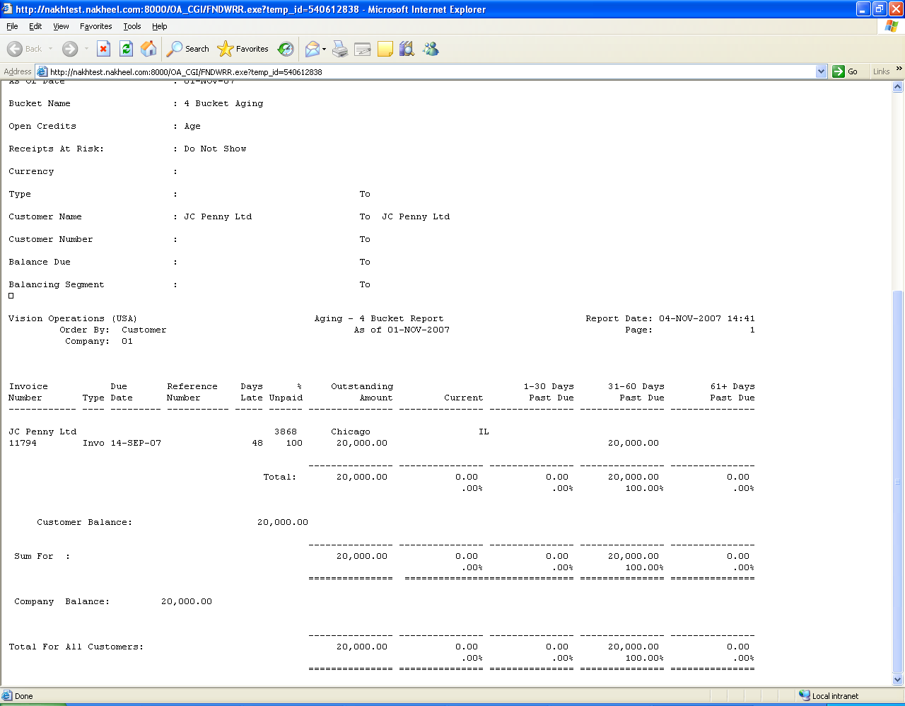

Let us run the Balance sheet and ensure that the Opening Balances are correct

Note: As I mentioned before, please consider only the Period Balances for this case study and ignore the YTD balance which are Vision Operations Entry Balances

Navigation Path
General ledger, Vision Operations
Reports / Financial
Company Balance sheet

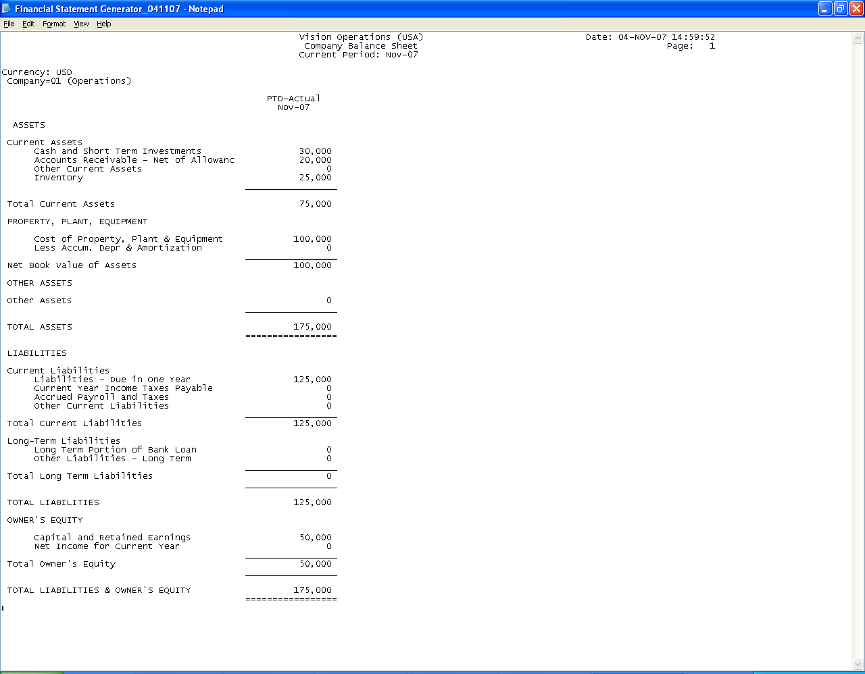

3. Transactions Creation

Let us execute the Transactions one by one as mentioned in the case study and view their Accounting Impact

1)
a) Purchased Inventory as follows
    - Milk 500 Ltrs @ 12USD per Ltr – 6000 USD
    - Sugar 500 Kgs @ 10USD per Kg – 5000 USD
    - Cocoa 500 Kgs @ 25 USD per Kg – 12500 USD

We will create a PO for the above through supplier Nestle Ltd.

Important Note: There is No actual accounting Entry Generated, when you create a Purchase Requisition (PR) or Purchase Order (PO). If you have enabled budgetary control in GL Set of books and Encumbrance Accounting in Financial Options, then Encumbrance entries are created in Purchasing Module. Encumbrance is not covered in this Exercise.

Navigation Path
Purchasing, Vision Operations
Purchase orders / Purchase orders

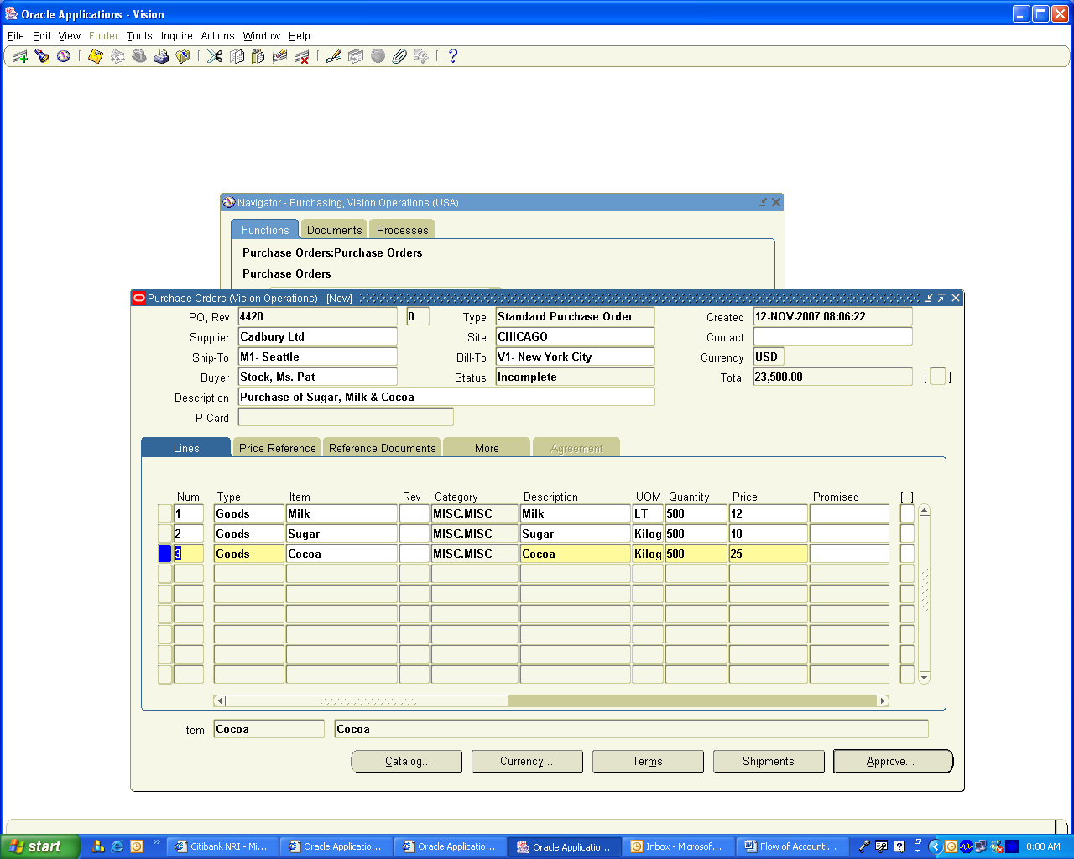

The PO 4420 is created with Status incomplete and we need to get this approved by clicking Approve Button

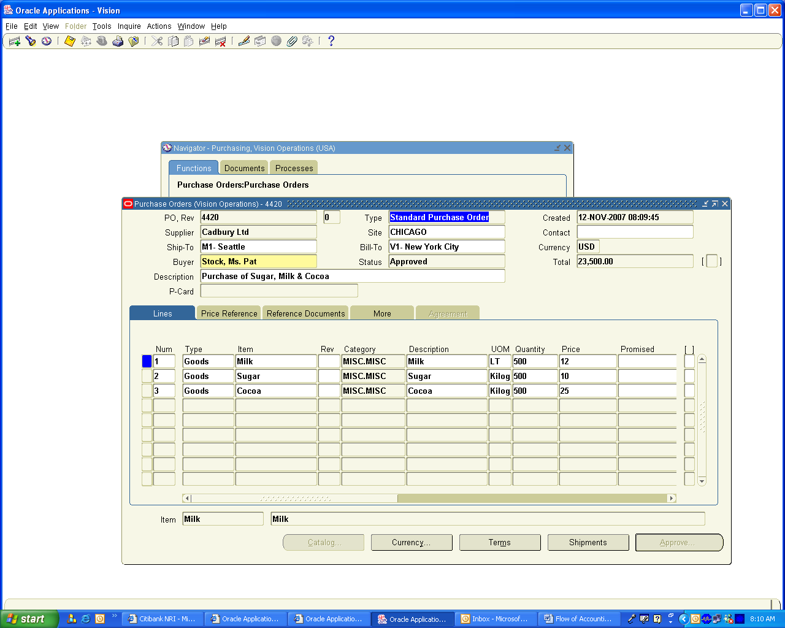

Note: The Standard cost of Milk is 10 USD per Ltr and I have created PO with the rate of USD 12 to get the Purchase price variance account getting created. We will check when we receive the Inventory Account at the time of inventory receipt.

Create Receipts for the Inventory Items

Navigation Path
Purchasing Vision Operations
Receiving / Receipts
Choose Inventory Org M1
Enter Purchase Order field 4420
Click on Find Button

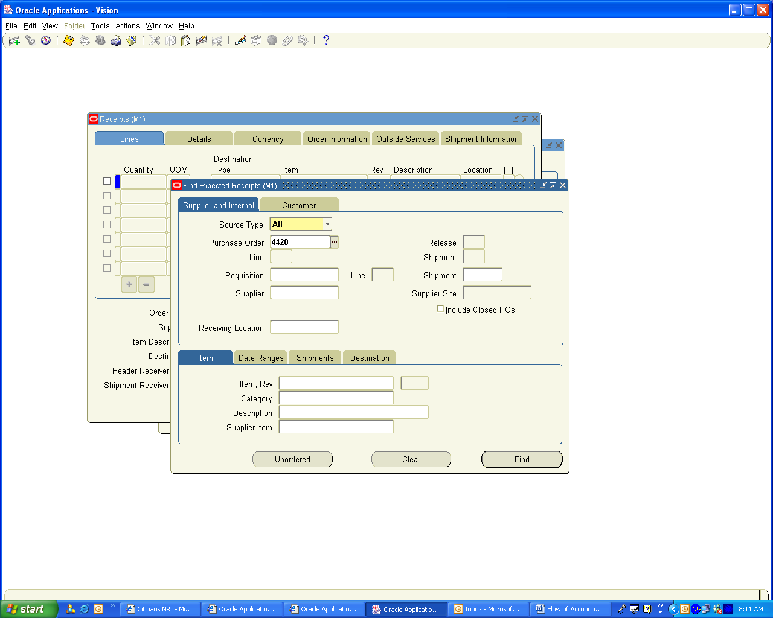

Select the check box for the inventory Received and enter the Sub inventory as Stores and Save the Record. Receipt 9610 is created.

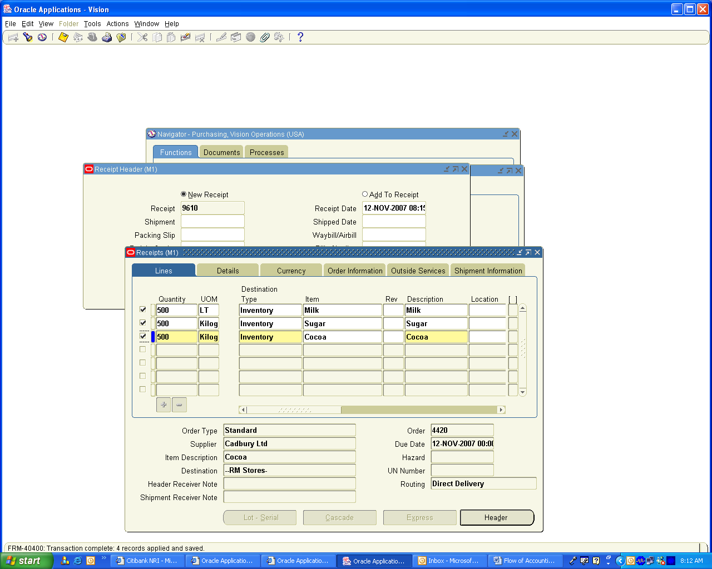

To view the Accounting Distribution Lines created go to

Navigation Path
Purchasing Vision Operations
Receiving / Receiving Transactions Summary
Enter Receipt Number as 9610 and click on Find Button

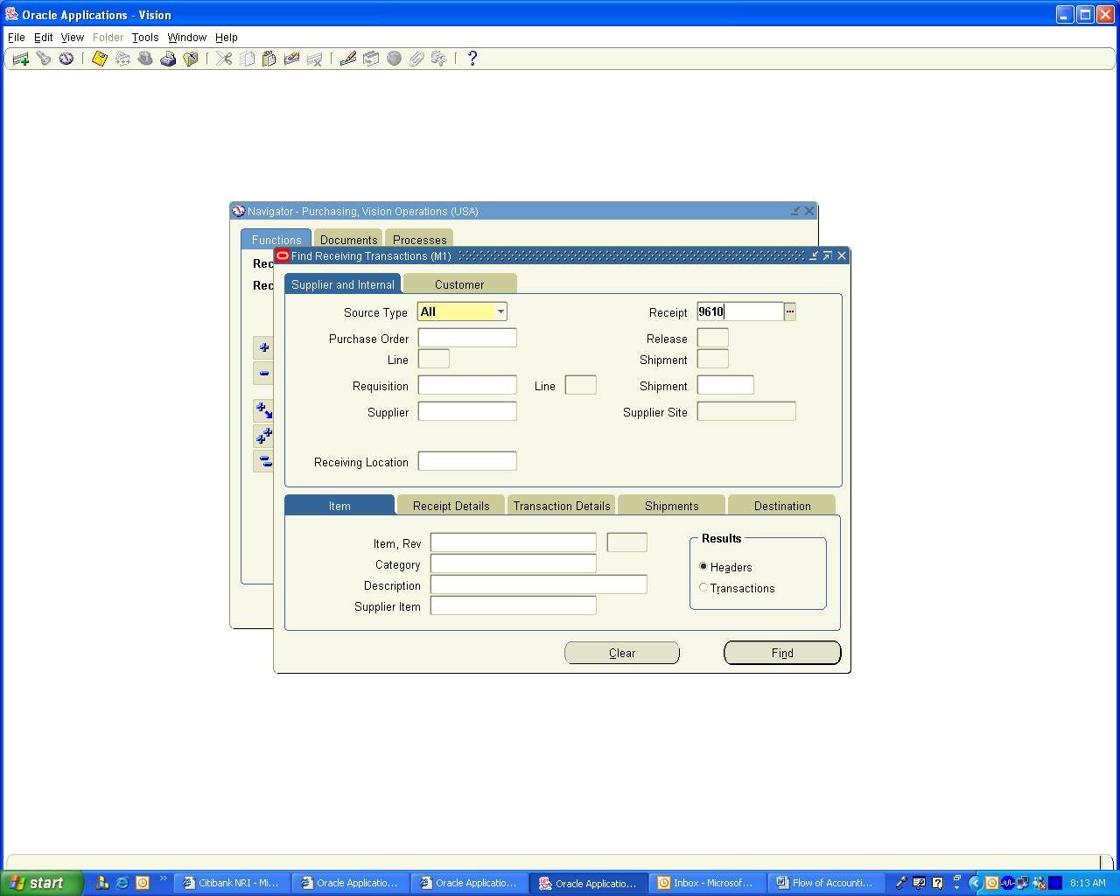

Click on Transactions Button

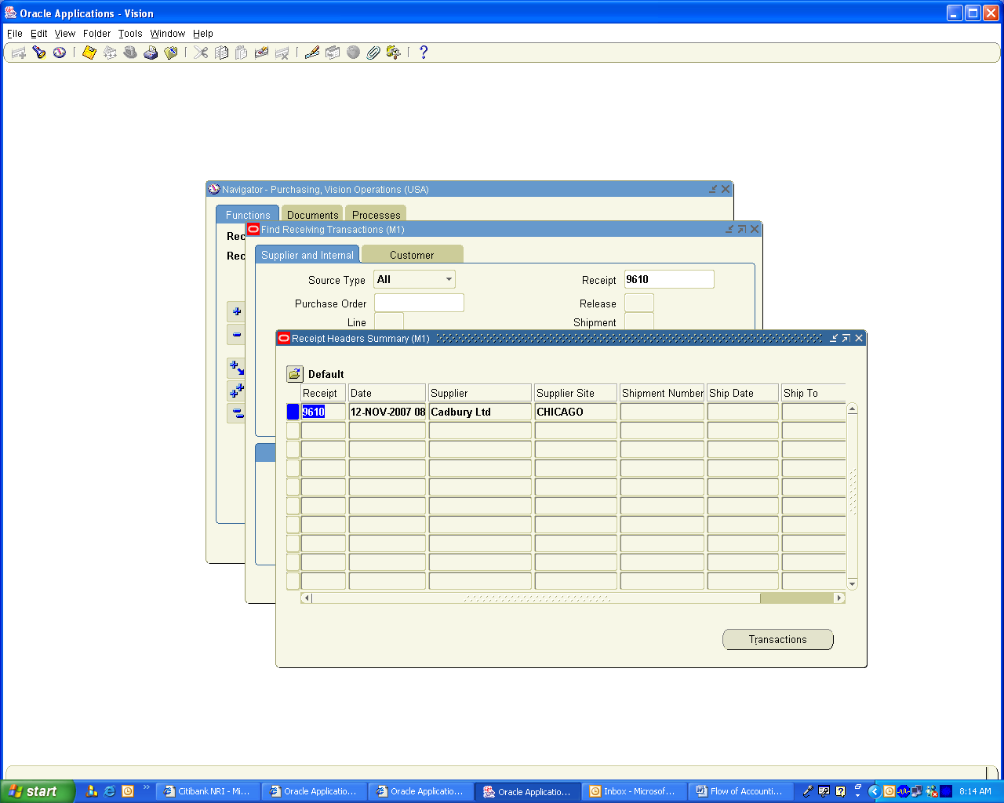

Receipt Transactions Summary form Opens. Click on Tools / View Accounting to view the Accounting Entries created

Important Note: The Destination Type is showing as receiving for the first line Receive transaction type and Second Line Destination Type is showing as Inventory for deliver transaction type. The Functionality of this is as follows. The First line is created when you receive inventory in main Inventory Organization and when you do enter Receiving Transactions; it will change it from Main Inventory Organization to Sub Inventory. It depends on the Receipt Routing what you enter in PO Receiving control form. When You set it as Direct delivery both lines will get created simultaneously and when you set it as Standard Receipt, then the first line will get created when you enter Receipt and second line will get created when you do Receiving transaction and choose the Sub inventory.

The Significance of this from Accounting Perspective is the destination type of receiving (i.e.) First line only you can view the accounting in Purchasing Module. The Second line where the Destination type is Inventory, you can view only in Inventory Module. If you Keep the Cursor in second line and click on Tools, the View Accounting is disabled.

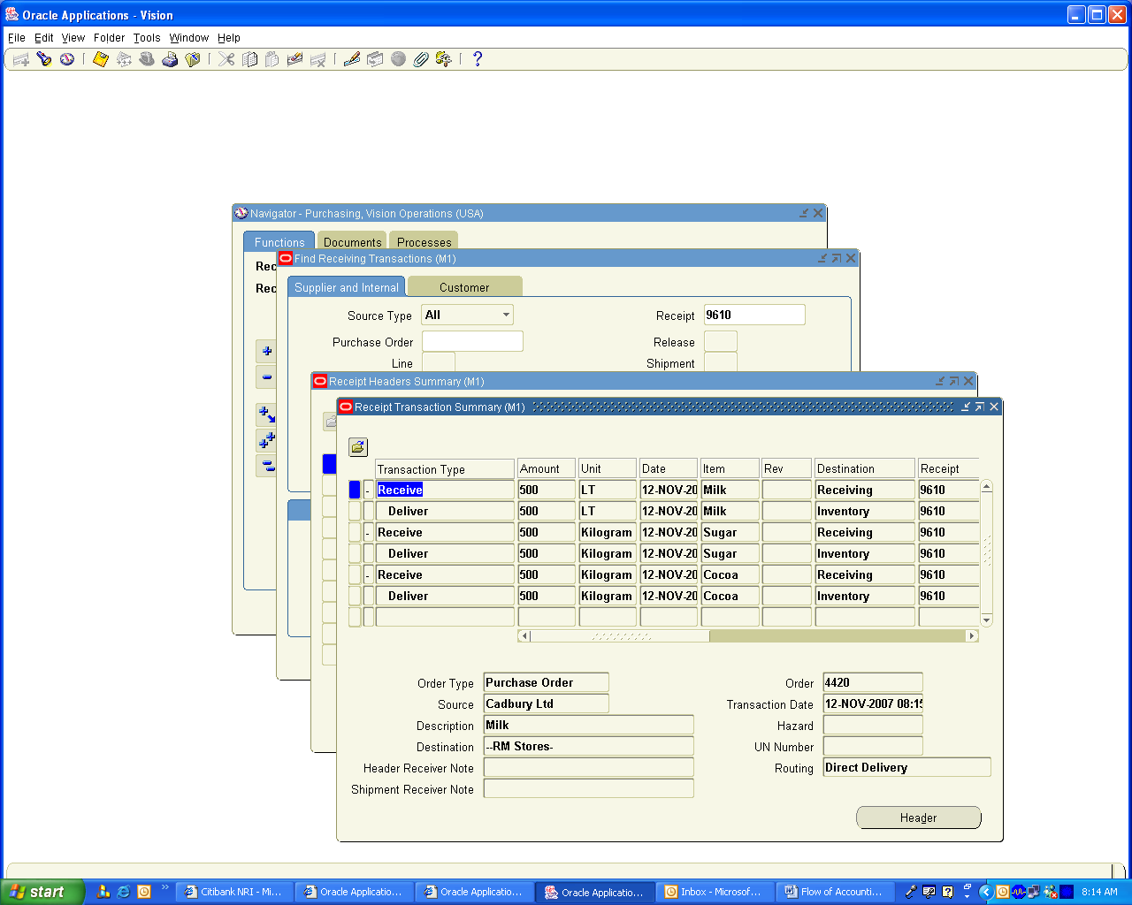

This has created following Accounting Entry in Purchasing Module

Material Inspection Account Dr
Inventory AP Accruals Account Cr

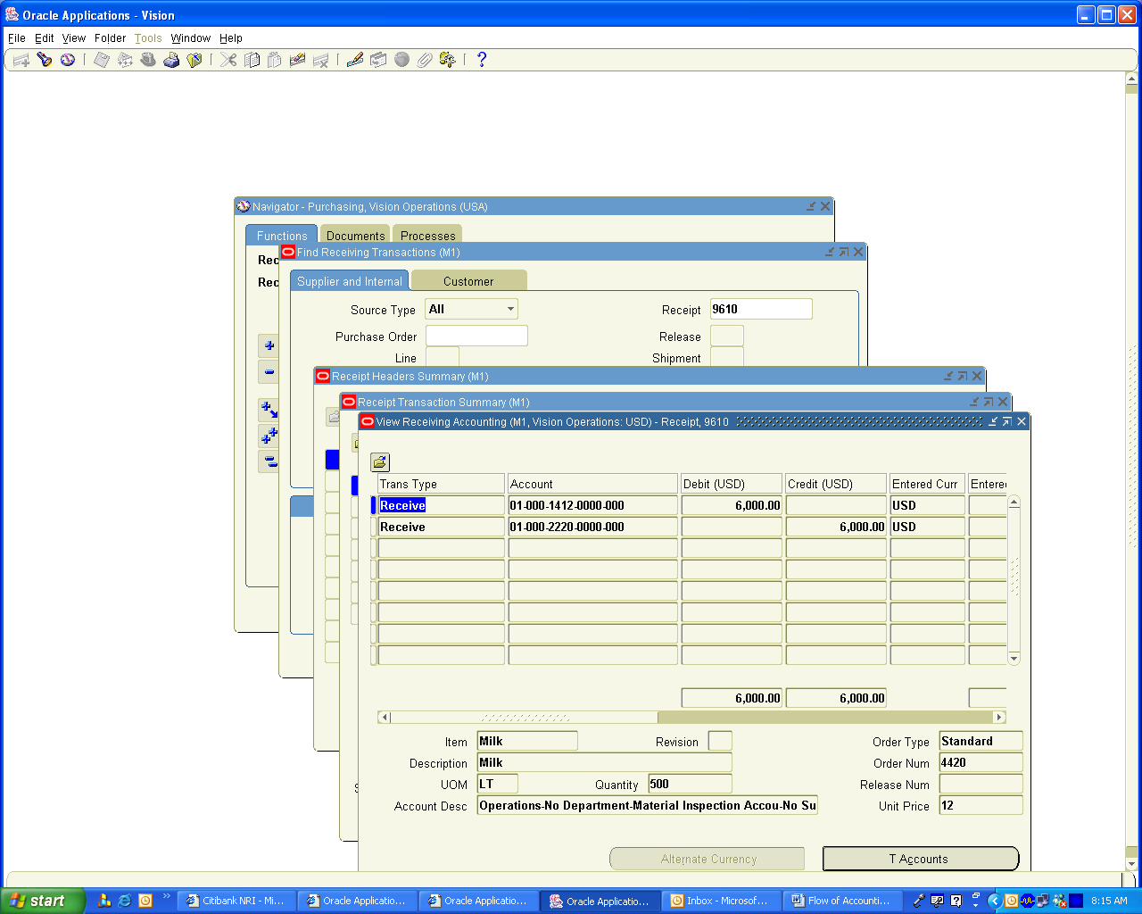

To view the Inventory Module Accounting Entries

Navigation Path
Inventory Vision Operations
Transactions / Material Transactions
Give Date Range to find Transactions and choose the Milk distribution Line

It has created following accounting entries

Inventory A/c Dr 5000
Purchase Price variance A/c Dr 1000
Material Inspection A/c Cr 6000

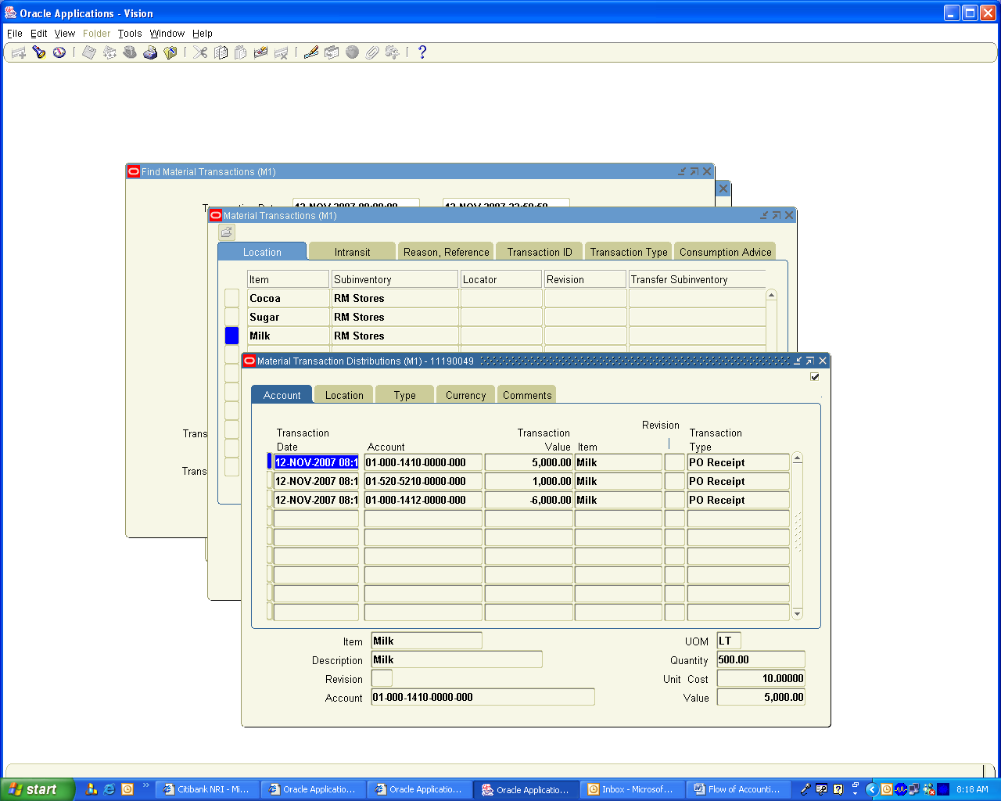

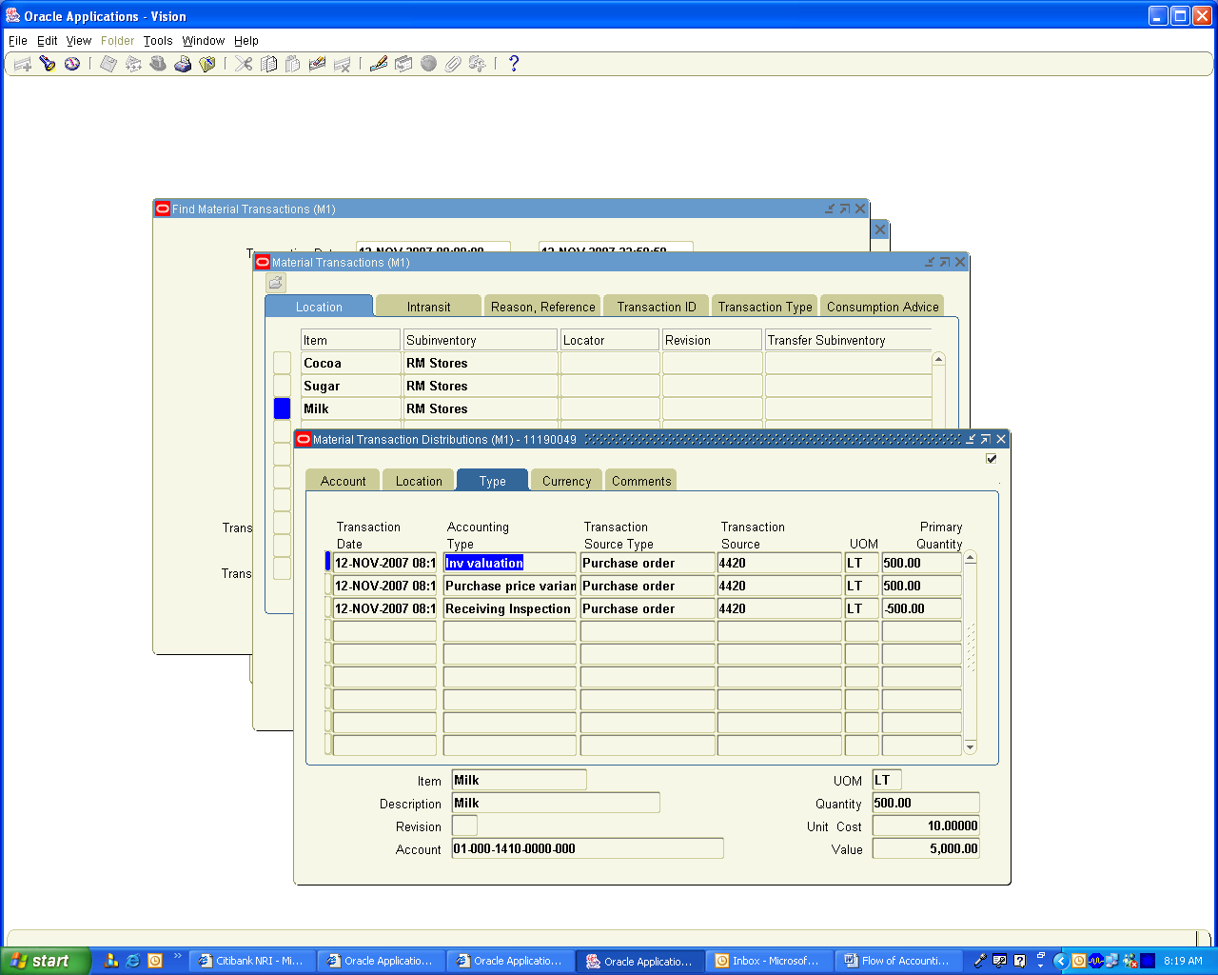

You Can View the Accounting Entries for Sugar and Cocoa also for which No Purchase Price Variance created because there is no difference between Standard Cost and the PO price

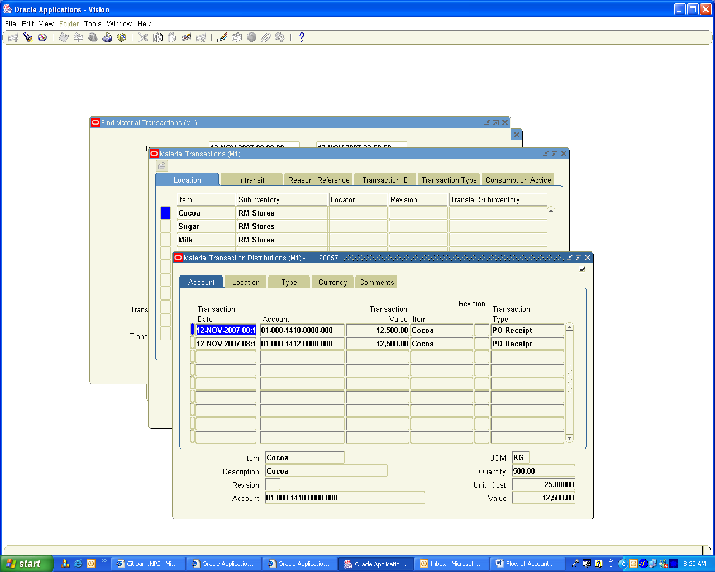

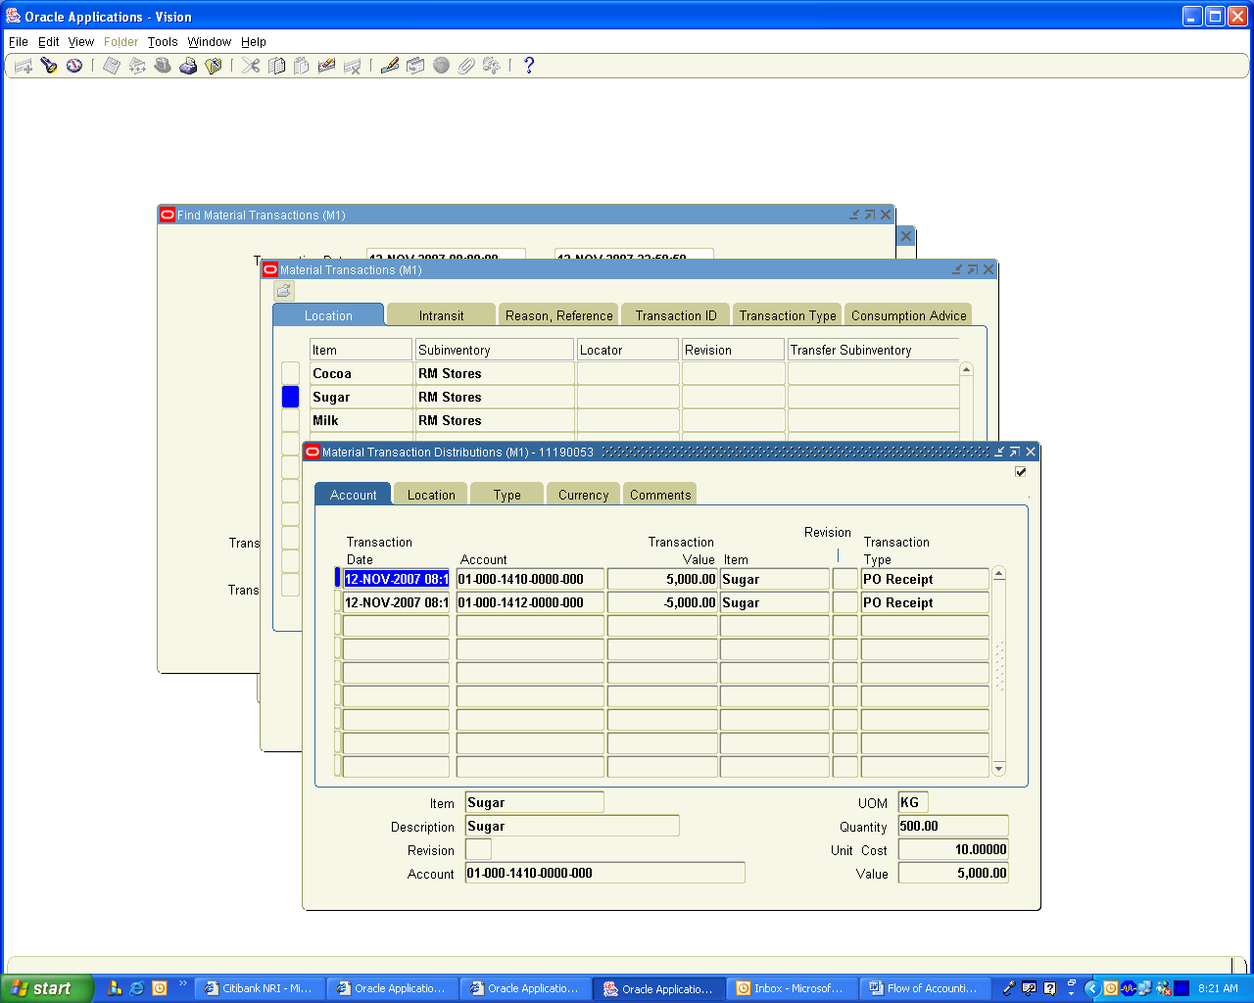

4. Material Returned to Supplier

Returned Materials to Supplier is 50 Ltrs of Milk

Navigation Path
Purchasing, Vision Operations
Receiving / Returns
Enter 50 Ltrs against the Receipt Number and Save the Transactions

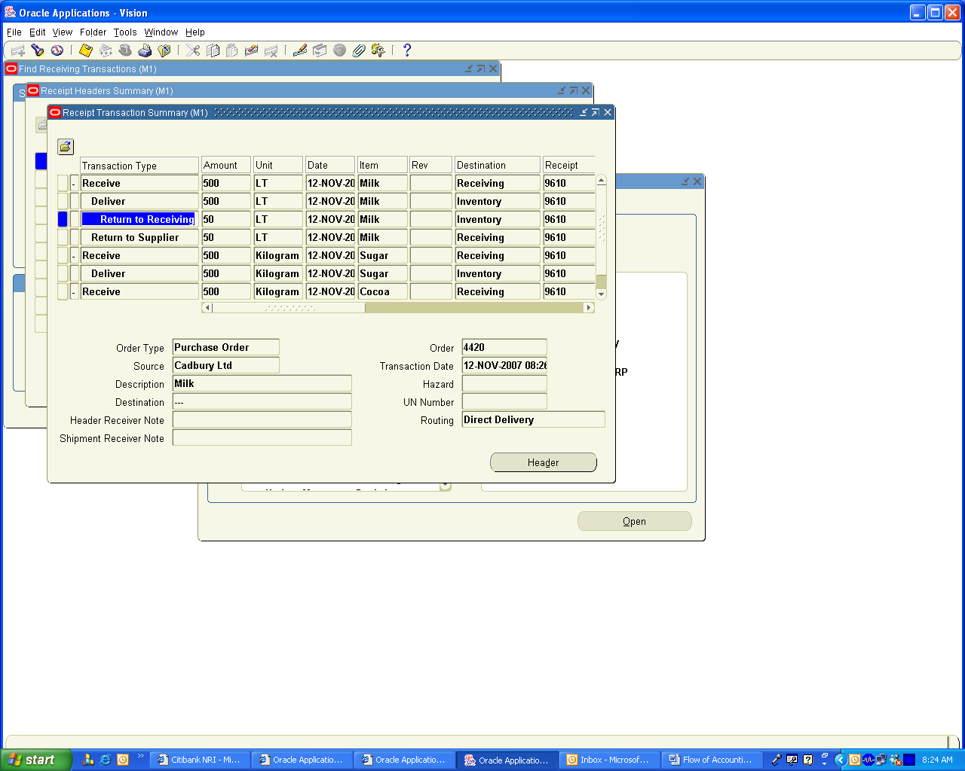

To view the Accounting Distribution Lines in Purchasing created go to

Navigation Path
Purchasing Vision Operations
Receiving / Receiving Transactions Summary
Enter Receipt Number as 9610 and click on Find Button

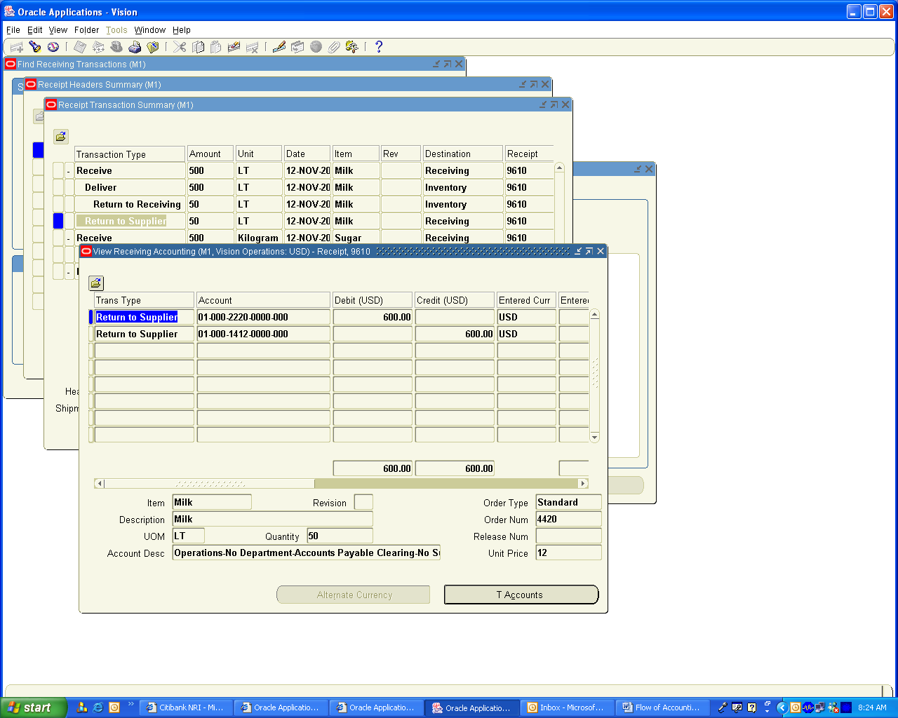

To view the Inventory Module Accounting Entries

Navigation Path
Inventory Vision Operations
Transactions / Material Transactions
Give Date Range to find Transactions and choose the Milk distribution Line

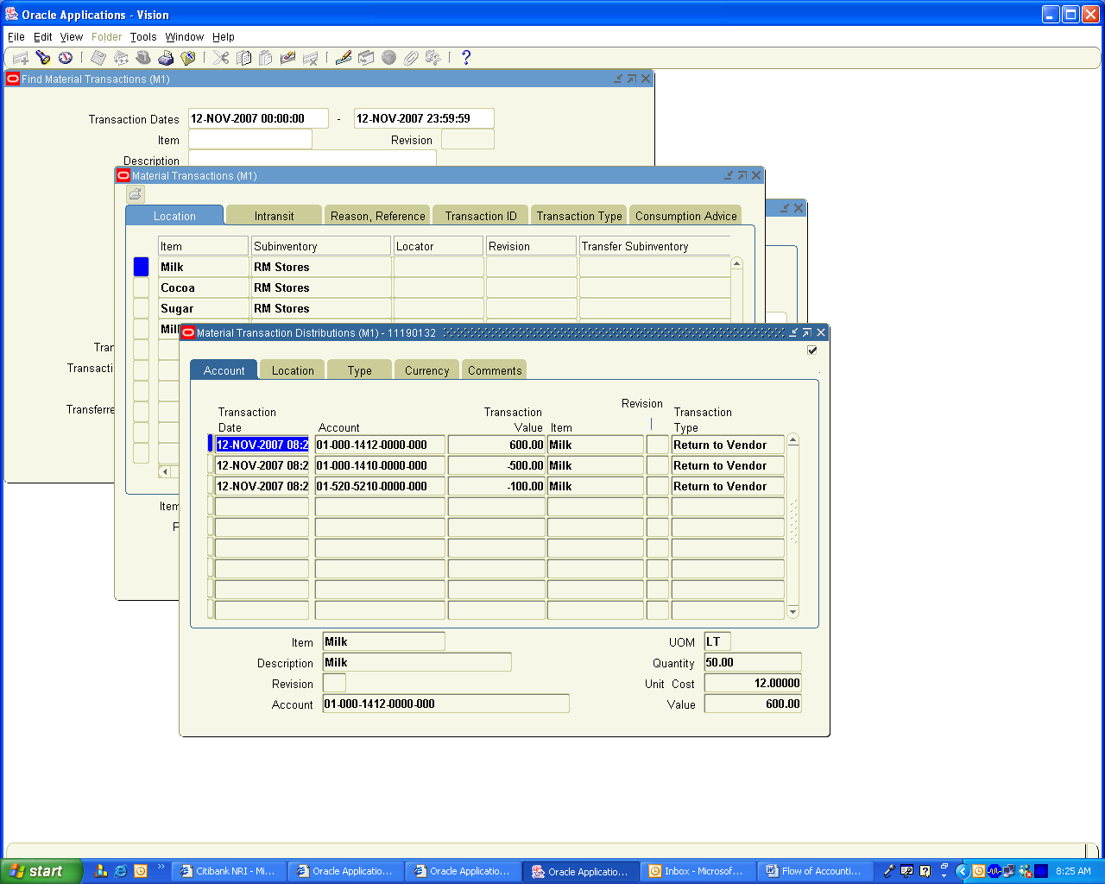

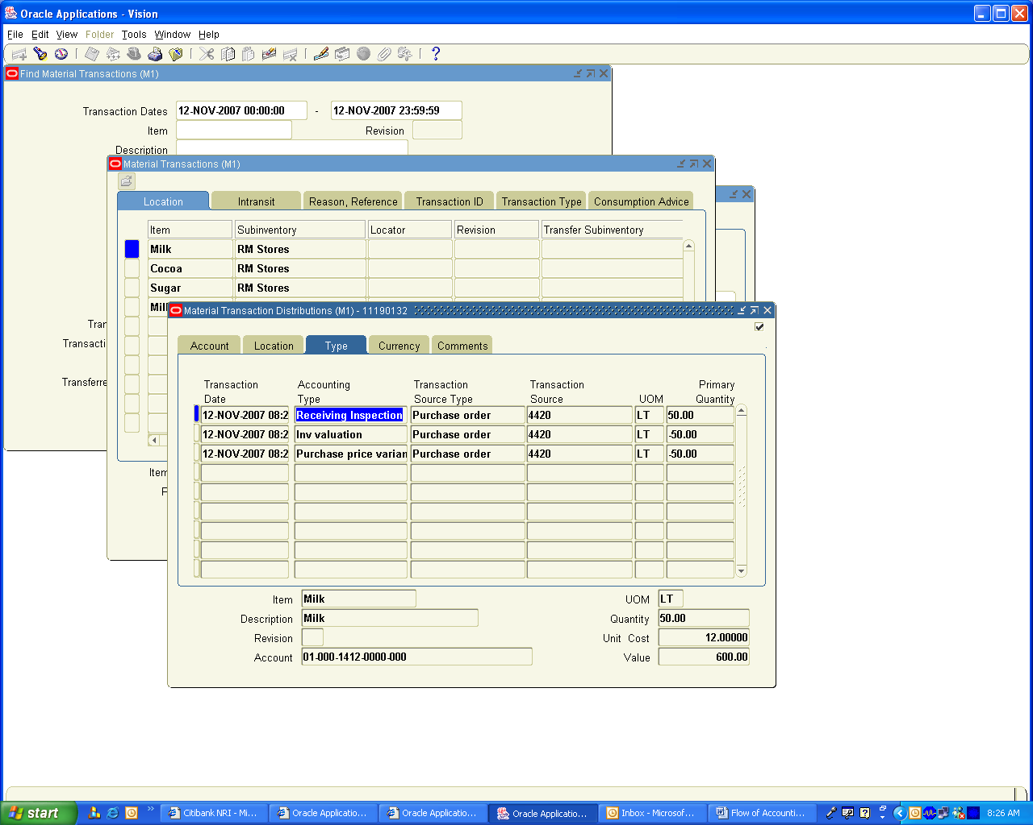

5. Create Supplier Invoice and Make payment to Supplier

Made Payment to Suppliers for Milk and Sugar

Navigation Path
Payables, Vision Operations
Invoices / Enter / Invoices
An Invoice Received from Cadbury for 10900 USD. Create an Invoice for 10900 USD and match to PO 4420

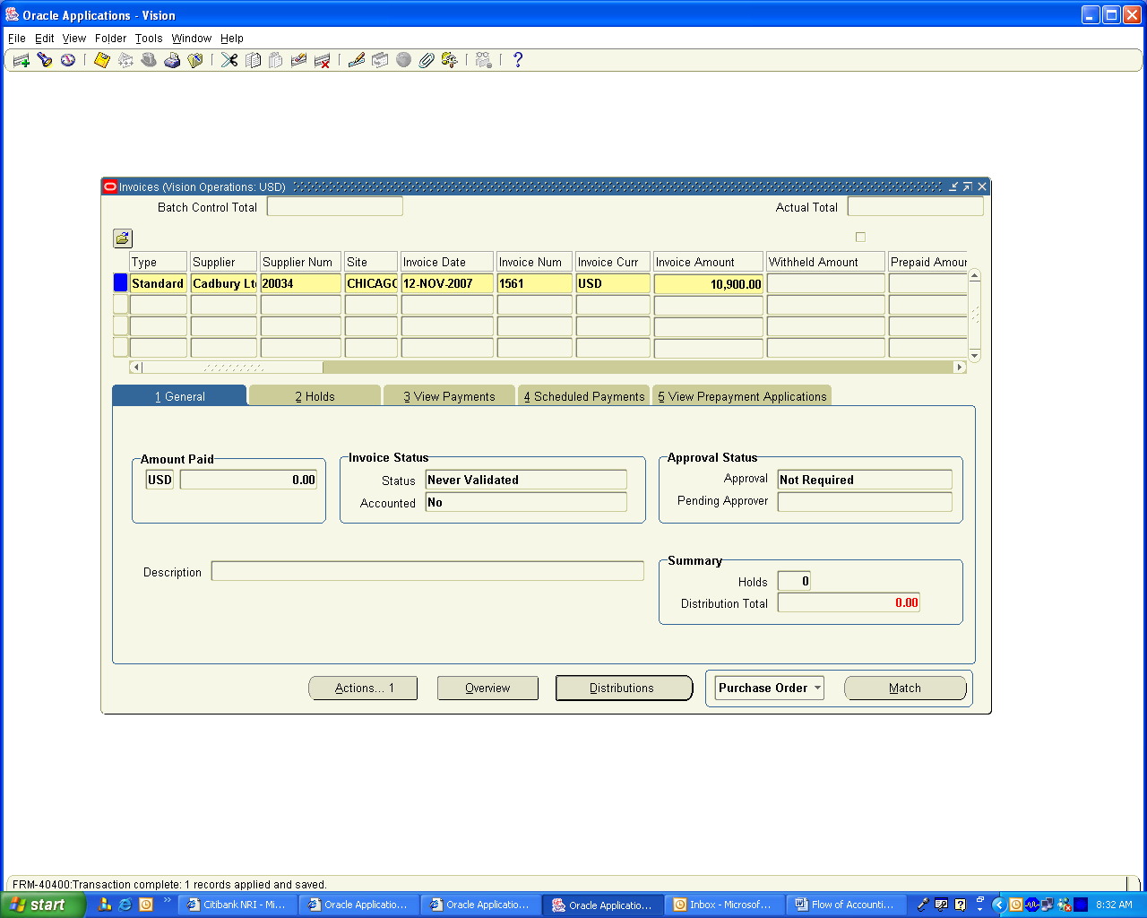

Click on Match Button and Choose the PO and enter the Quantities as per the Invoice

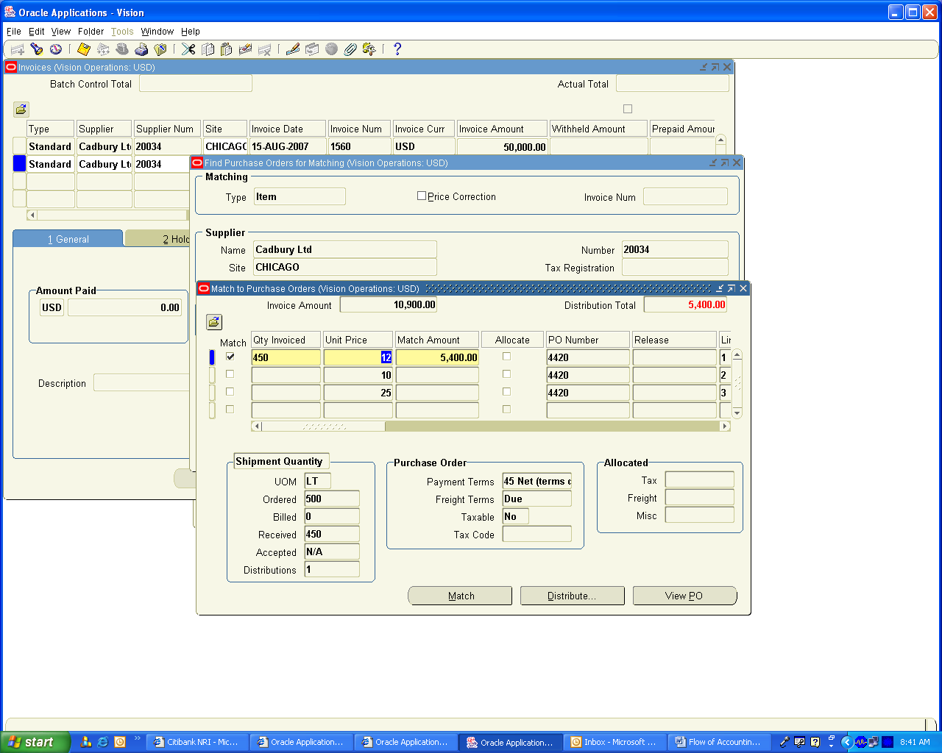

Click on Match Button Now

You will get the following lines in the distribution Lines of invoice

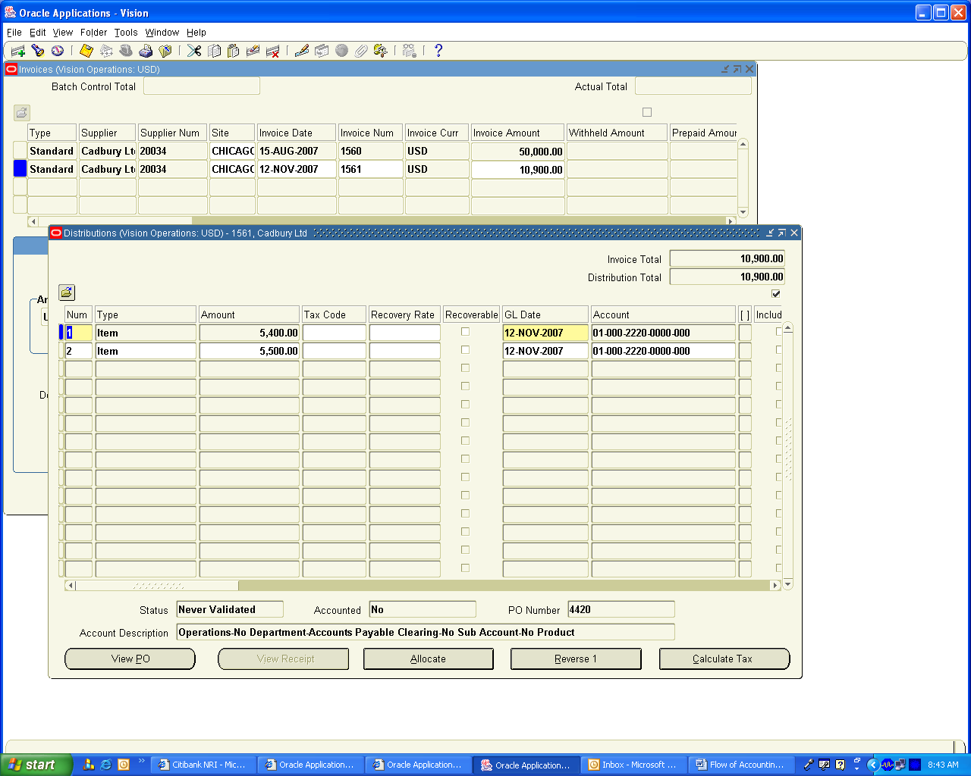

Click on Actions Button and Validate and then run the Create Accounting Button.

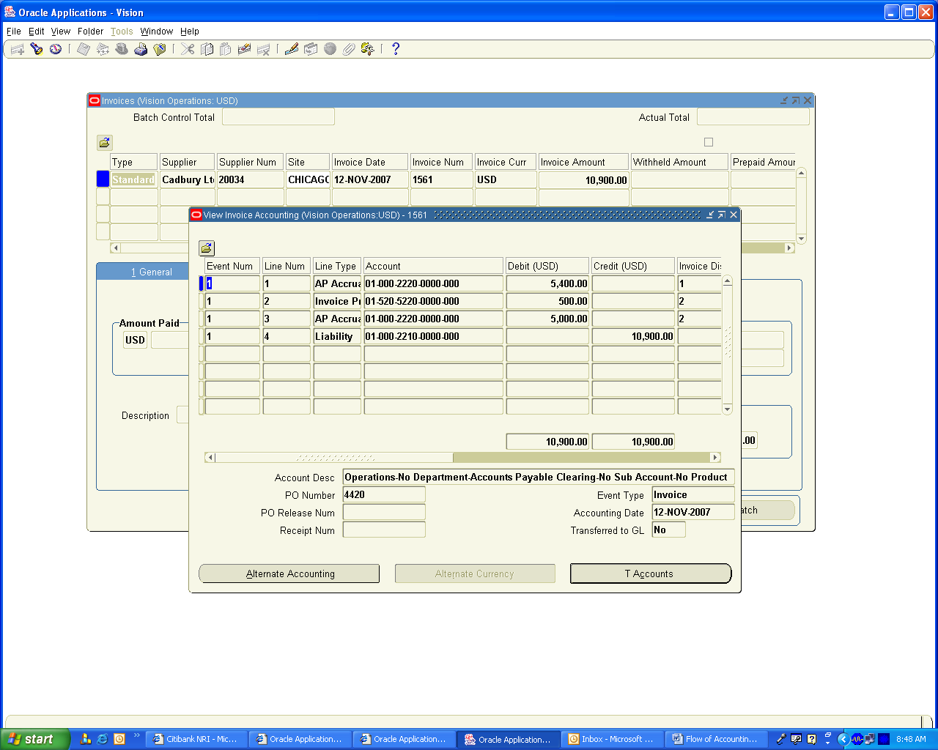

You can see that system has created an Invoice Price Variance for USD 500

Now we need to make payment for the Invoice

Navigation Path
Payables, Vision Operations
Invoices / Enter / Invoices
Query the Invoice Number 1561
Click on Actions Button and check the pay in Full check Box

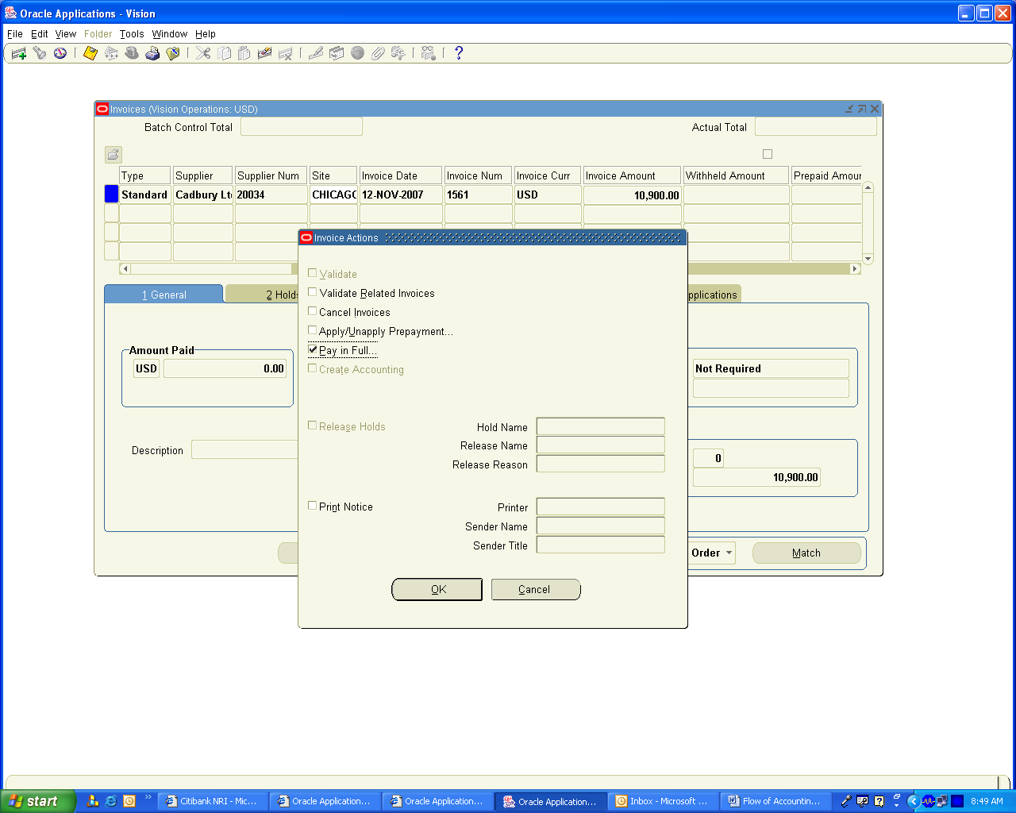

Click on OK button

The Payment Form opens and chooses the document number, it reserves the Document and click on Actions Button and enable the check box, Format, Print and Create Accounting. You will get the following screen

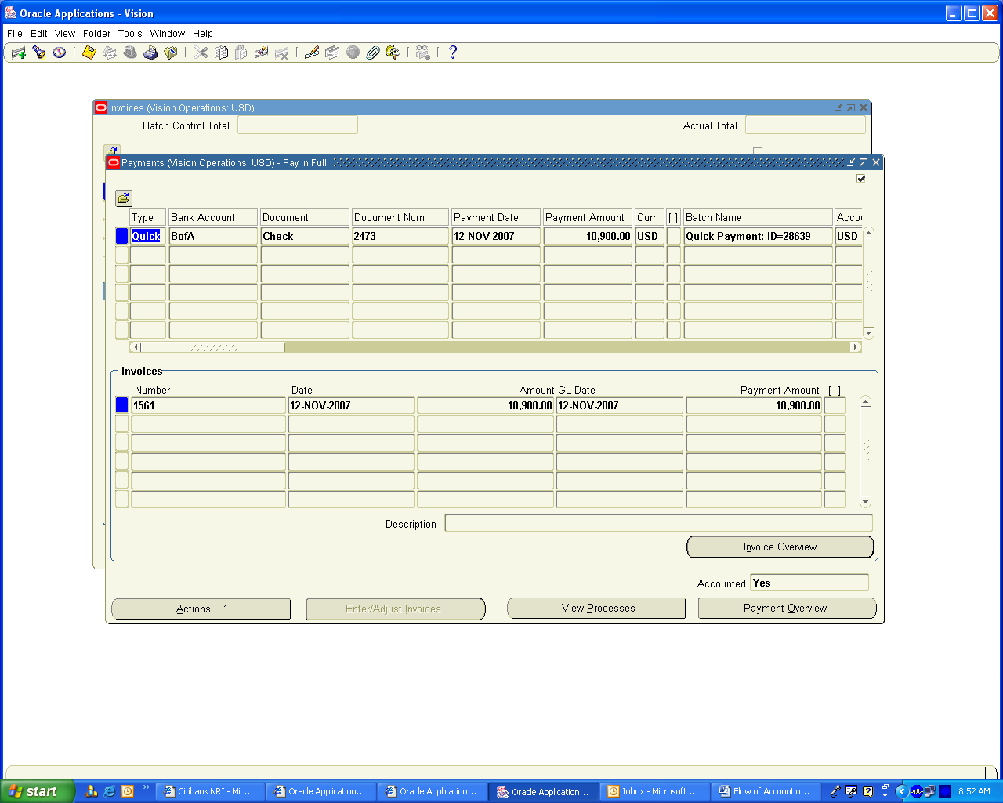

Click on Tools / View Accounting Screen to view the Accounting Entries generated

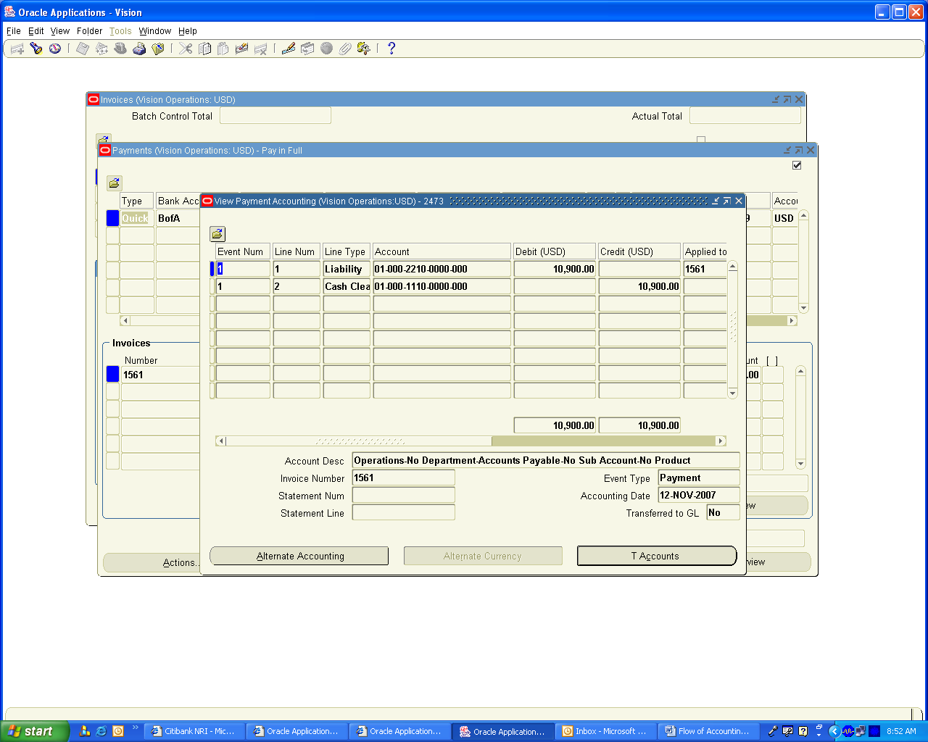

Log on to Cash management Module and Create a Bank Statement for this amount and Clear the Transaction

Navigation Path
Cash Management, Vision Operations
Bank statements / Manual Clearing / Clear transactions
Choose the Transaction and click on clear transactions button. You will find the transaction is vanished which means it is cleared.

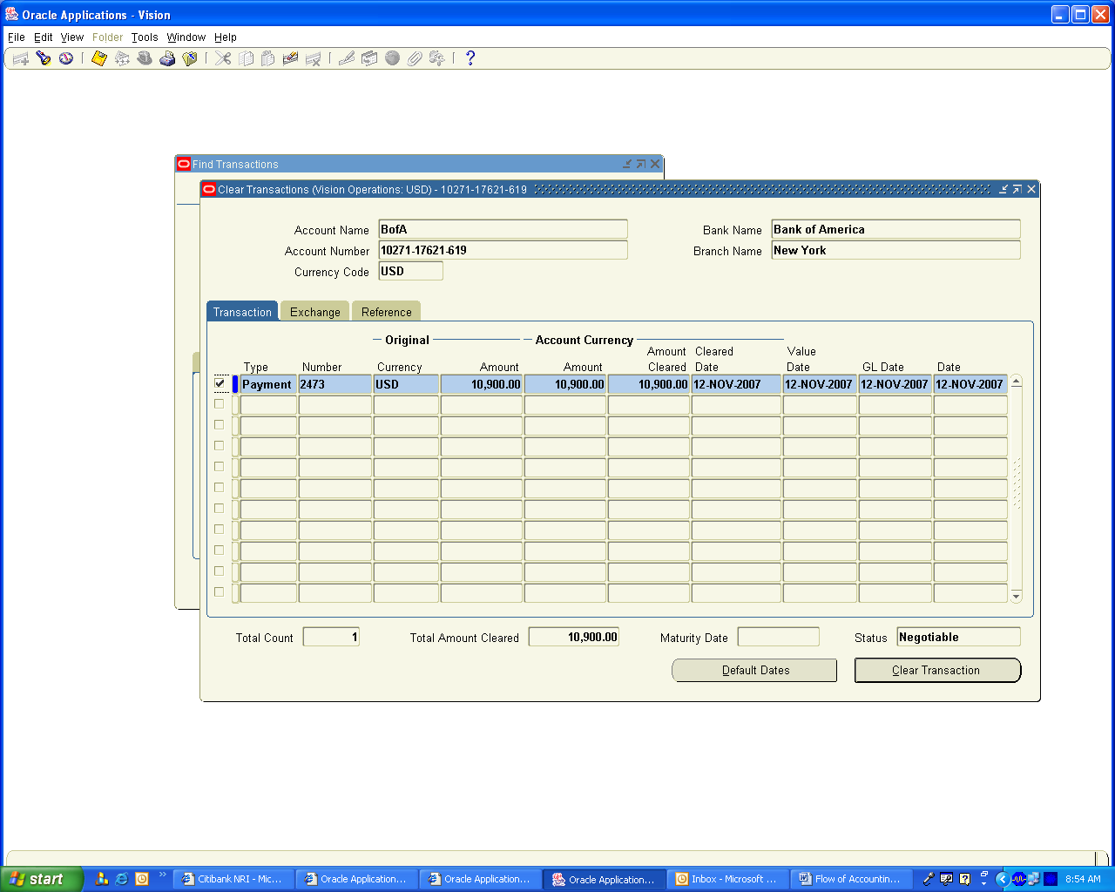

Navigation Path
Payables, Vision Operations
Payments / Entry / Payments
Query for the payment Number 2473
You will find Accounted Status changed to partial

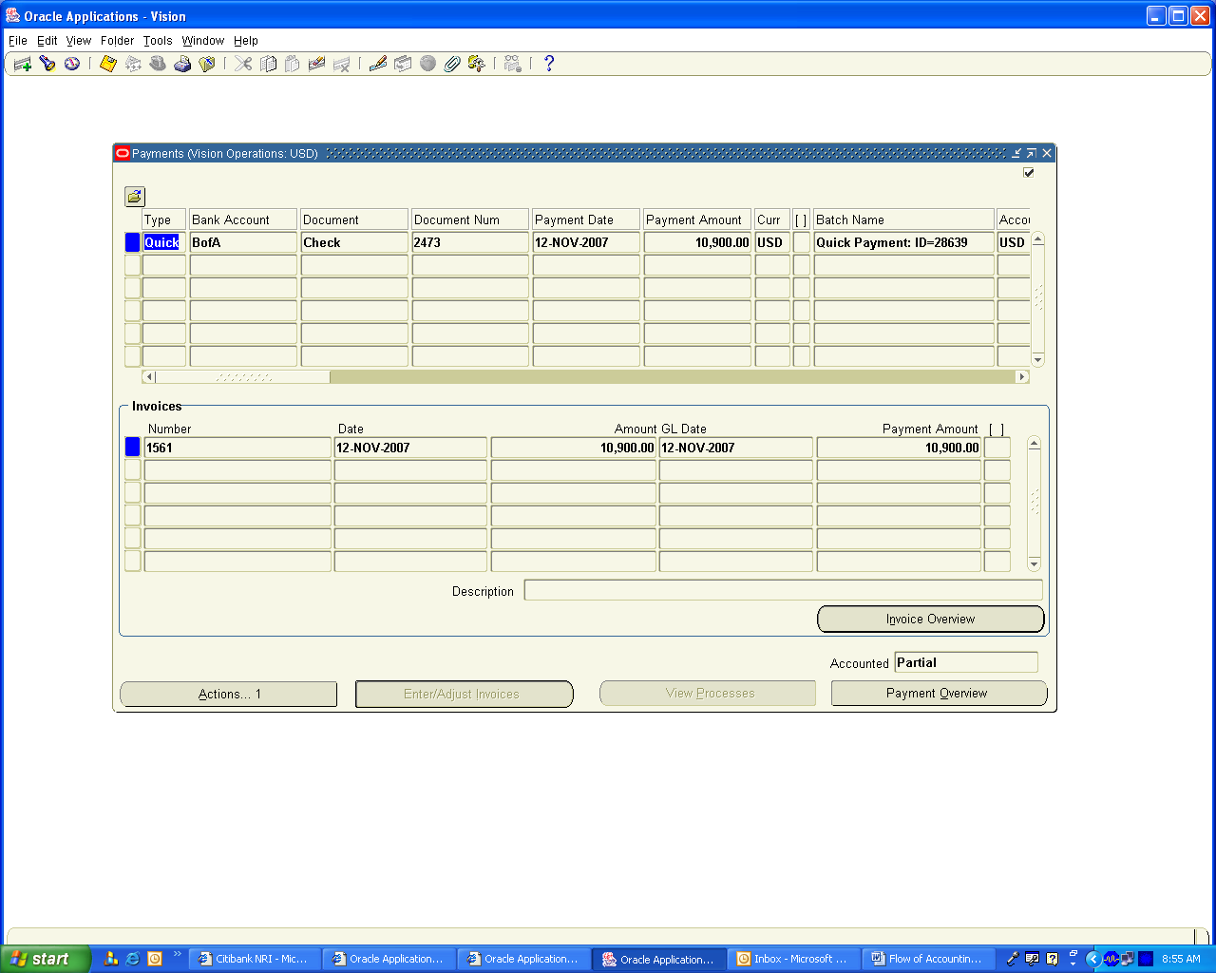

Click on Actions Button and Enable create Accounting check box and click on OK button

Click on Tools / View Accounting to view the Accounting Entries Created

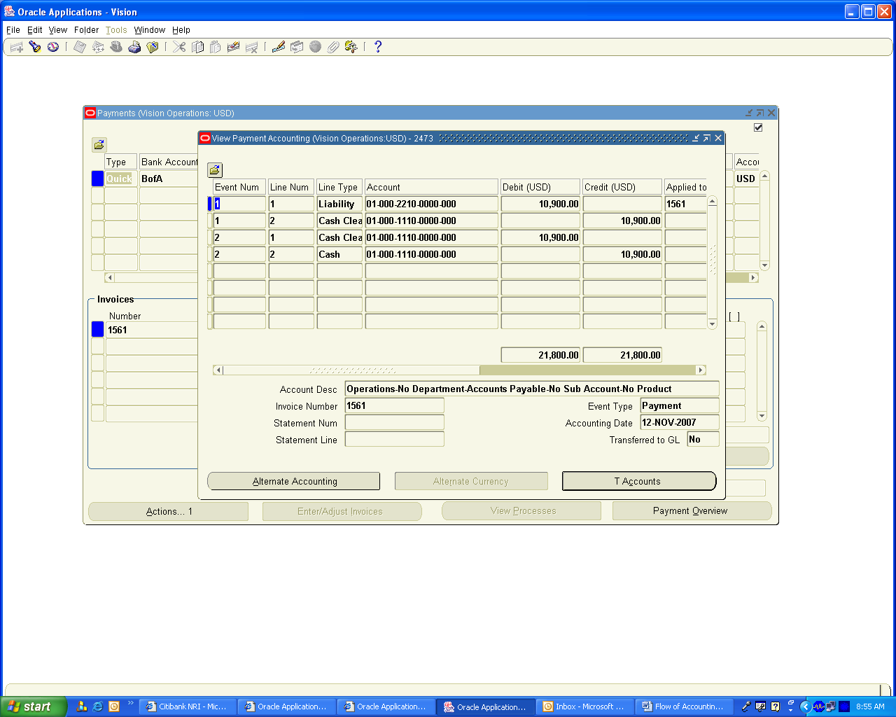

This Completes the Procure to Pay cycle Accounting Transactions. We will proceed for Manufacturing Transactions.

6. Create Discrete Job for Coffeebite, Caramilk and Lactoking

During the month 7 kgs of Caramilk, 12 Kgs of Coffee Bite and 6 Kgs of Lackto King Chocolates the Discrete job is created

Navigation Path
Manufacturing, Vision Operations
WIP / Discrete / Discrete Jobs
Create a New Discrete Job for each of the Product as mentioned above and change the status from Unreleased to Released

For detailed steps of creating Discrete Job Refer my Previous Document “Procure to pay and Manufacturing Cycle”

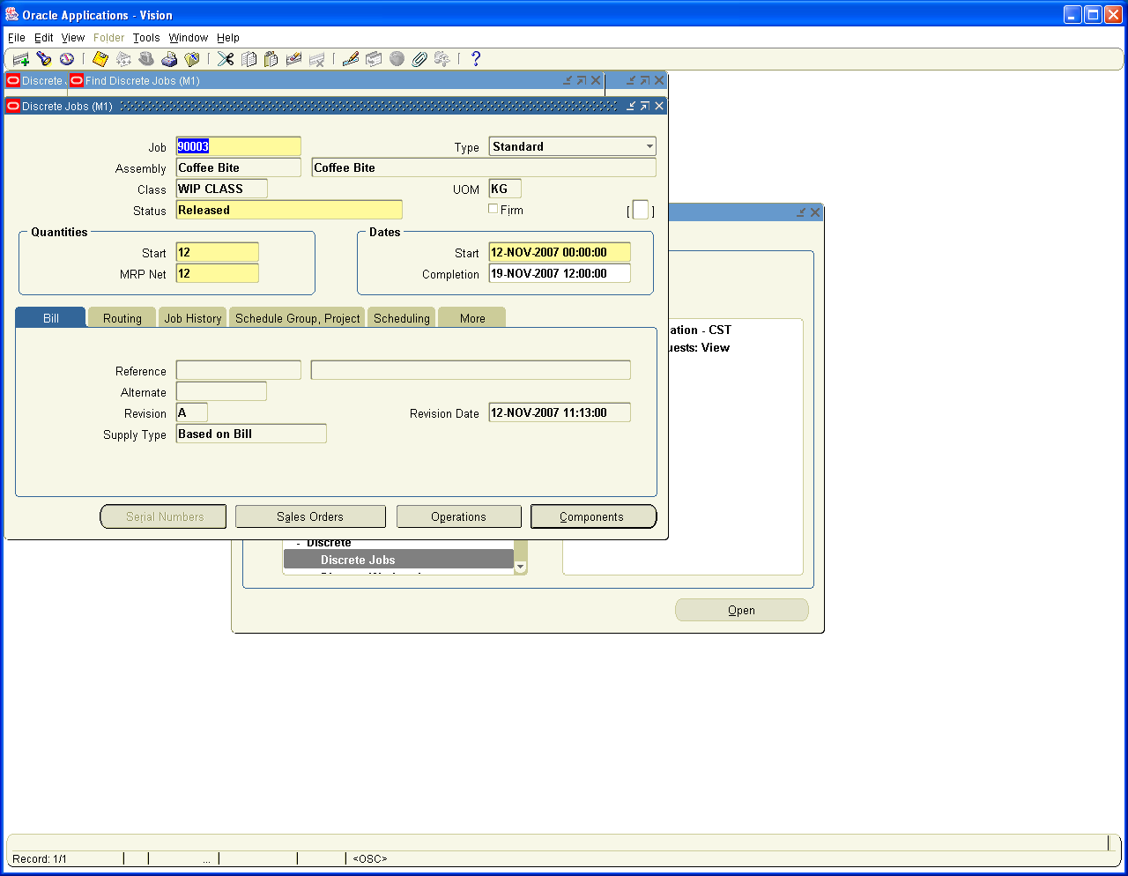

Navigation Path
Manufacturing, Vision Operations
WIP / Move Transactions / Move Transactions
Enter the Job order 90003 and in Quantity column enter the Completed Quantity as 10 and save the transaction.

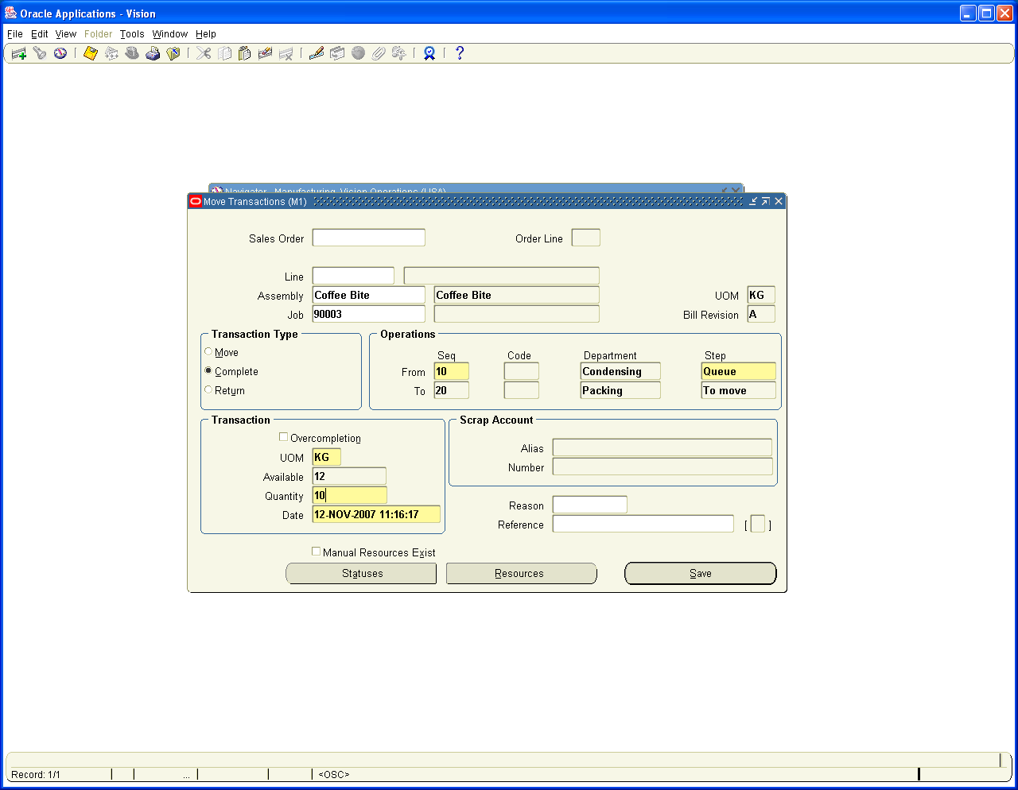

Again enter the same Job Order 90003 and move the Balance Two Kgs as Rejected item to view the accounting Impact on Rejected Transactions

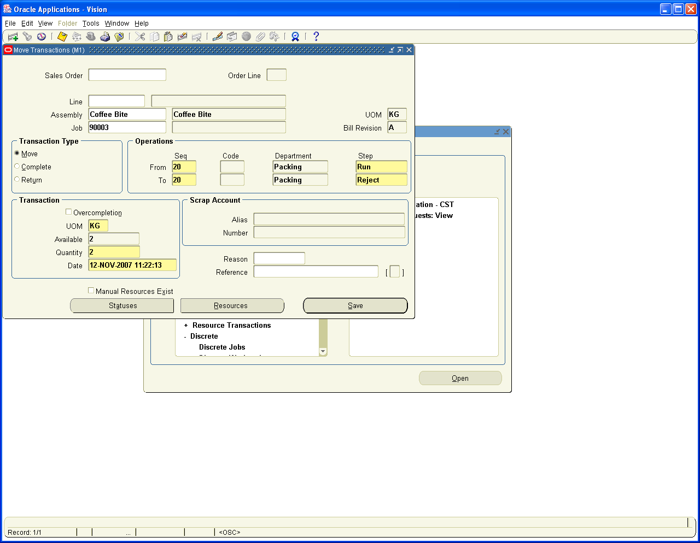

Go back to Following Navigation Path and Search for Job order 90003

Navigation Path
Manufacturing, Vision Operations
WIP / Discrete / Discrete Jobs

You will find the Job status as Complete and Completed Quantities as 10. The remaining balance 2 Kgs Reject is Reworkable and the Job is still in released status and the job is not yet closed.

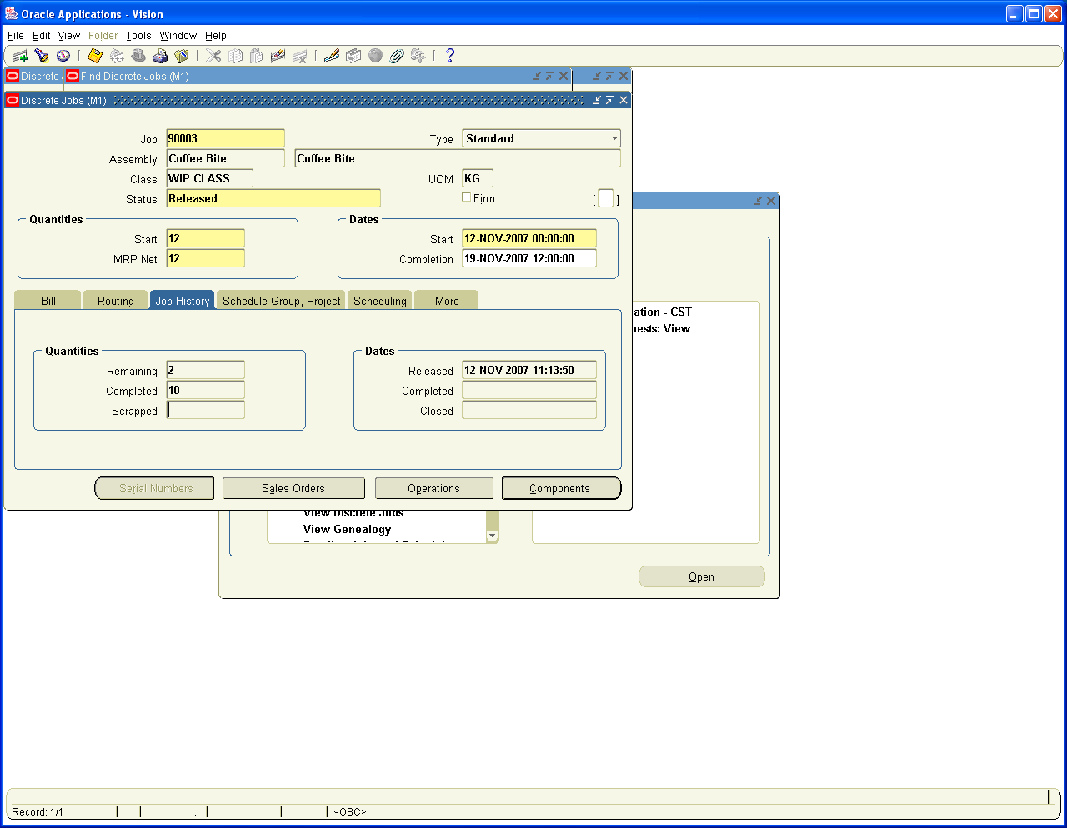

Go back to Following Navigation Path and Search for Job order 90003

Navigation Path
Manufacturing, Vision Operations
WIP / Discrete / WIP Value Summary

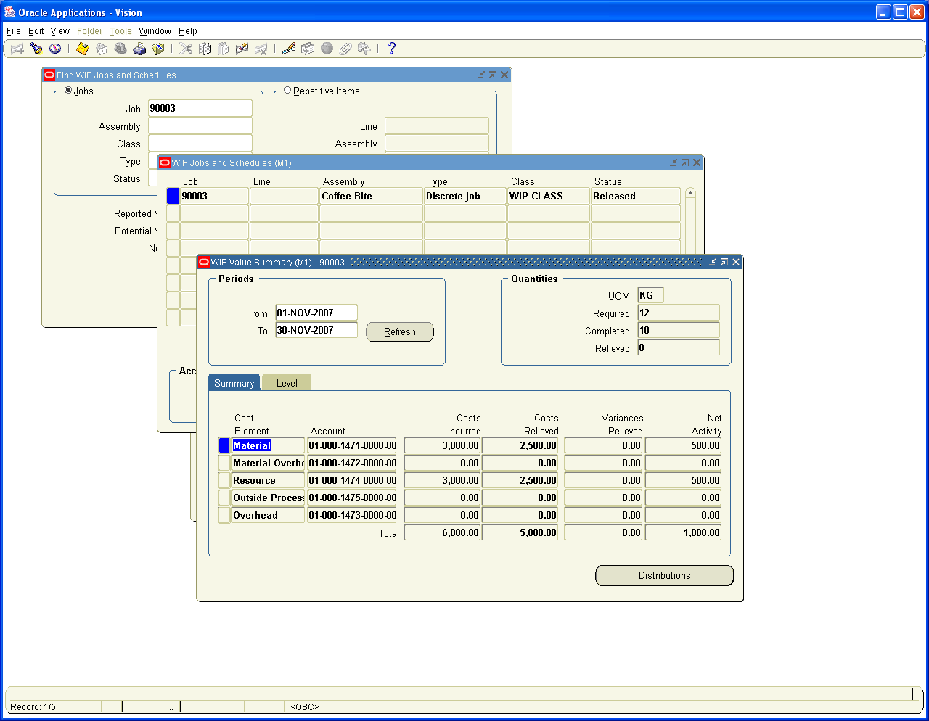

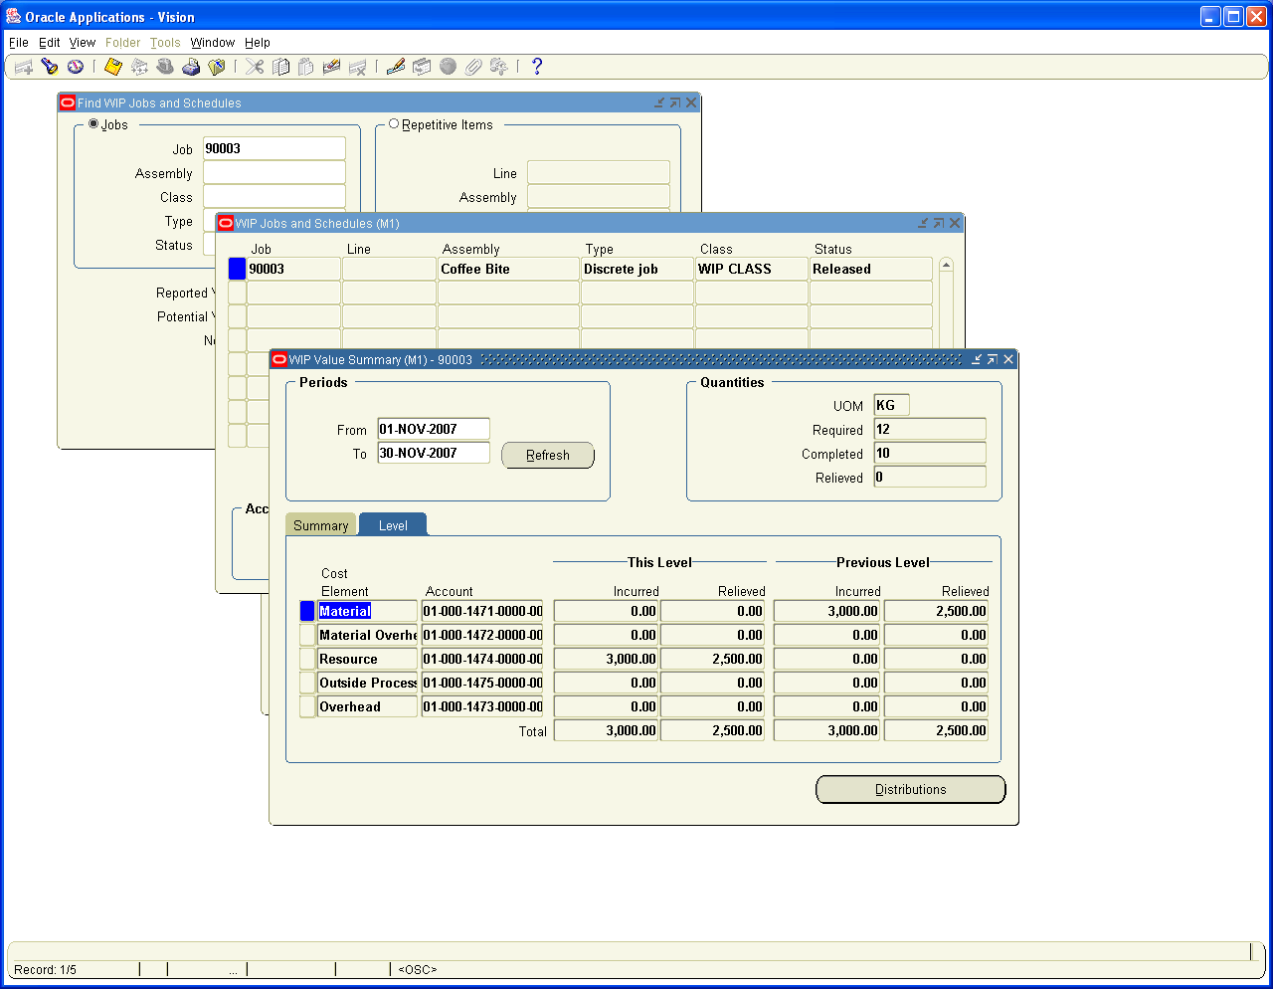

First we will complete the other two Orders also and Set one of the Job order to Scrap and See how the Scrap Accounting Takes places

Navigation Path
Manufacturing, Vision Operations
WIP / Move Transactions / Move Transactions

For Job Order 90002 we make 5kgs as completed and Balance 2 kgs, we will make it as Scrap and view the accounting Impact

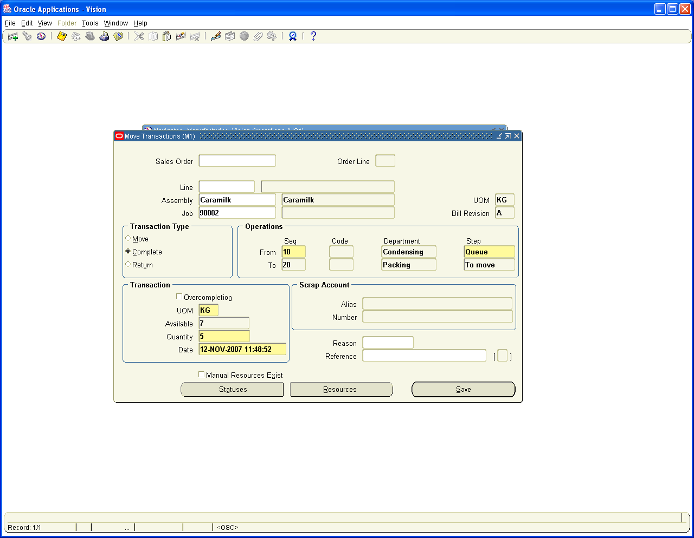

Balance Two Kgs of Caramilk moved to scrap as follows

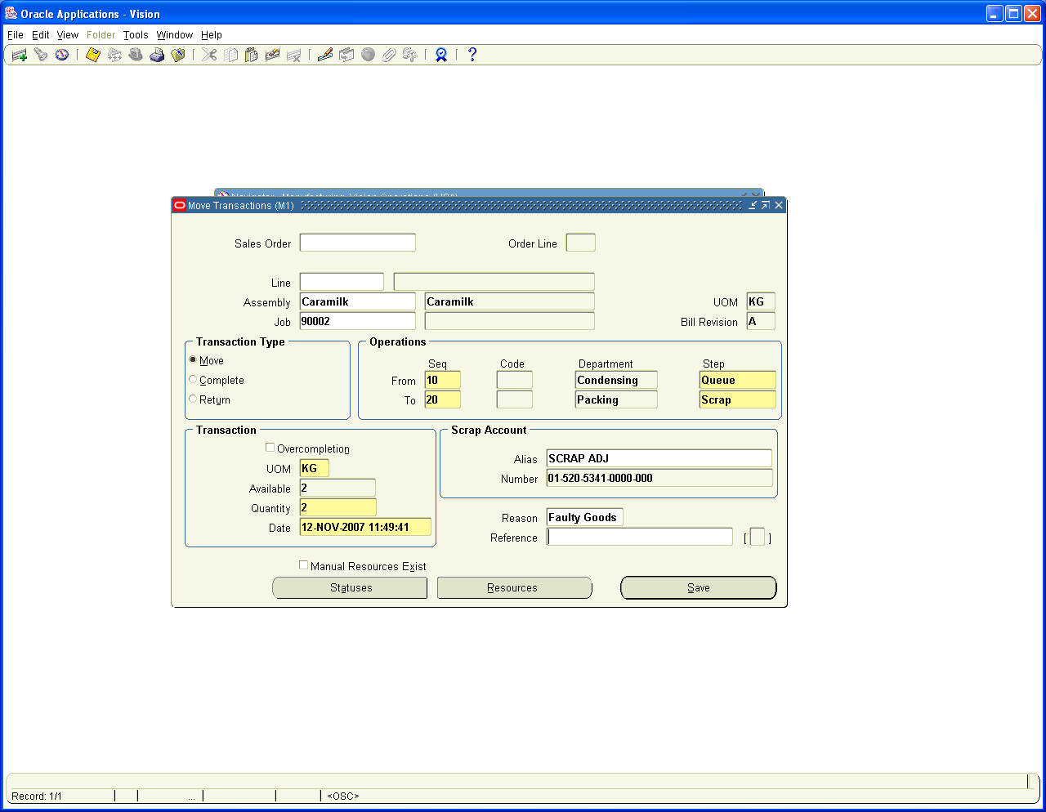

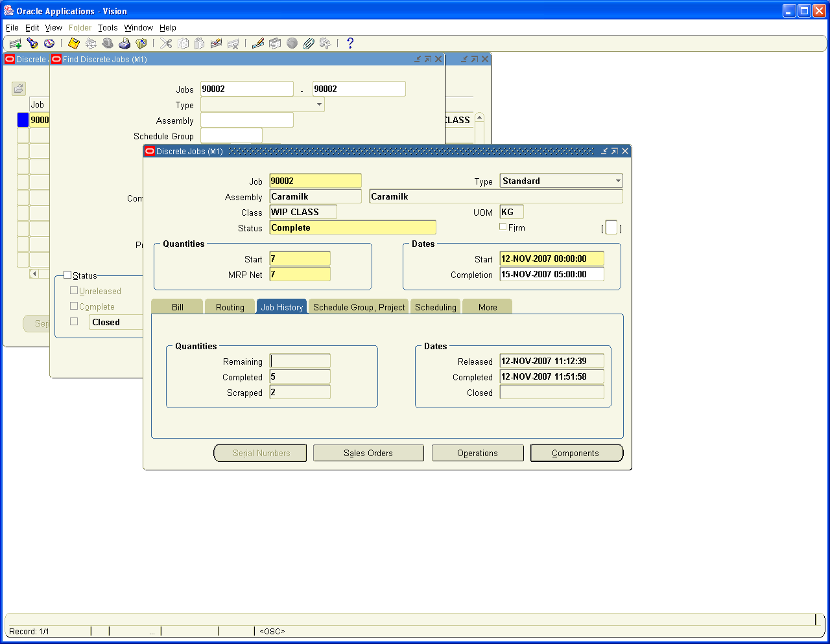

Job Number 90004 for Lactoking

Navigation Path
Manufacturing, Vision Operations
WIP / Move Transactions / Move Transactions

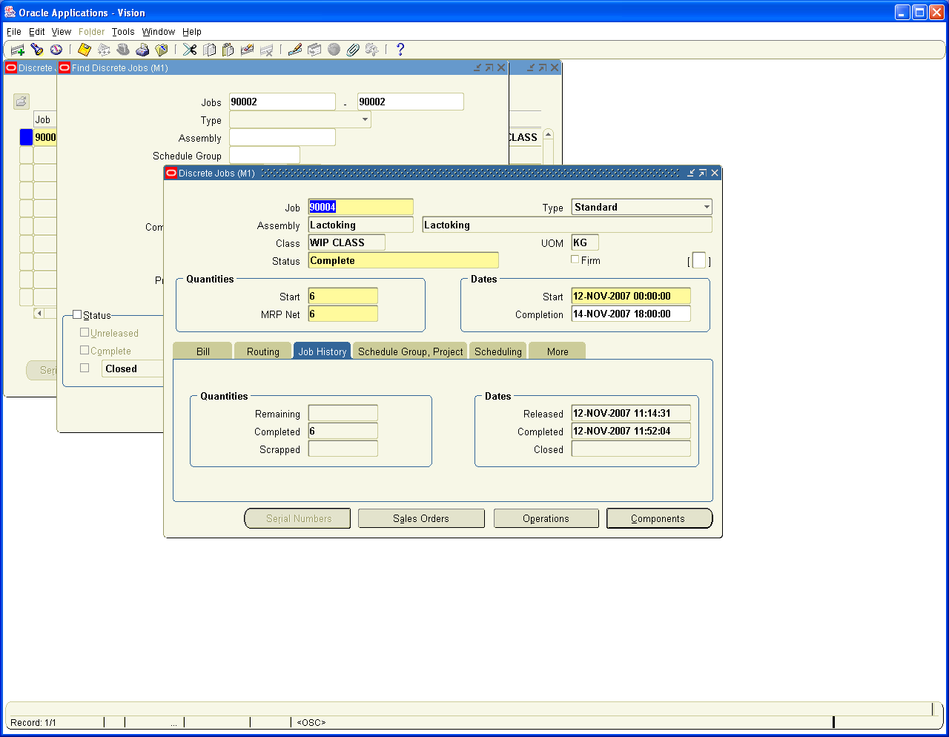

Next we need to close the Job Orders for the Variances to get relieved

Navigation Path
Manufacturing, Vision Operations
Discrete / Close Discrete jobs/ Discrete Jobs Forms
Enter Job order ranges 90002 and 90004

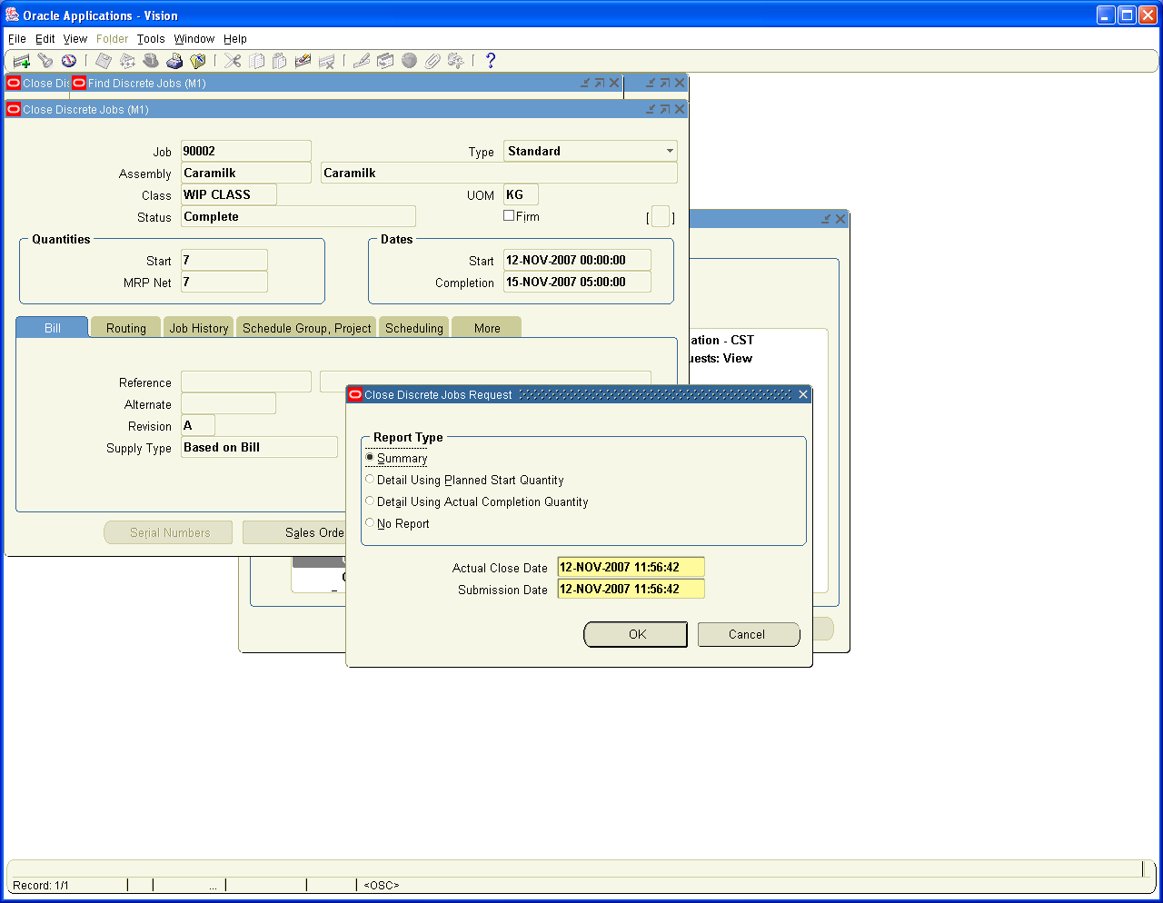

Status changed to closed

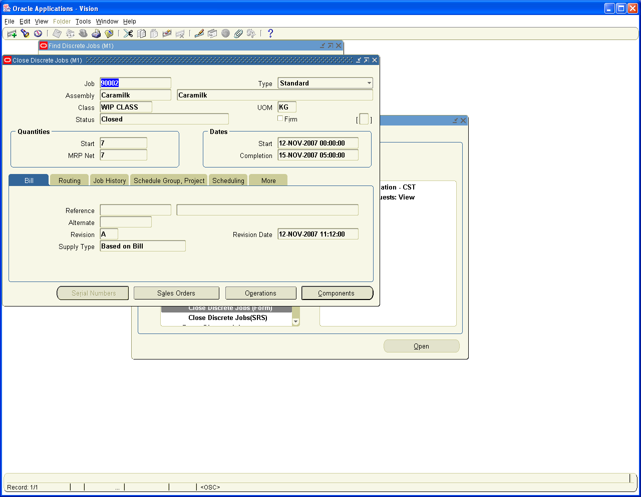

Let us view the WIP Valuation Summary for the Scrap and Rejection Accounting variances

Navigation Path
Manufacturing, Vision Operations
WIP / Discrete / WIP Value Summary

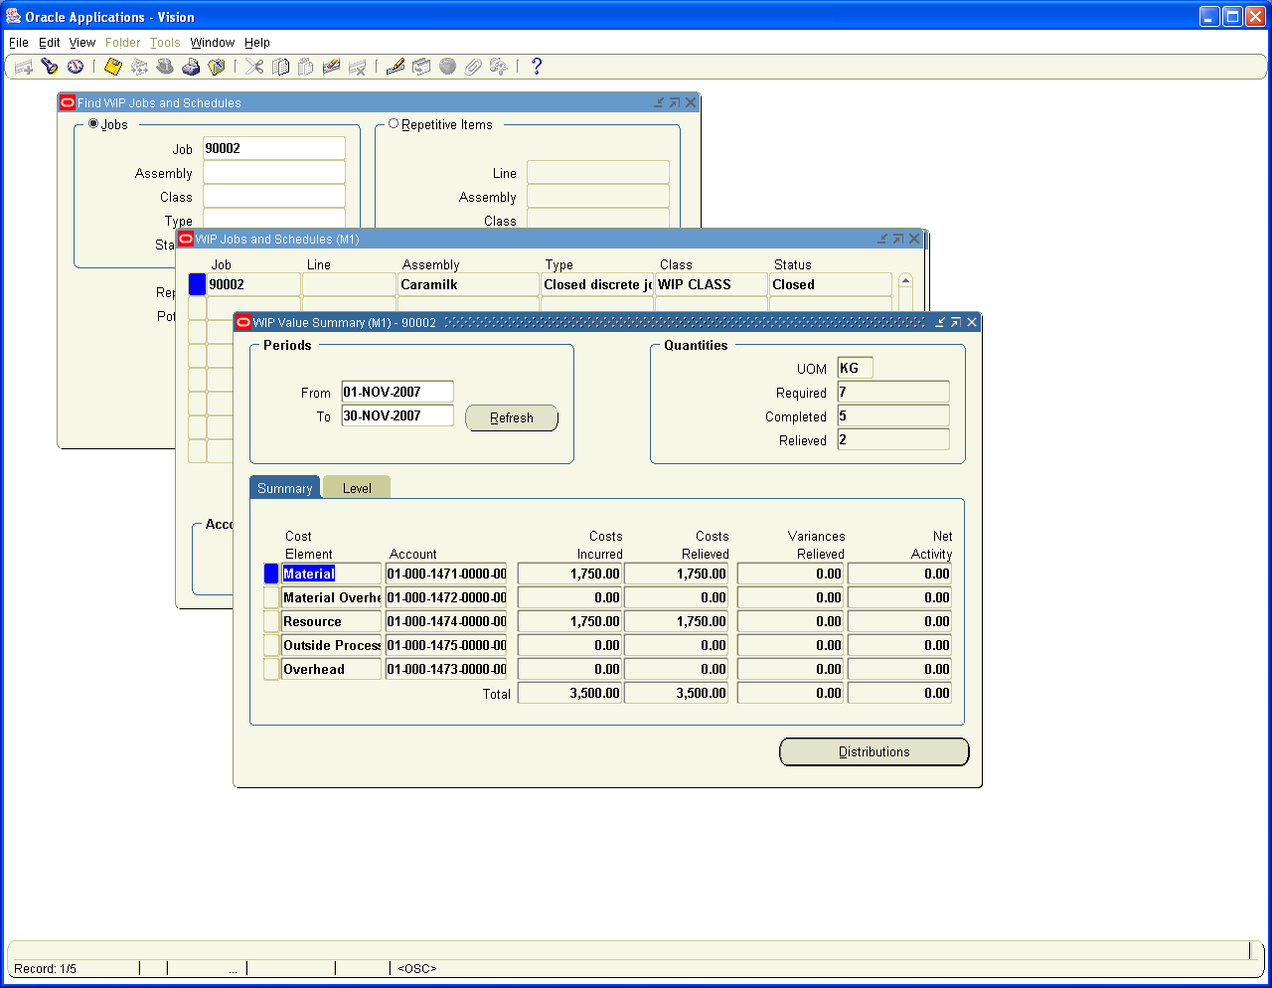

Job Order 90002 Where as Scrap Account accounting Distributions

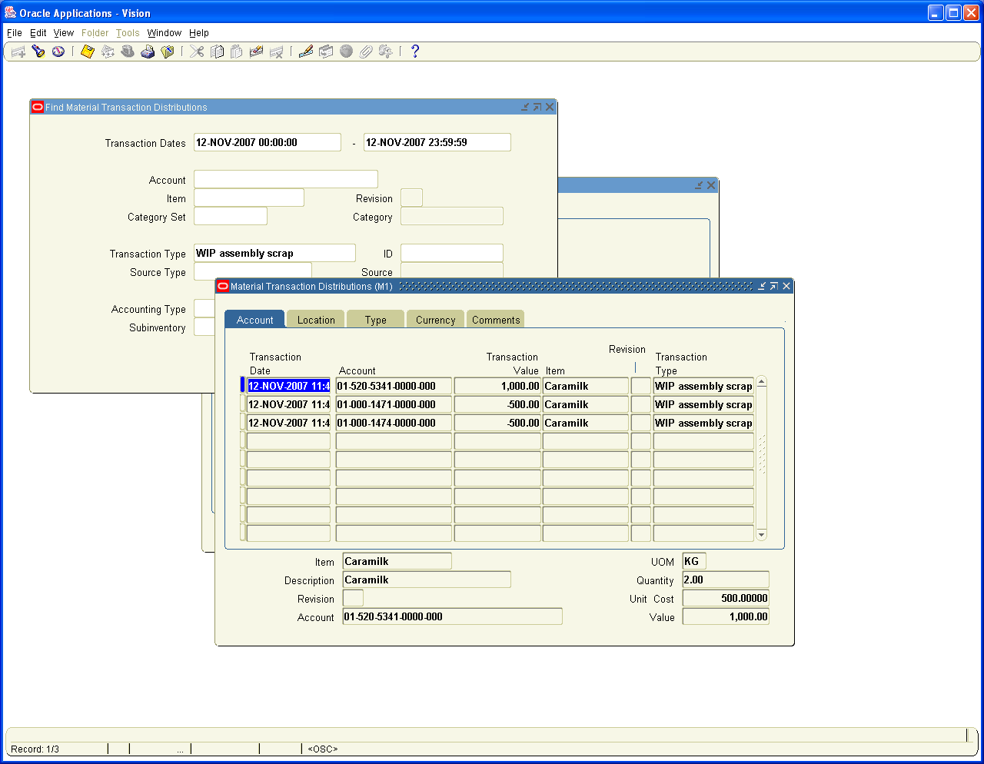

Job Order Number 90003 WIP Value Summary showing cost of 1000 USD for the Rejected goods not yet reprocessed

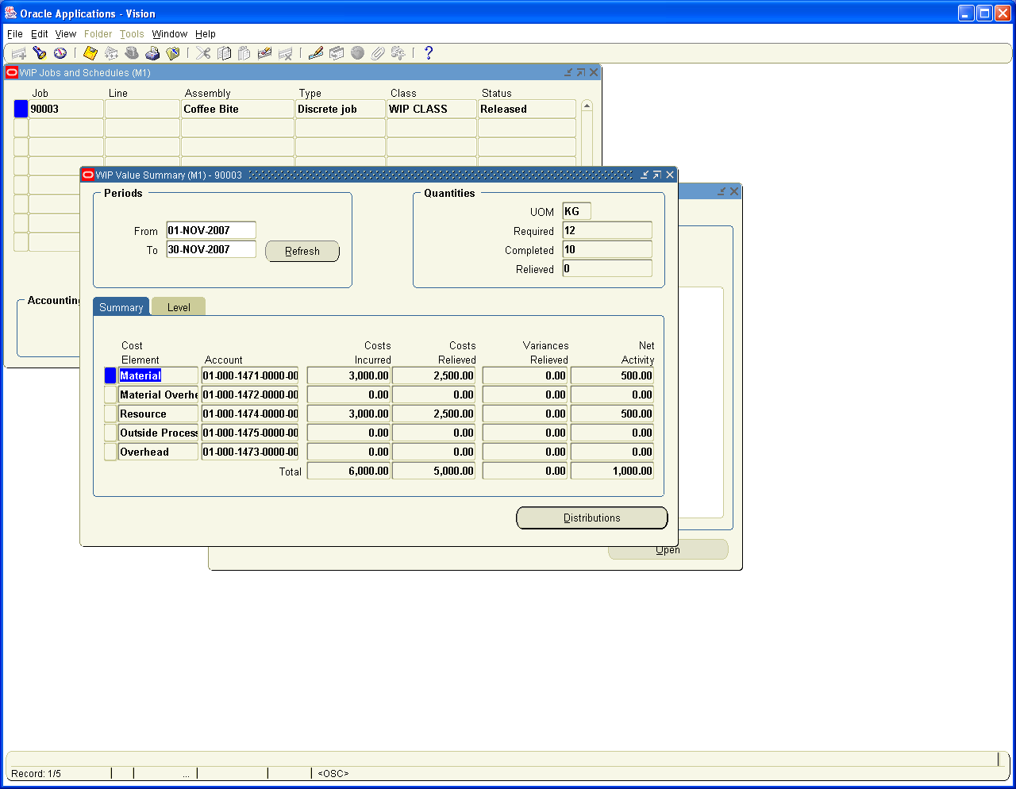

Job Order 90004 for the Lactoking which is completed in full

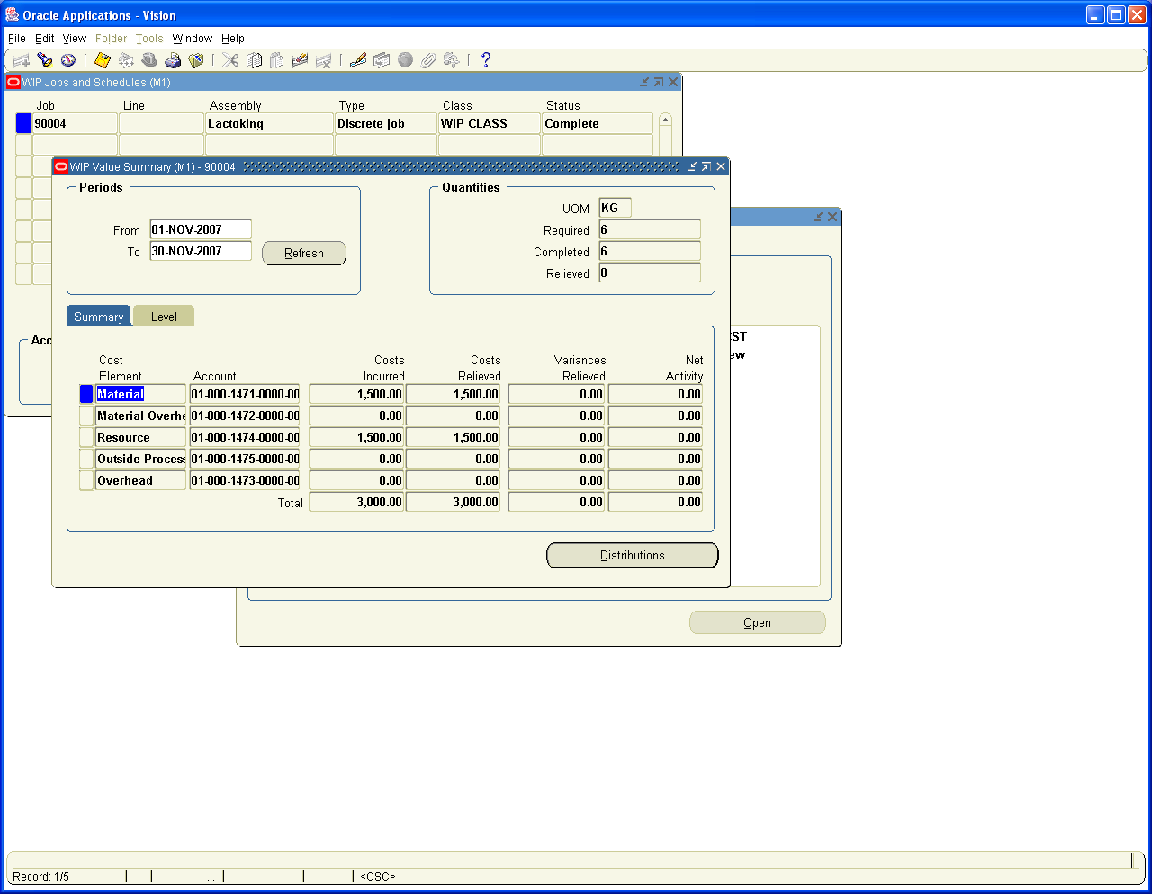

7. Create Sales Order, Book the Order, release and Ship confirm the Goods

Sales Made during the Month is 5 Kgs of caramilk and, 10 Kgs of Coffee Bite and 4 Kgs of Lacto King

Important Note: Order management does not generate any accounting entries and when we do ship confirm Goods Inventory Module Generates the Accounting entries

Navigation Path
Order management Super user, Vision Operations
Orders, Returns / Sales Orders

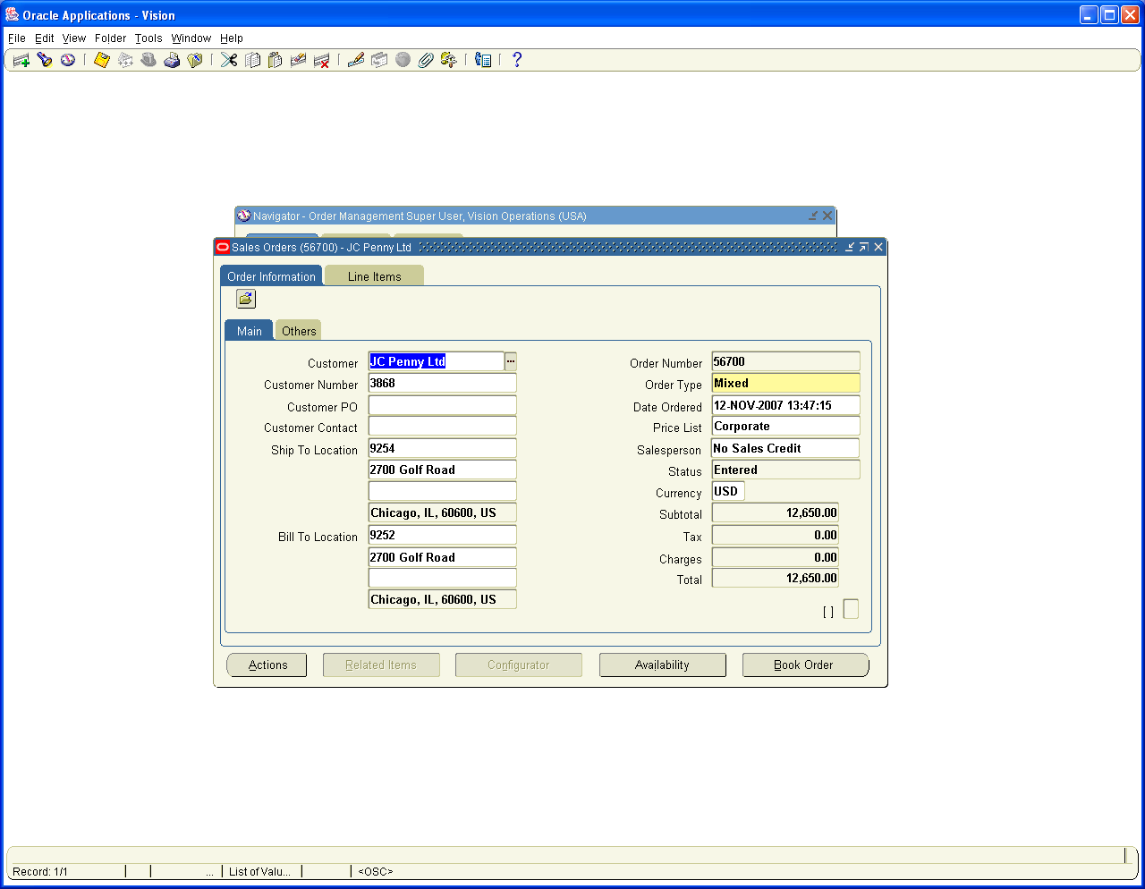

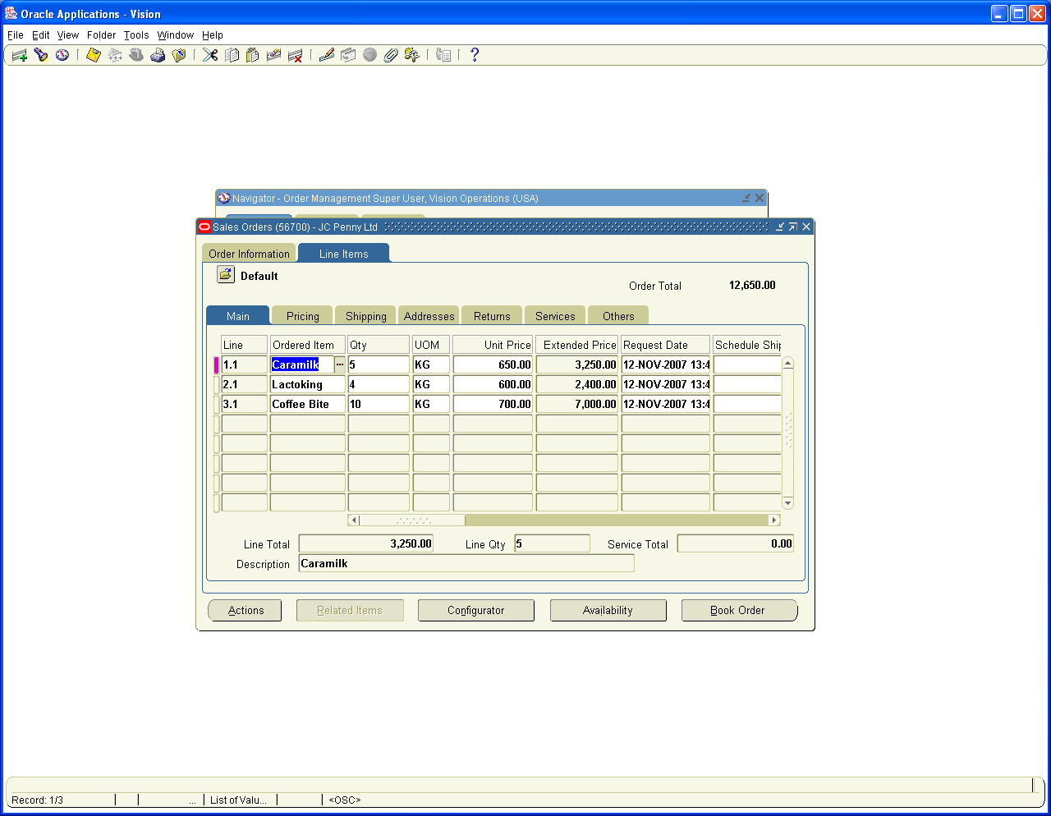

Navigation Path
Order management Super user, Vision Operations
Orders, Returns / Sales Orders

Book the Sales Order number 56700

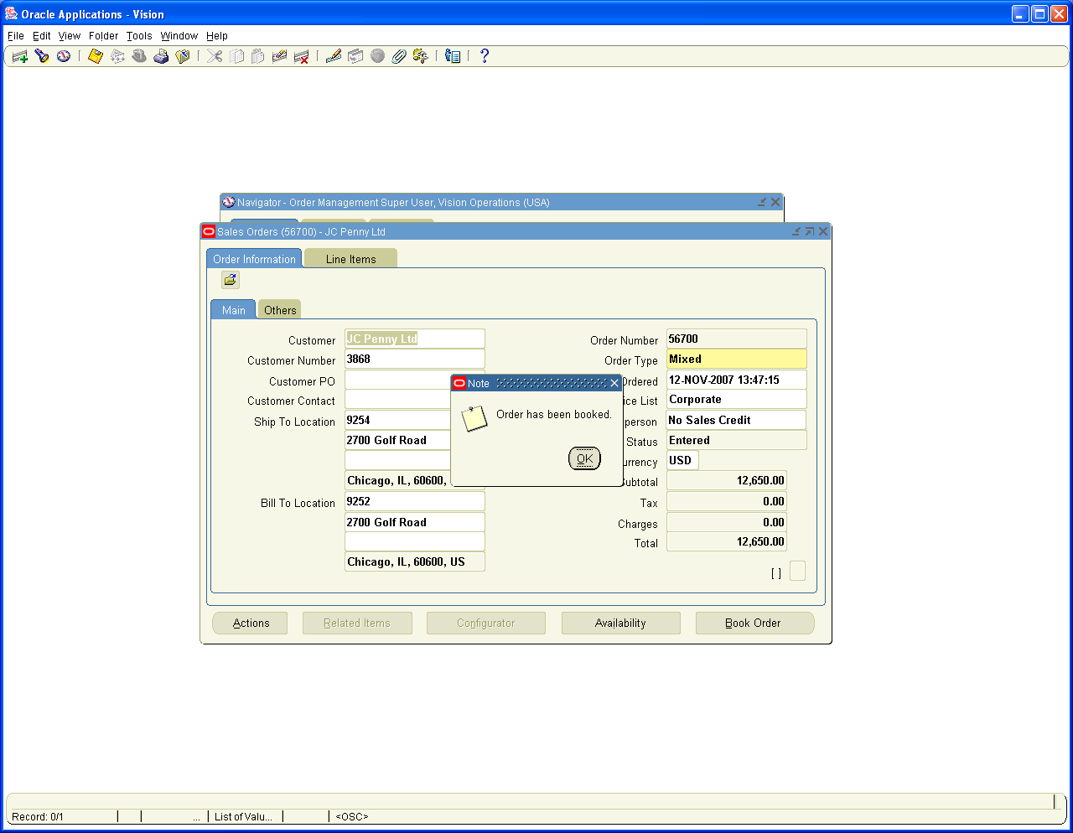

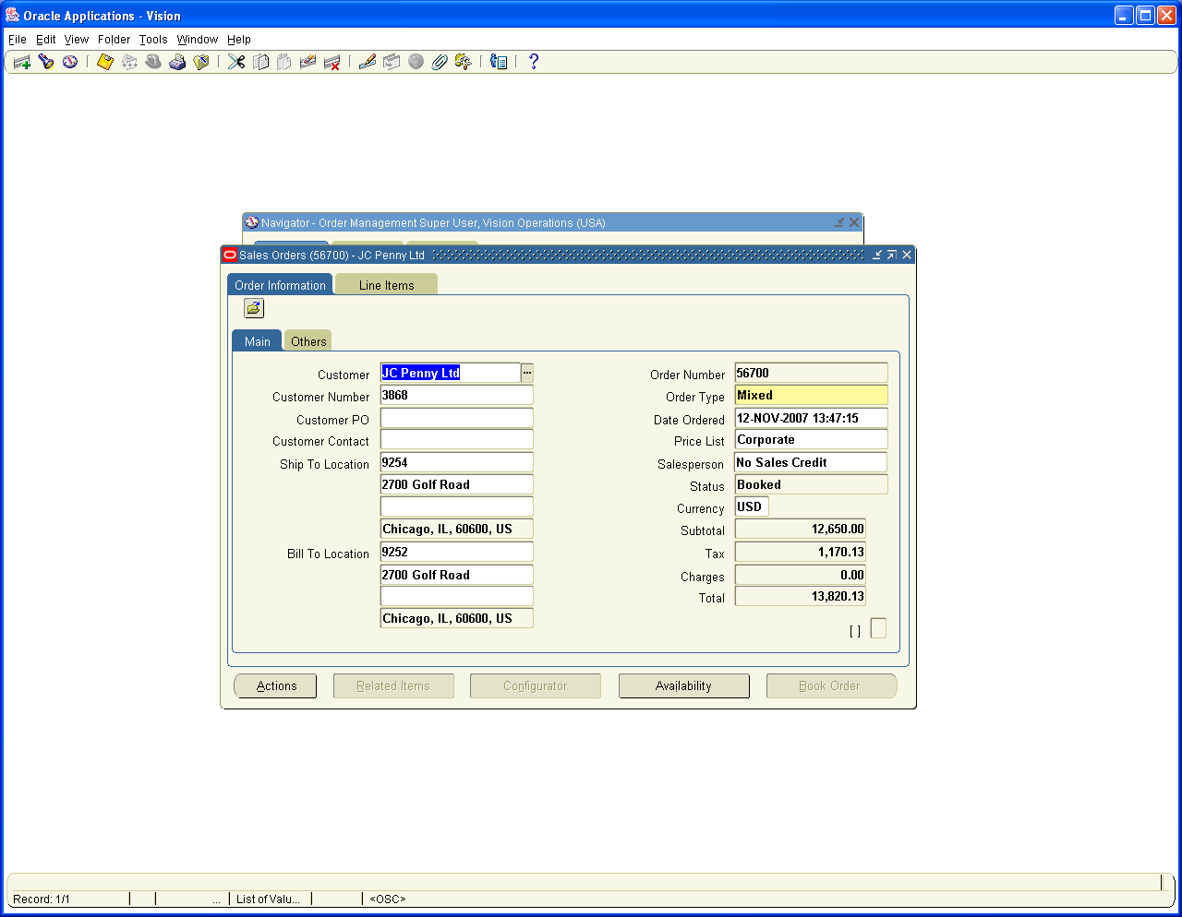

Next step is to Release the sales Order 56700

Navigation Path
Order management Super user, Vision Operations
Shipping / Release Sales Orders / Release Sales Orders

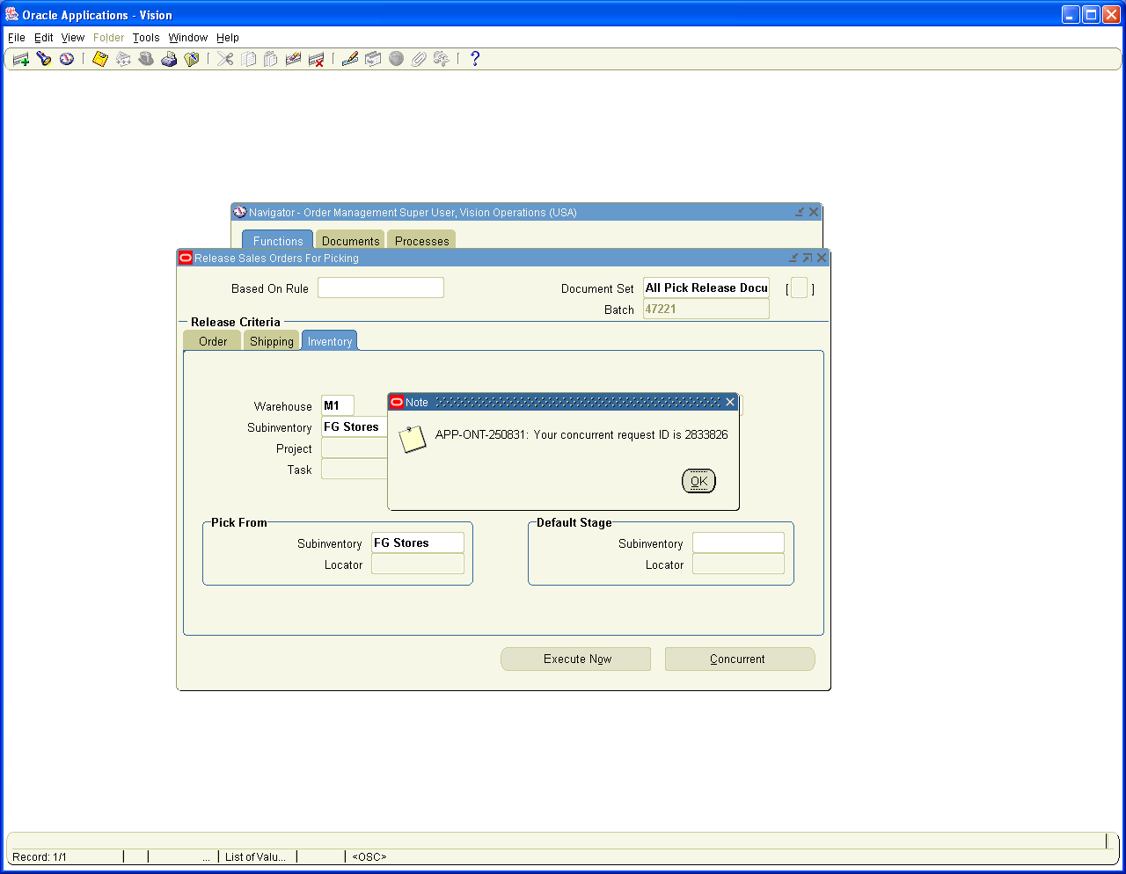

Navigation Path
Order management Super user, Vision Operations
Shipping / Transactions
Query sales Order 56700

Ship confirm the Goods

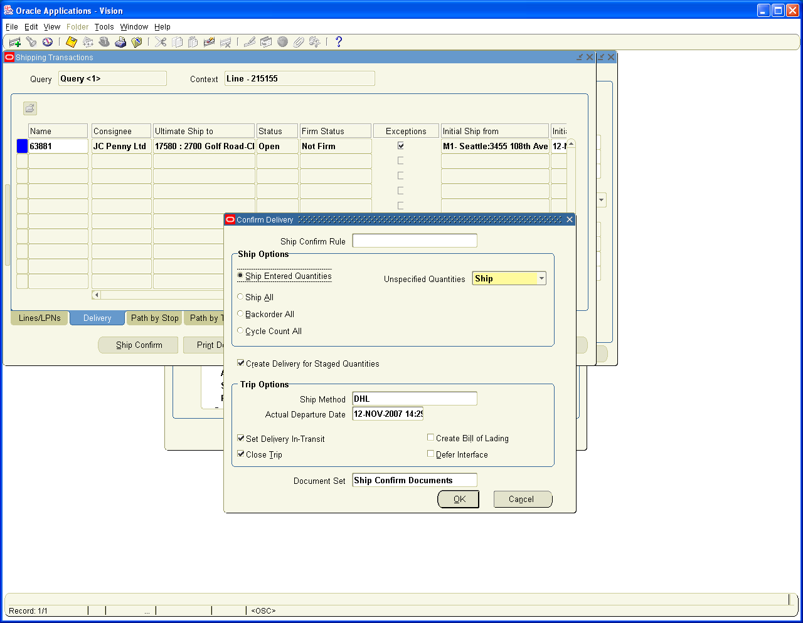

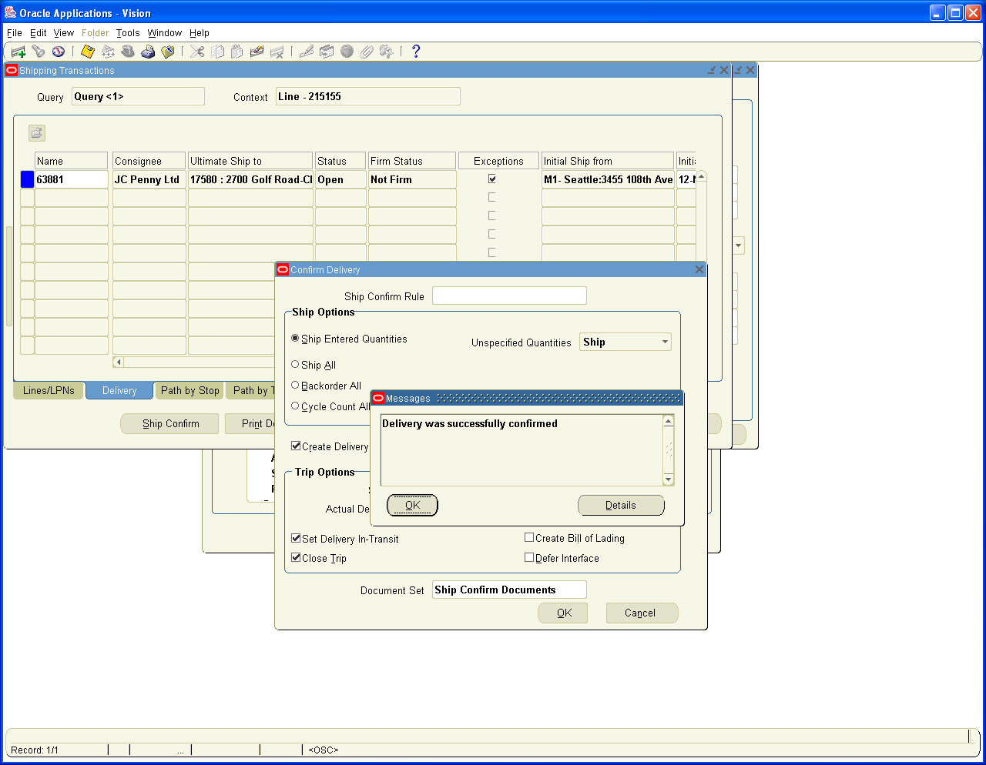

Order Line status changed to Shipped

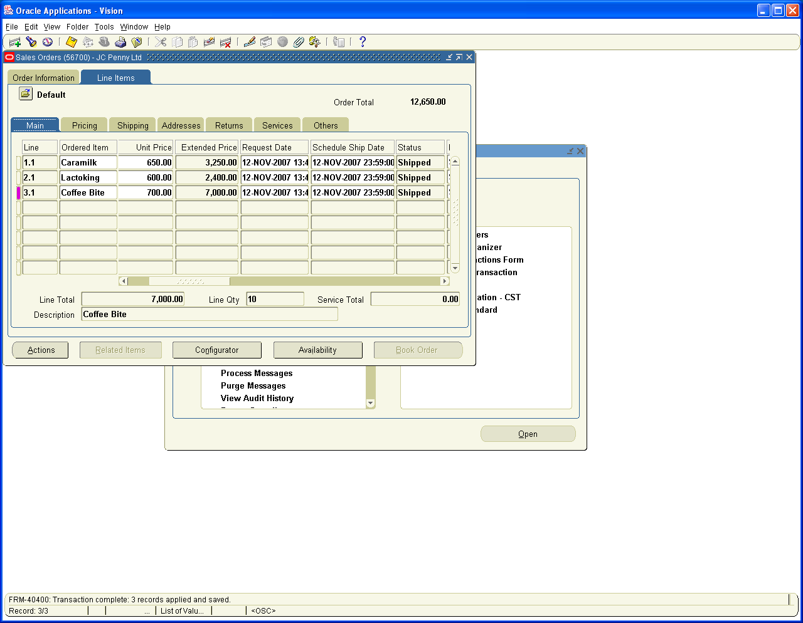

Let us check the Cost of Goods Sold Entries created for this Transaction. View the Quantity details in Inventory Module under Material Transactions Form

Navigation Path
Inventory, Vision Operations
Choose Inventory Org M1
Material distributions
Enter Source Type as sales Order and Order Number as 56700

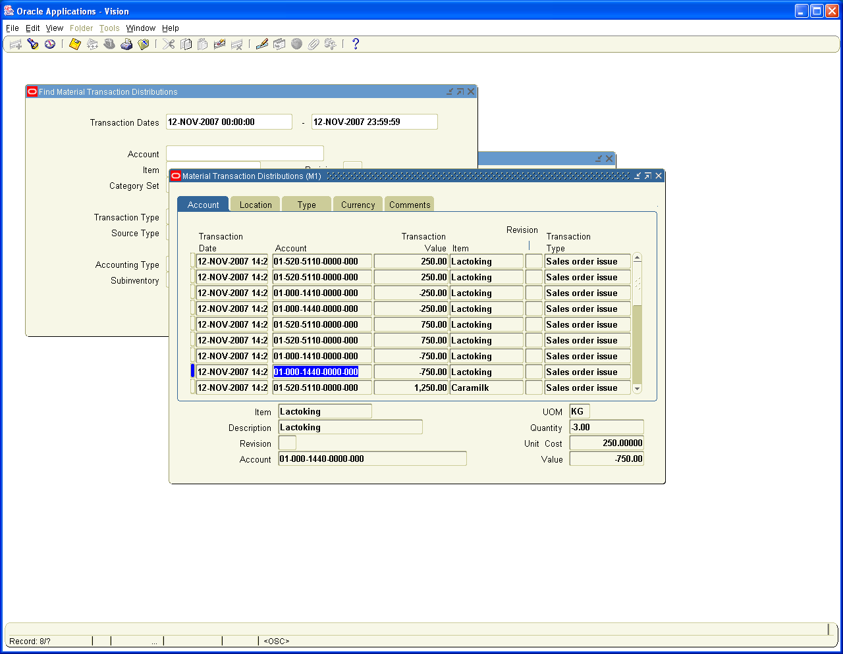

Run the WF Background Process to generate Invoice in Receivables

Navigation Path
Order Management Super User (Vision Operations)
View / Requests/ Single Request
WF Background Process

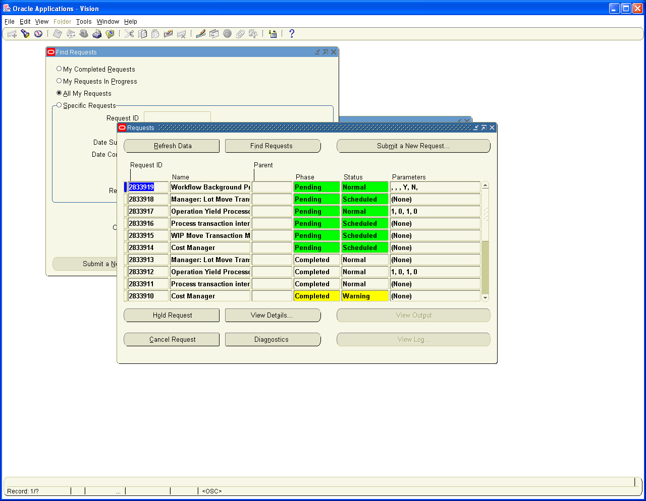

Log on to Receivables and run the Auto invoice Process to generate Invoice for the same

Receivables, Vision Operations
Transactions / Transactions
Query in Reference column with SO number 56700

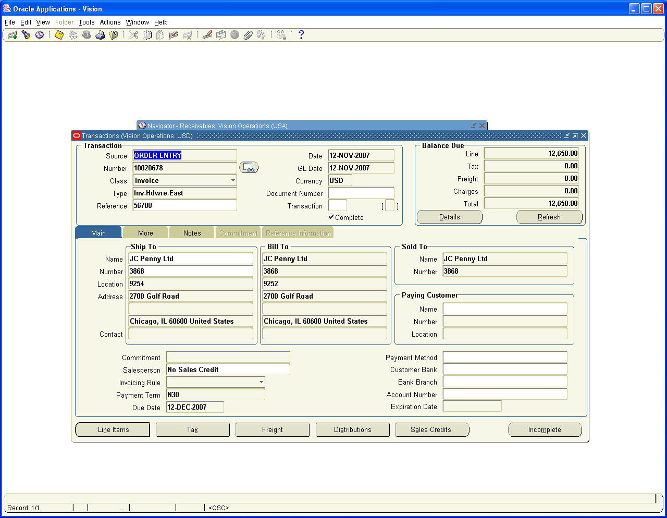

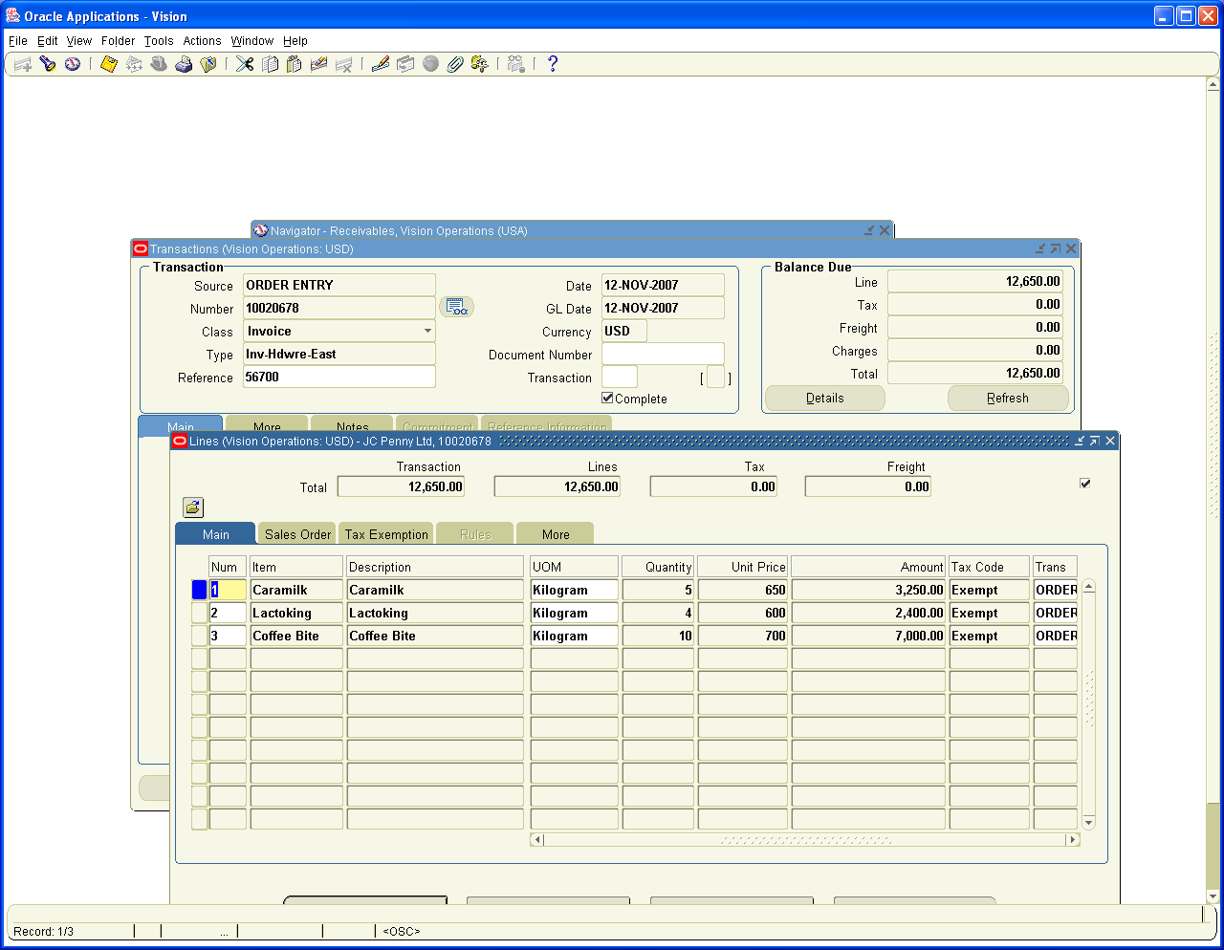

Let us view the Distribution Entries

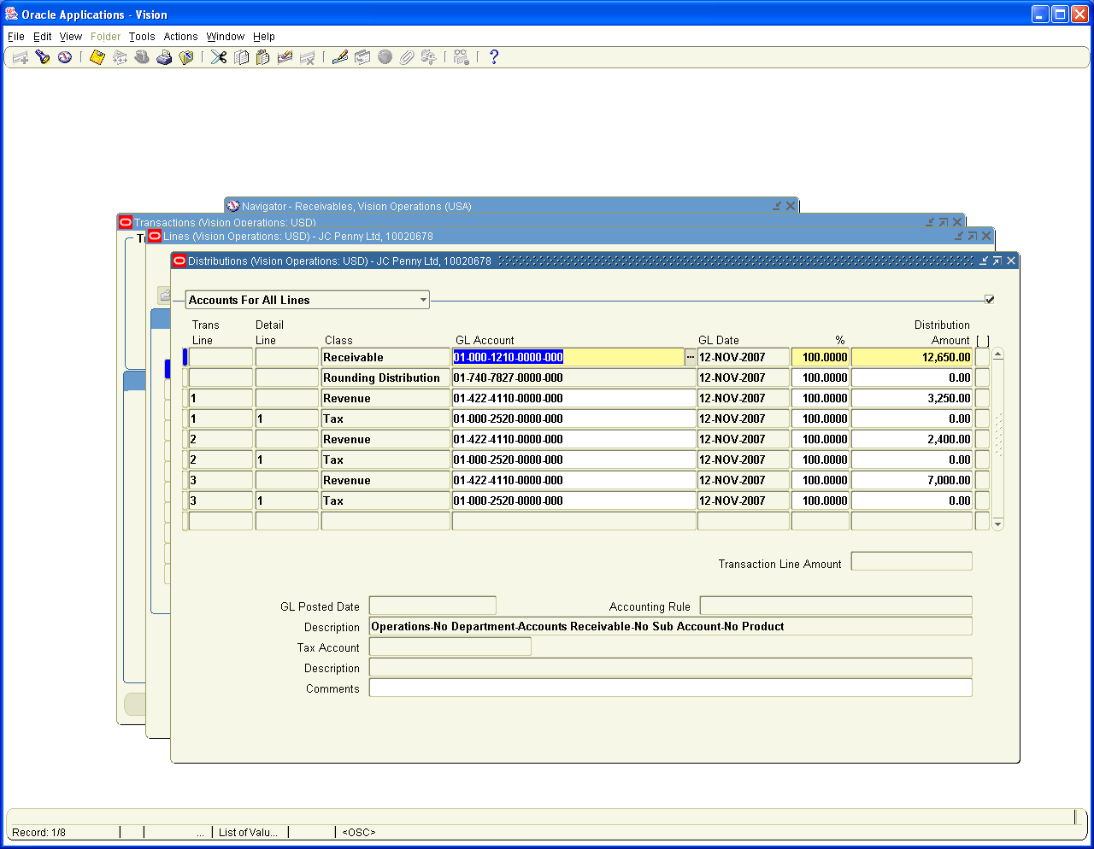

8. Payment received from Customers only for Coffeebite

Log on to Receivables Vision Operations
Receipts / Receipts

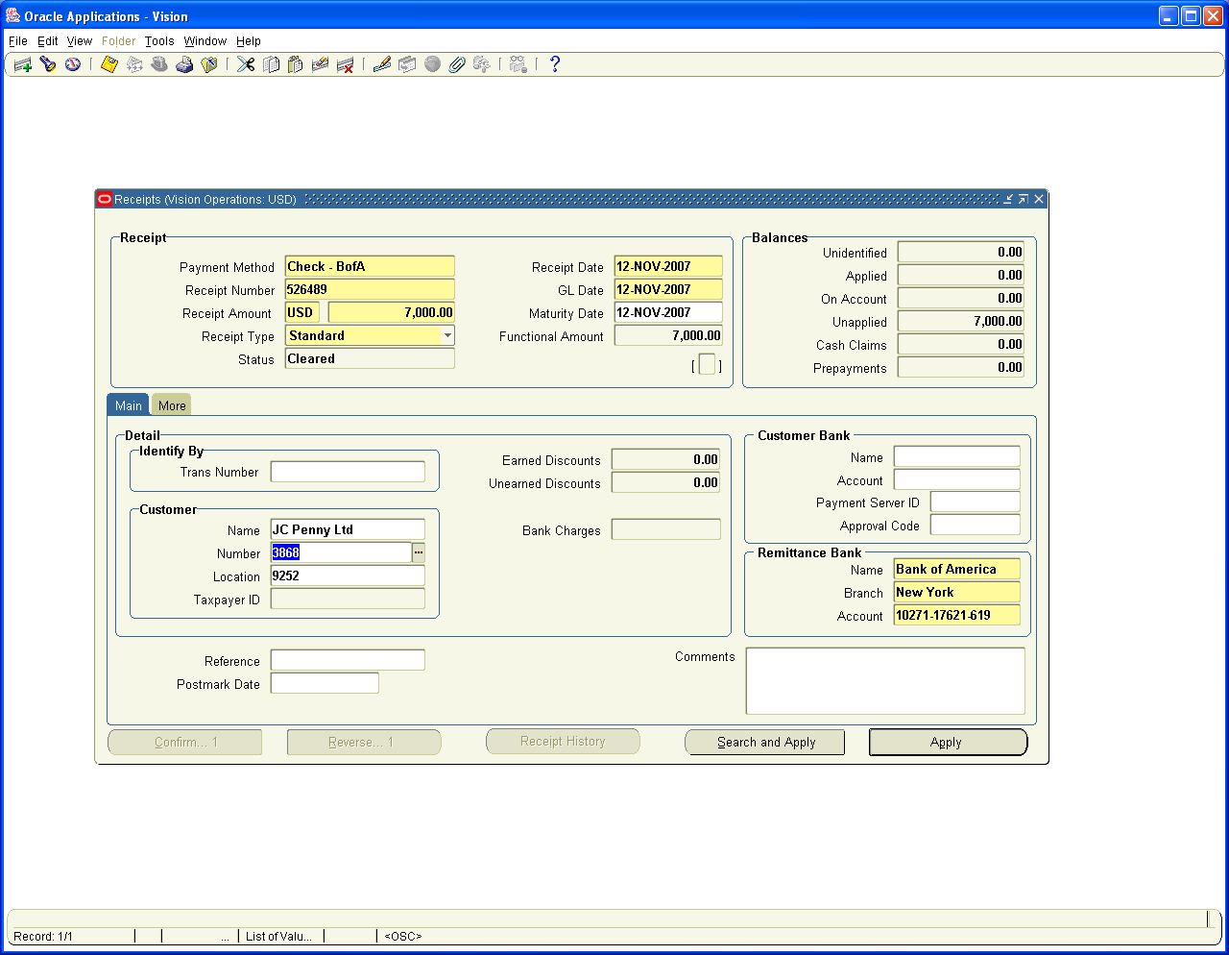

Click on Apply button and choose Invoice Number 10020678 and apply to line number 3

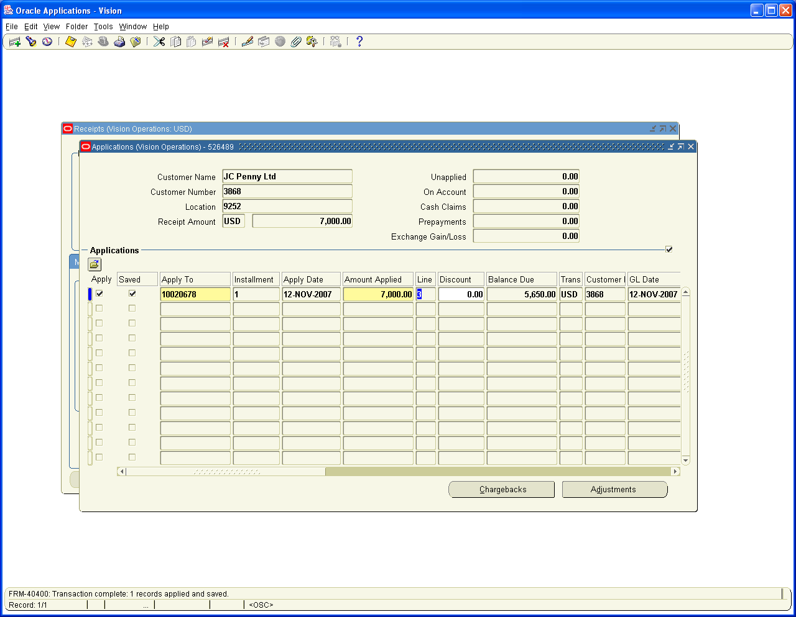

Go Back to Header to view the Accounting Entries

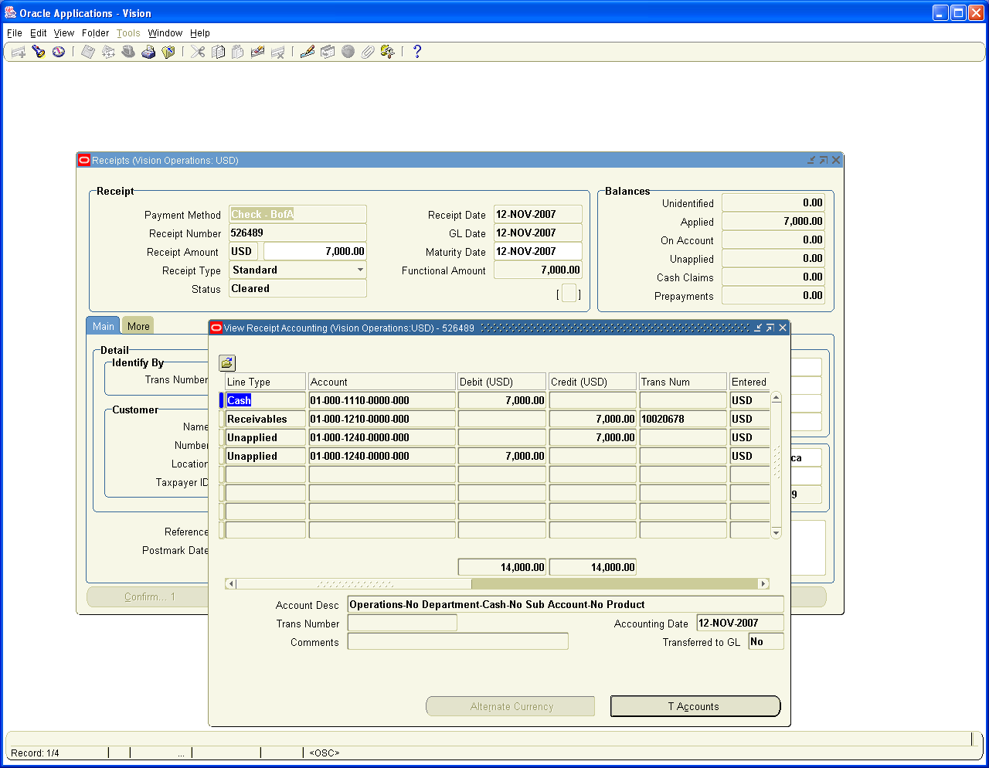

9. Out of the Items sold 1 kg of Caramilk was spoiled for which the Customer has sent back the material

Log on to Order Management Super user, Vision Operations
Orders / Returns
Sales orders

Create a Sales Order with Negative Quantity of 1 for Item caramilk

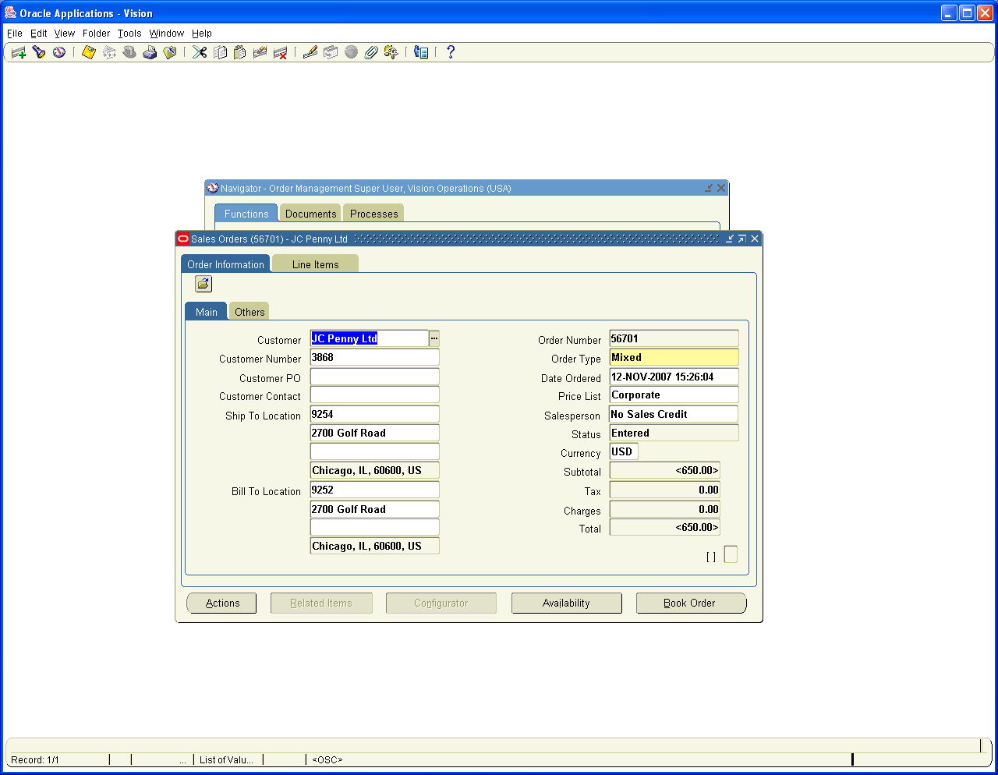

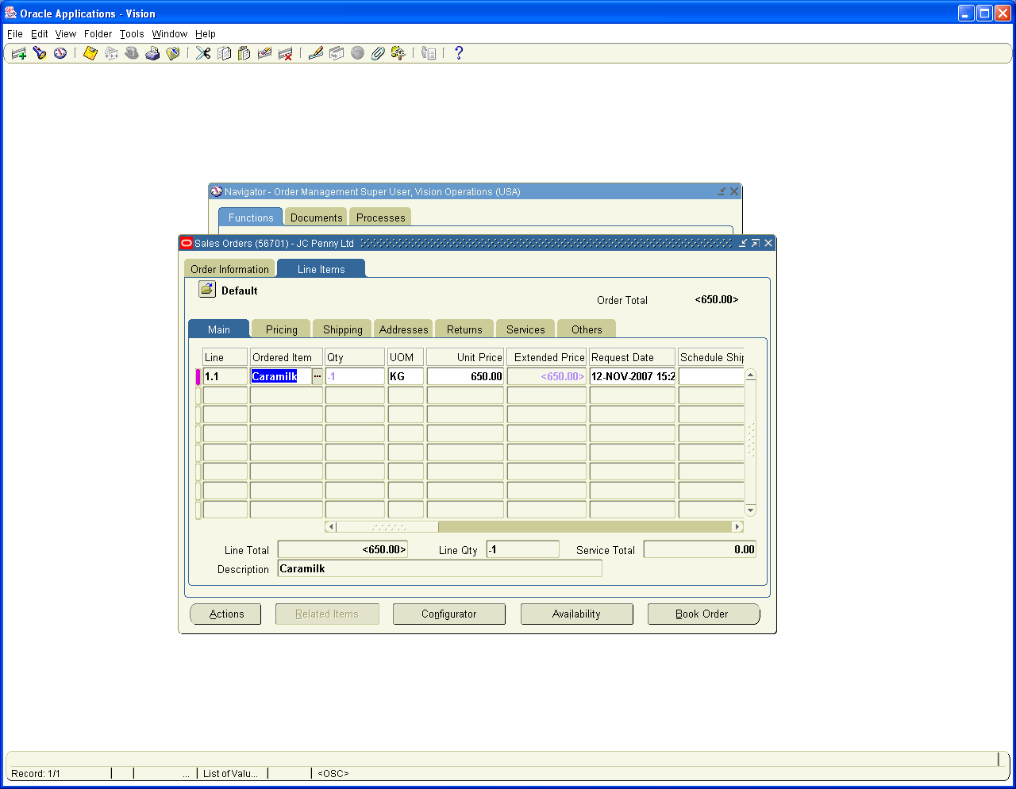

Book the Order

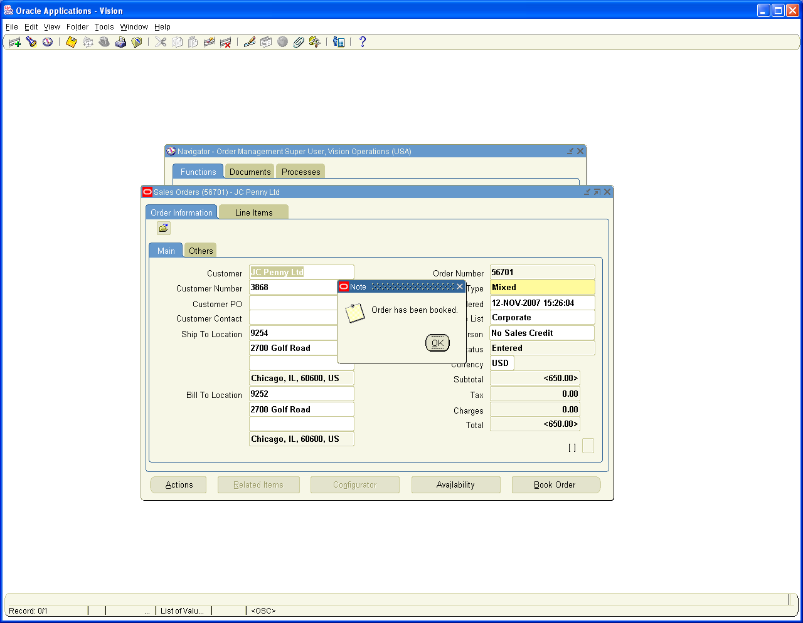

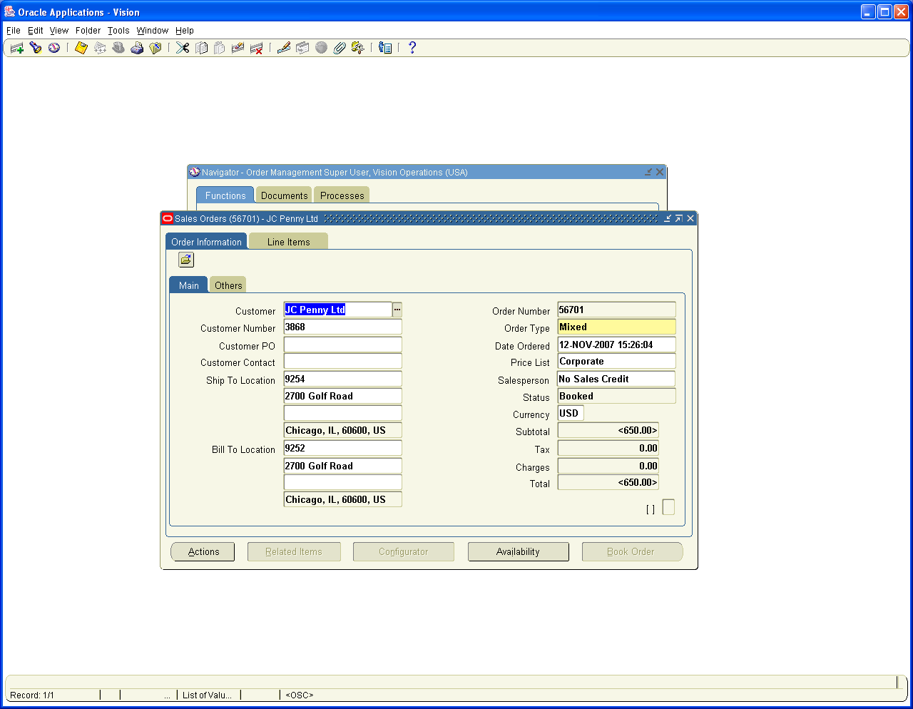

Now we need to Receive Inventory as it is an RMA (Return Material Authorization order)

Log on to Purchasing, Vision Operations
Receiving/ Receipts
Choose Inventory Org M1 Seattle Manufacturing
Go to Customer Tab and Enter RMA number 56701

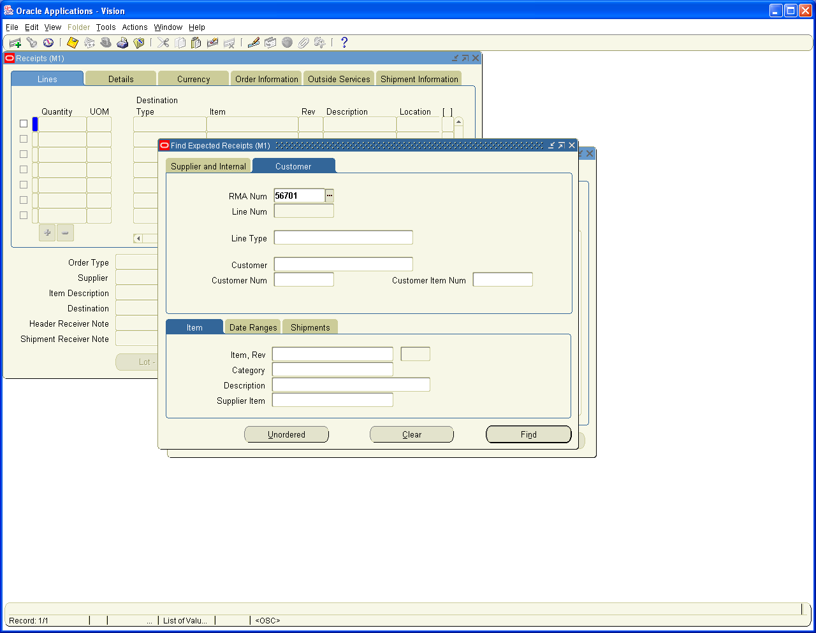

Click on Find Button

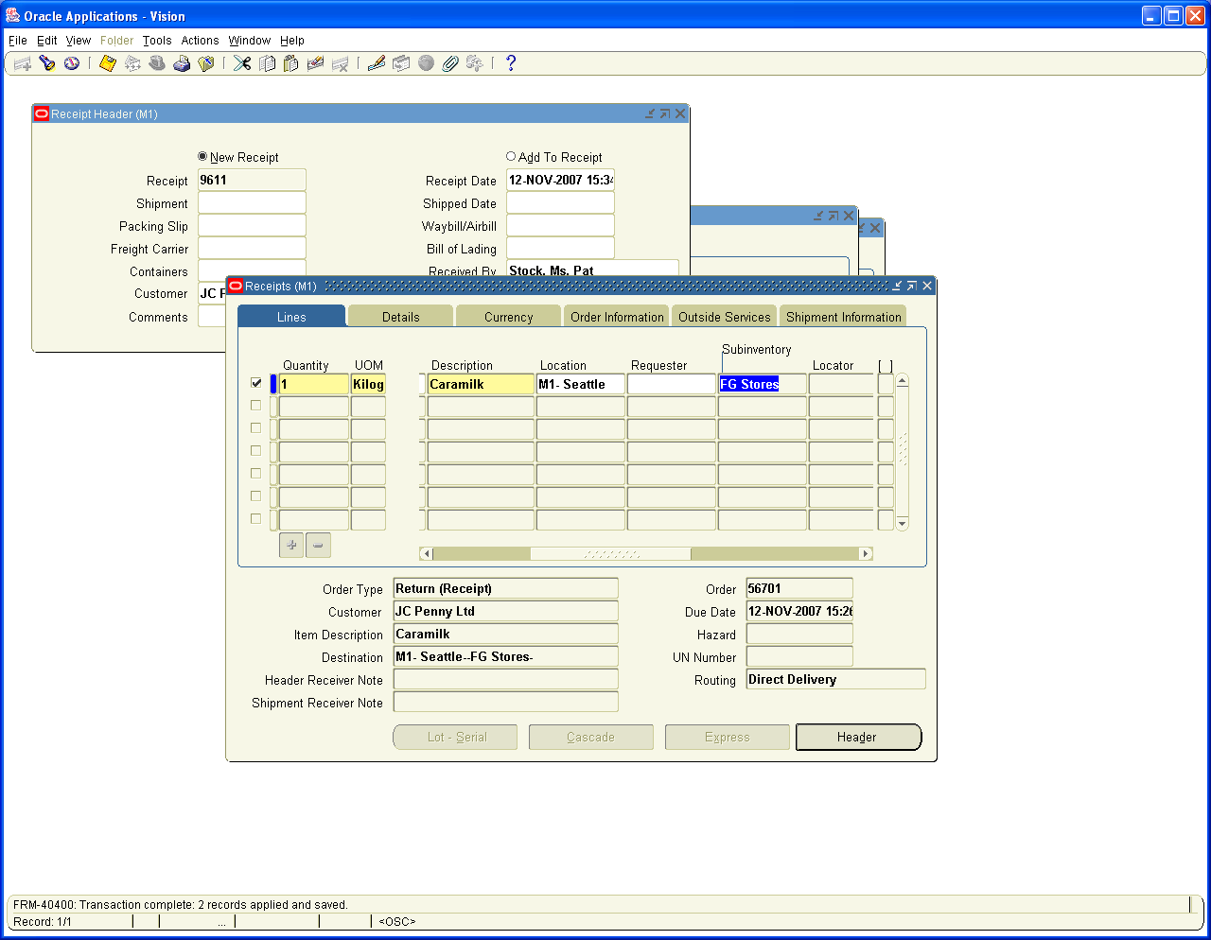

Receipt 9611 created.

Log on to Inventory Module to View the Accounting Entry

Navigation Path
Inventory, Vision Operations
Transactions / Receiving / Material Transactions
Query for Item Caramilk in Sub inventory FG Stores
Click on Distributions

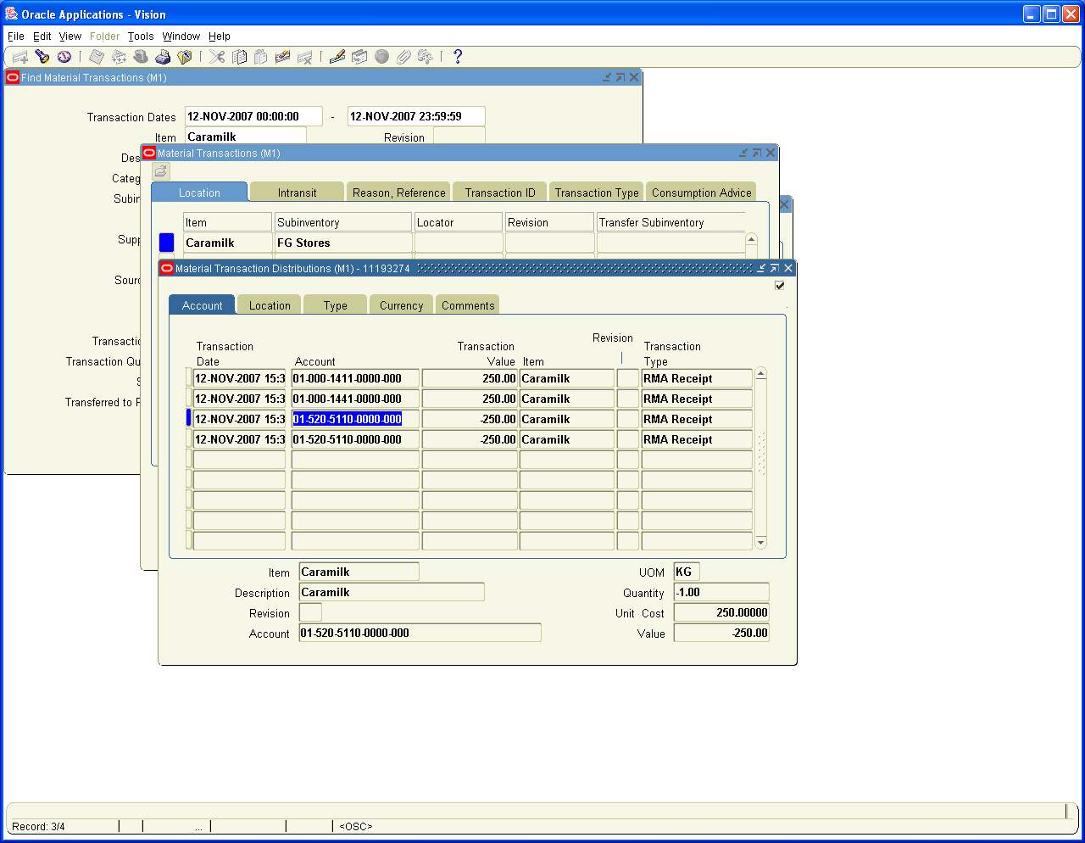

10. One Kg of Lactoking was spoiled in Transit for which Customer need to be issued a Credit note as Material non-returnable

Log on to Receivables Vision Operations
Transactions / Transactions

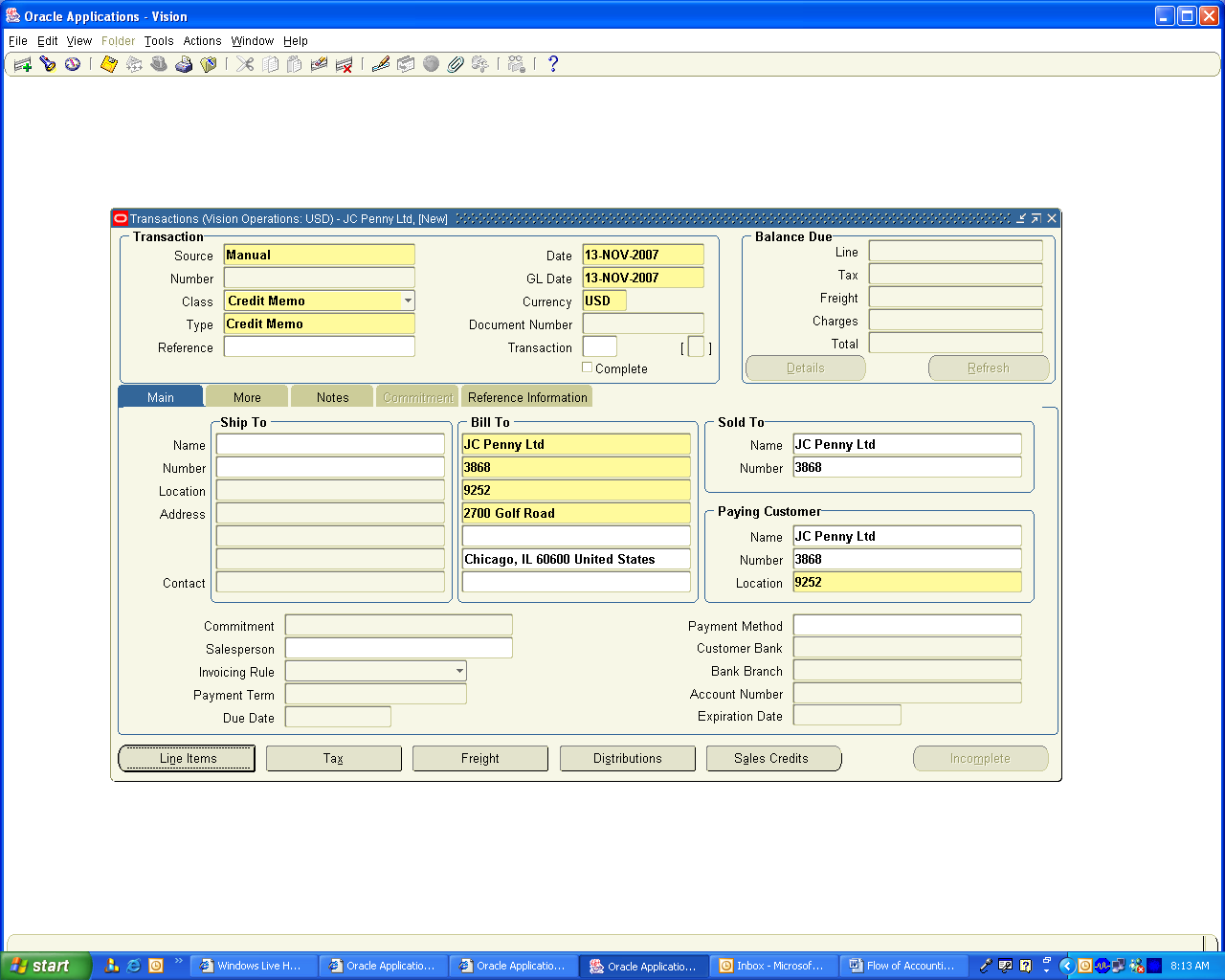

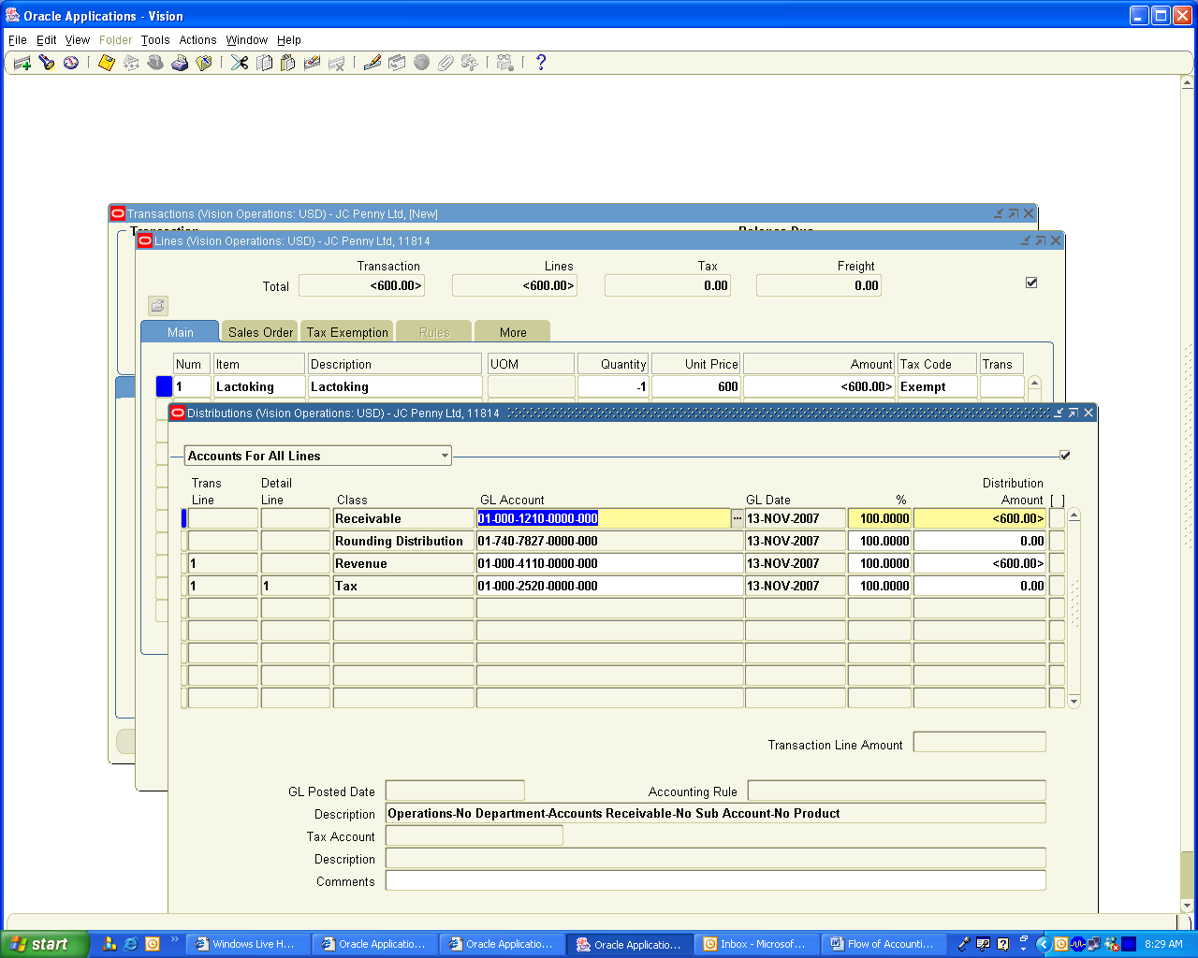

Complete the Transaction

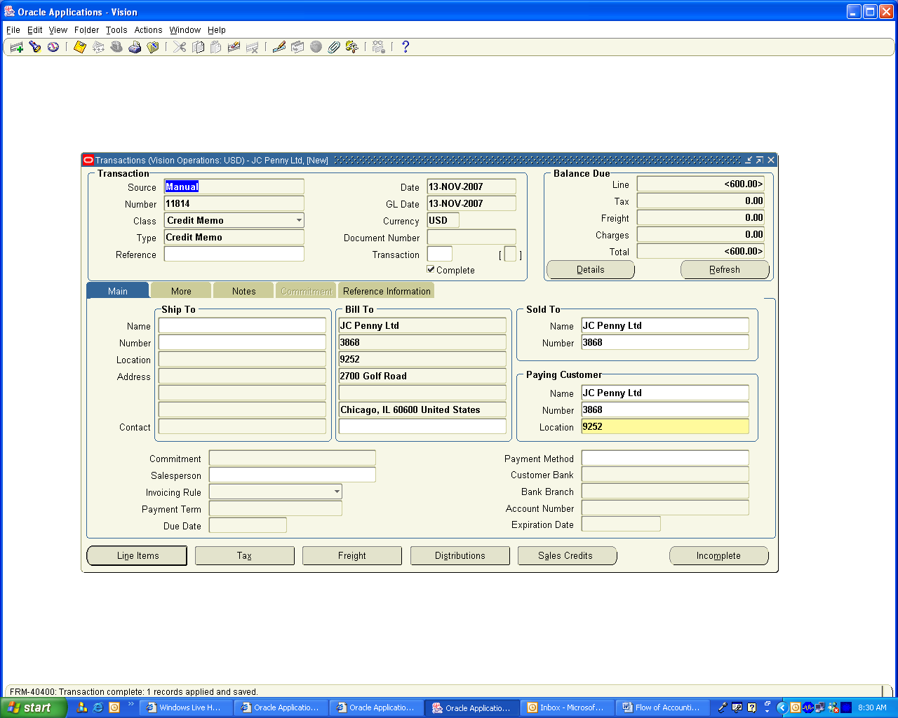

11. During the month the company paid following expenses

Packing Material –100 Paid by Cash

Advertisement – 250 Paid by Bank to Org Marg Company

For Transaction (i) Create a Supplier with the Name Petty cash and Create a Bank Account also with the Name petty cash and in cash Account attach the Petty Cash Account

Navigation Path: Payables, Vision Operations
Invoices / Entry / Invoices

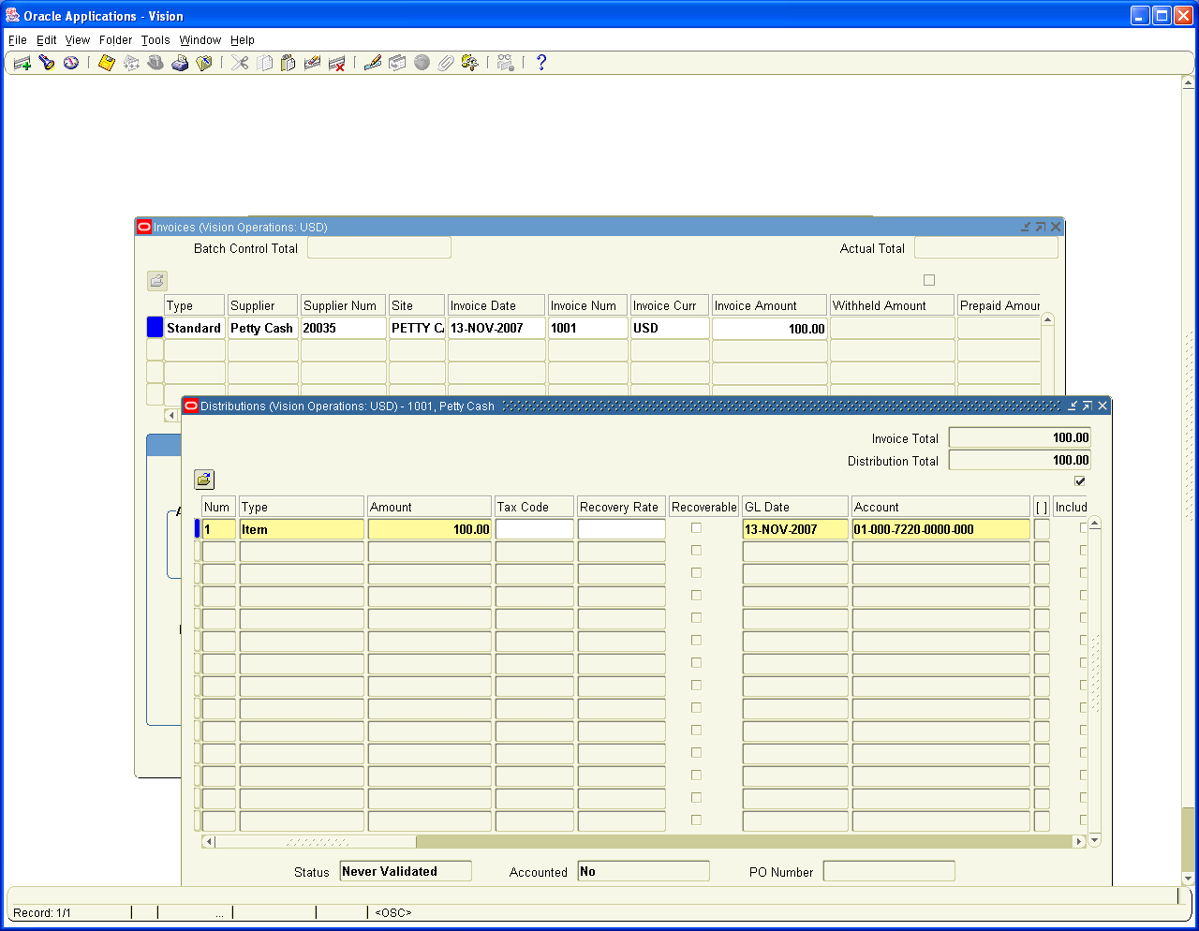

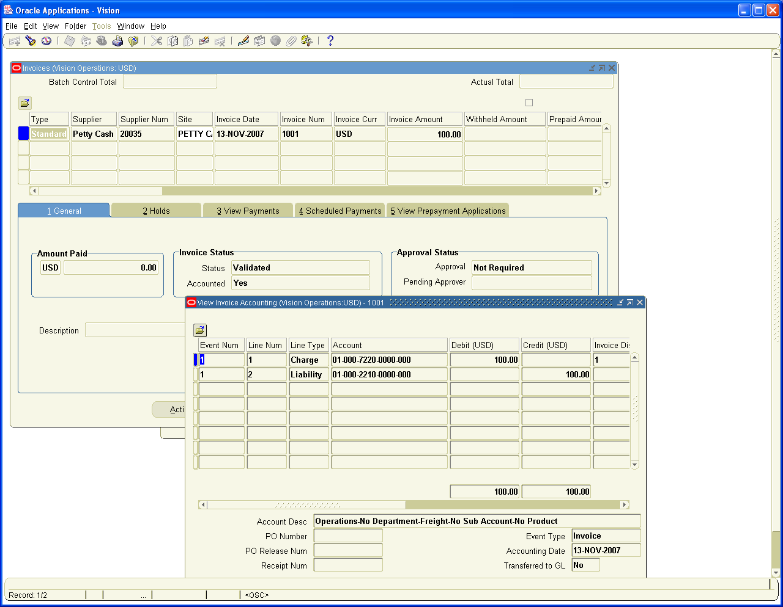

Click on Action and Check the check box Pay in Full

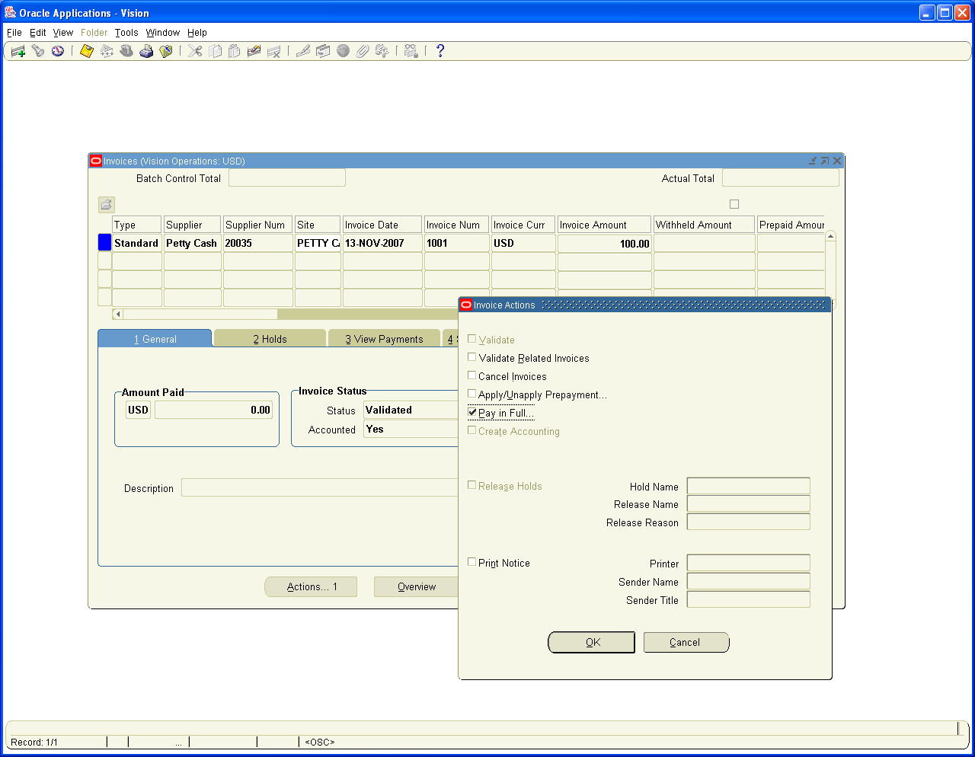

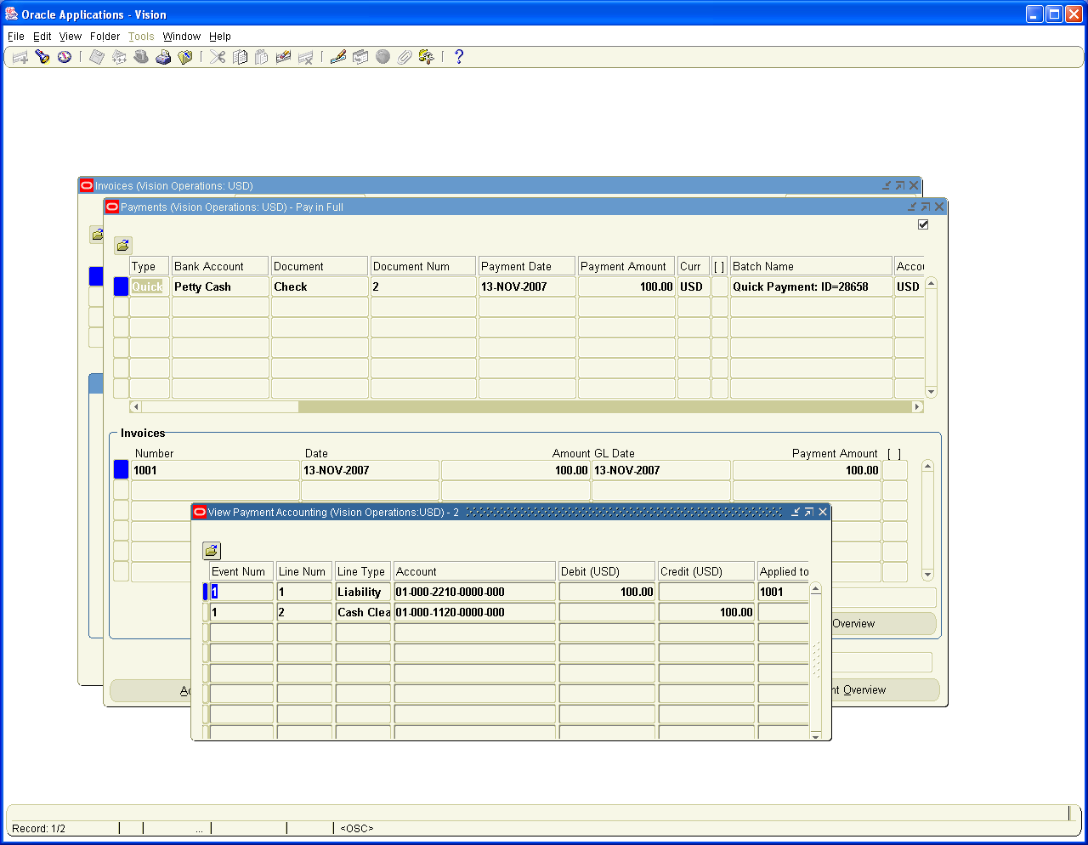

We need to create a Bank Statement and Clear this Payment against Statement to Clear the Transaction

Navigation Path: Cash Management, Vision Operations
Bank Statements / Manual clearing / Clear transactions

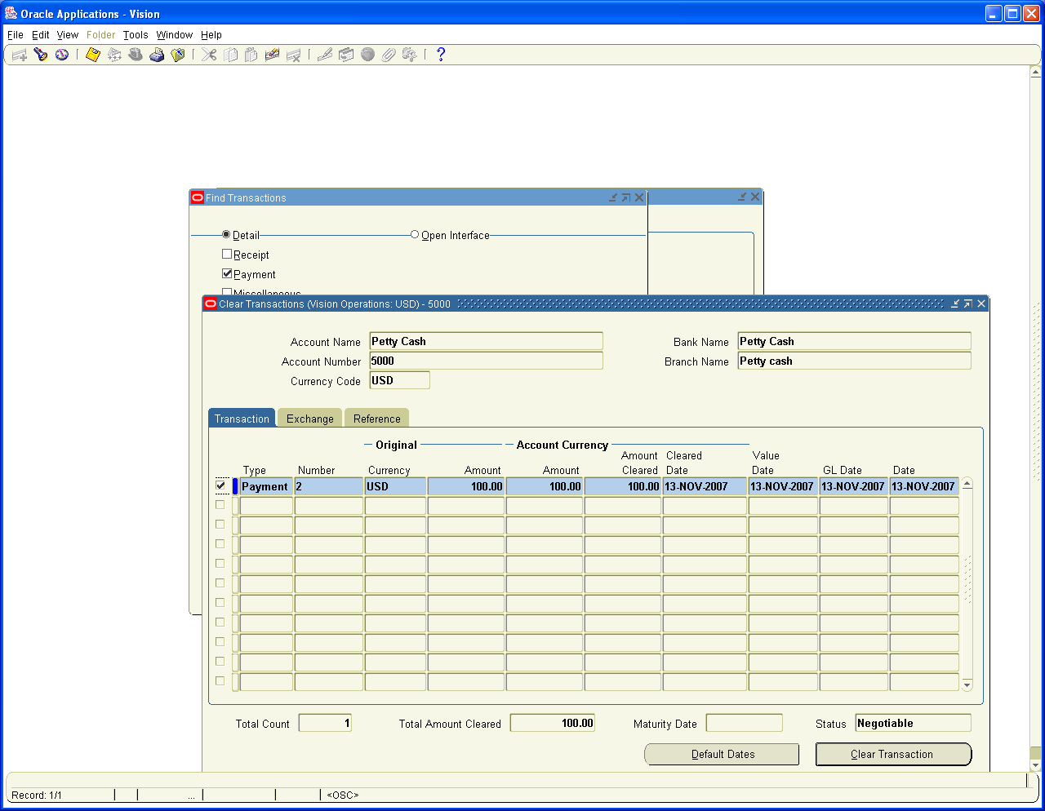

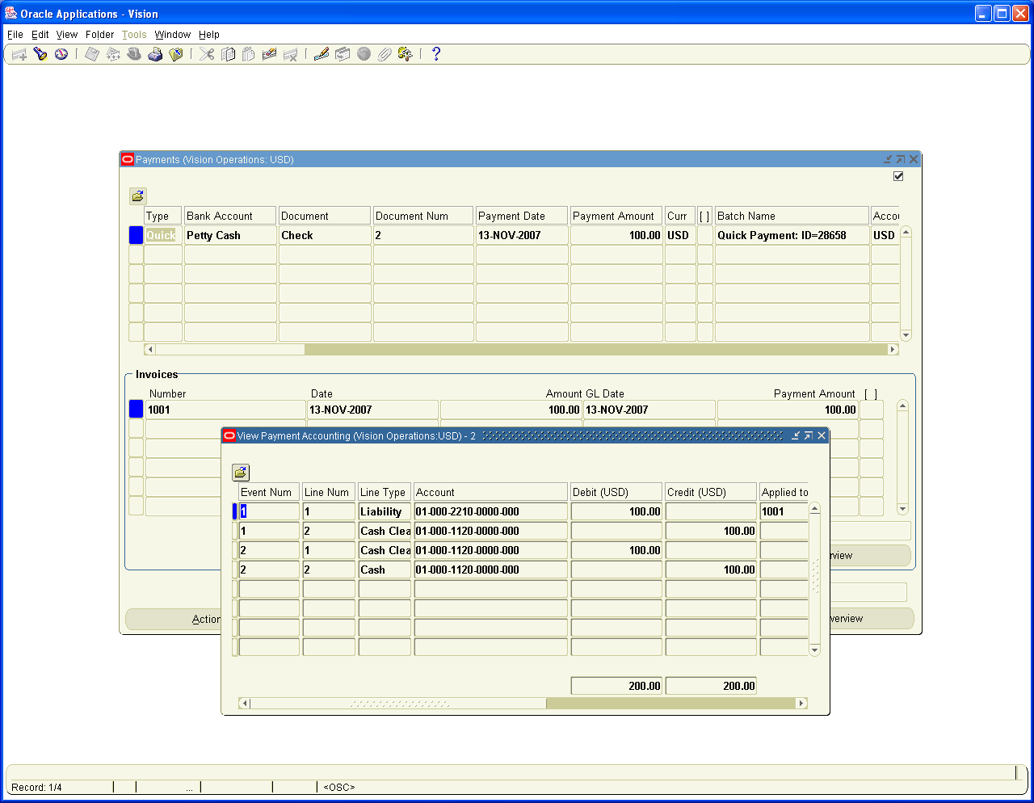

On the basis of same steps as above, we need to do the second step of making Payment to Org Marg Company. The Difference between the two is to show How a Petty Cash Payment can be handled in Accounts Payables. The cash Receipt of Petty cash can be seen in Next step

Navigation Path: Payables, Vision Operations
Invoices / Entry / Invoices

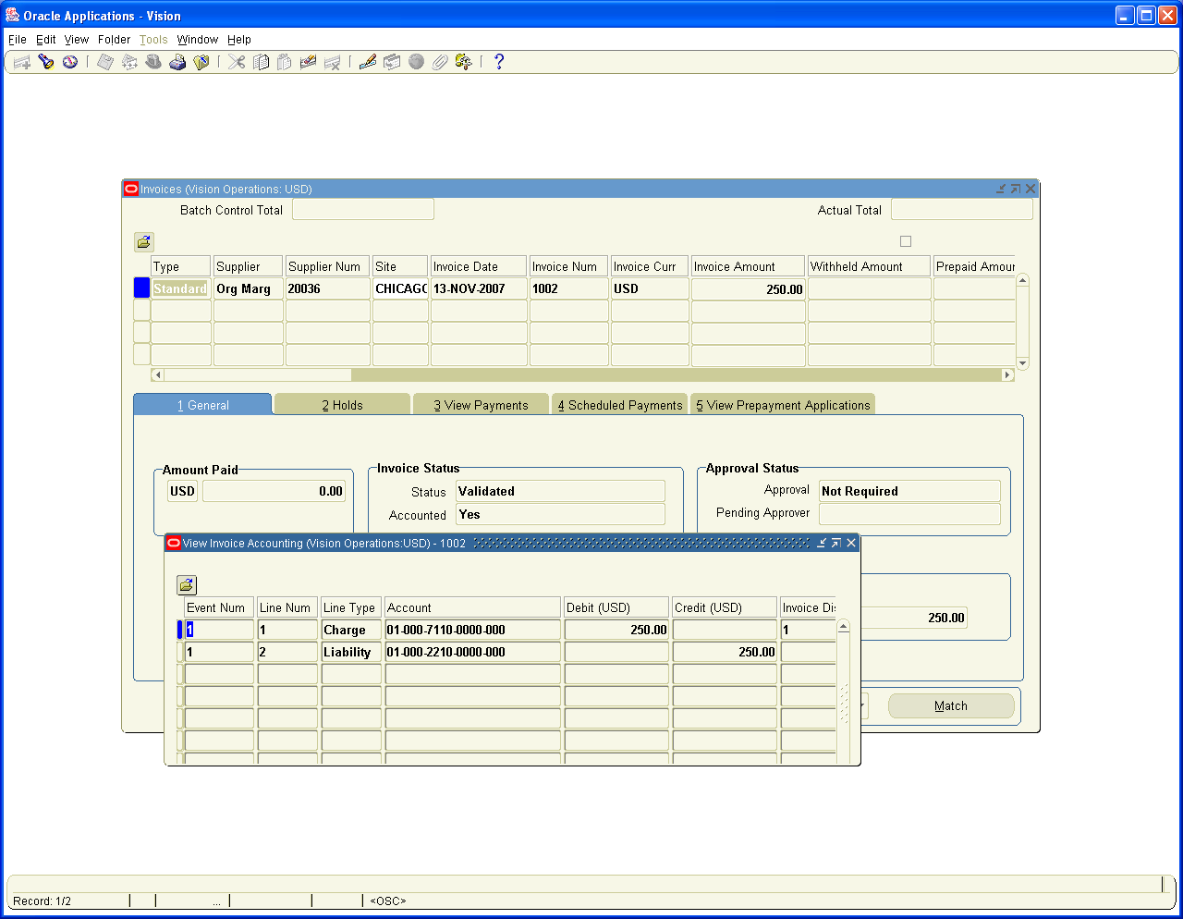

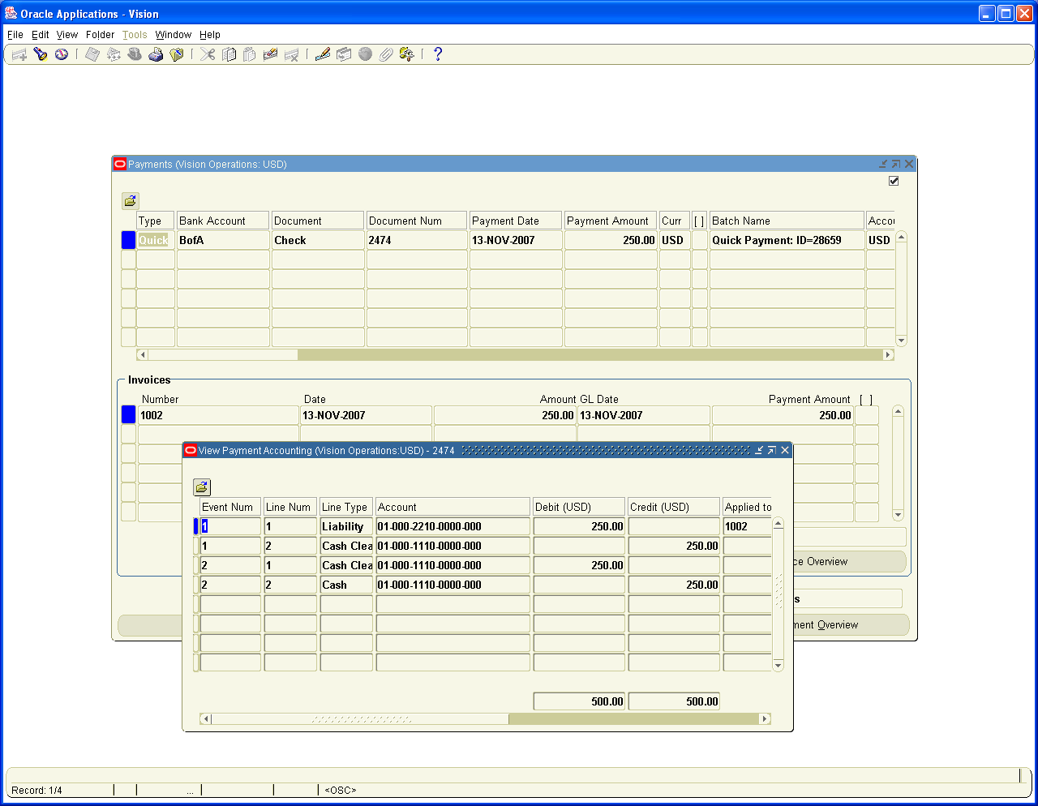

12. Company withdrew 1000 USD for Office use

This is a Petty Cash withdrawal which can be handled through Prepayment Invoice

Navigation Path: Payables, Vision Operations
Invoices / Entry / Invoices
Create a Prepayment Invoice for 1000 USD for Petty cash Supplier and make Payment.

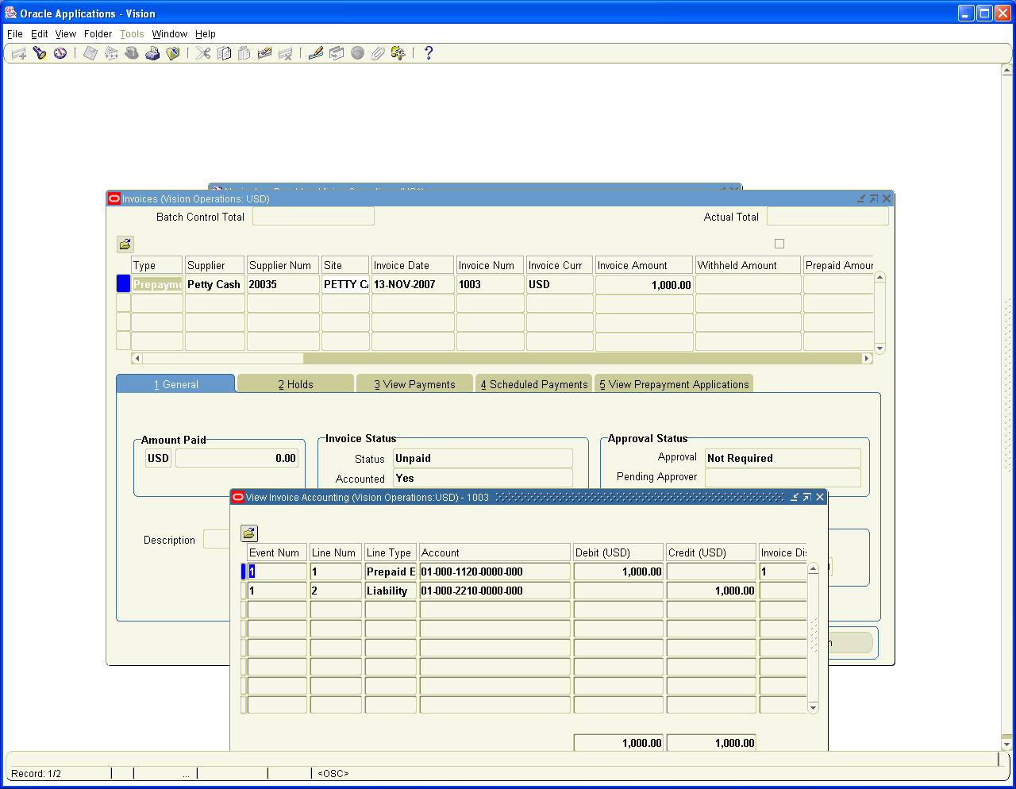

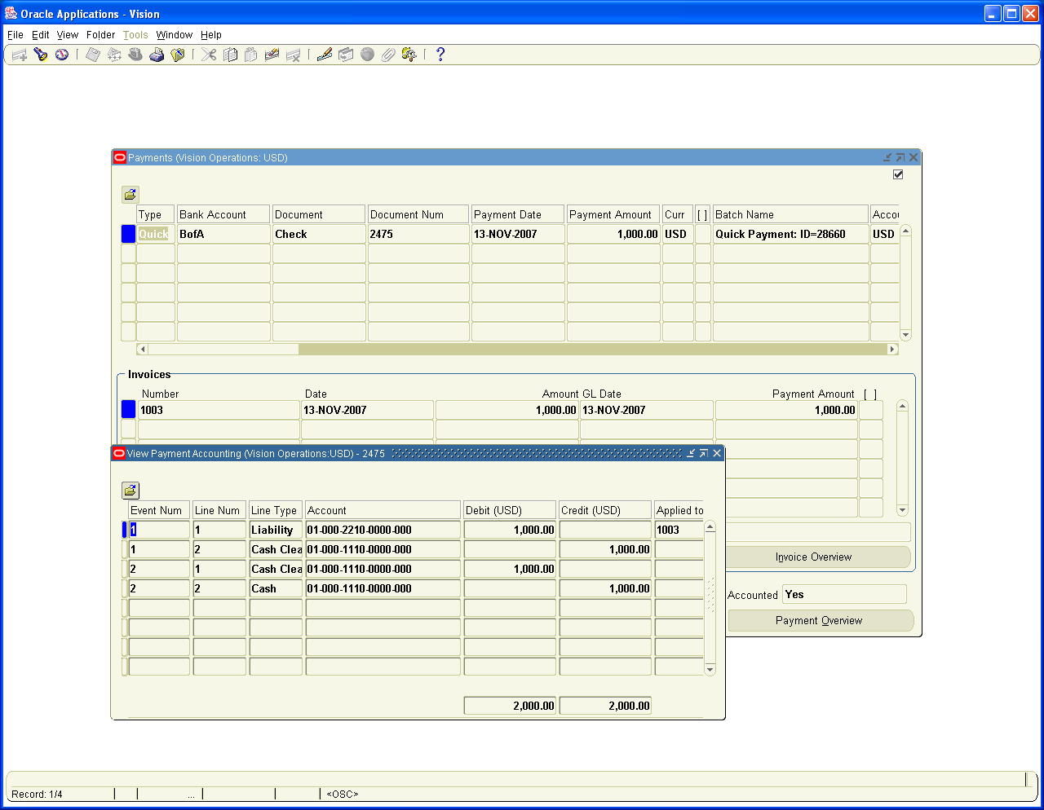

13. Interest Income received for the month is 100 USD

Navigation Path: Vision Operations, Receivables
Receipts / Receipts

Create a Miscellaneous Receipt for 100 USD for Interest Income.

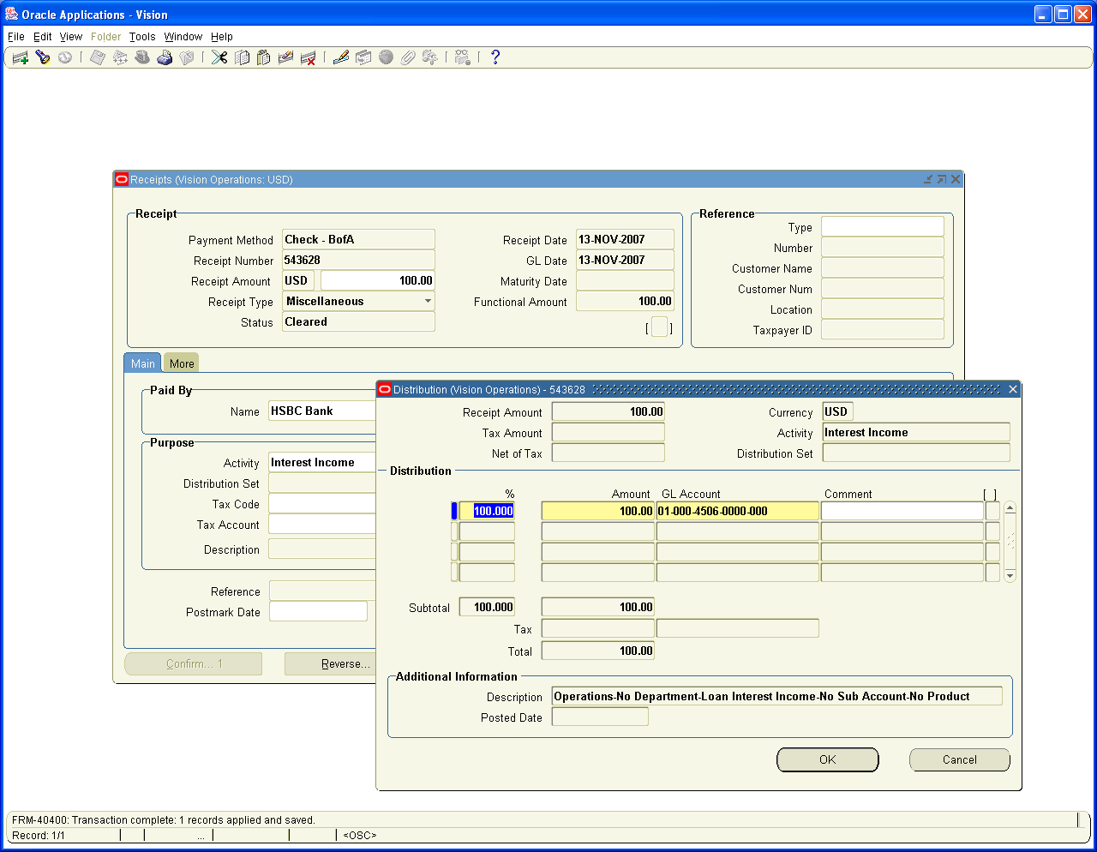

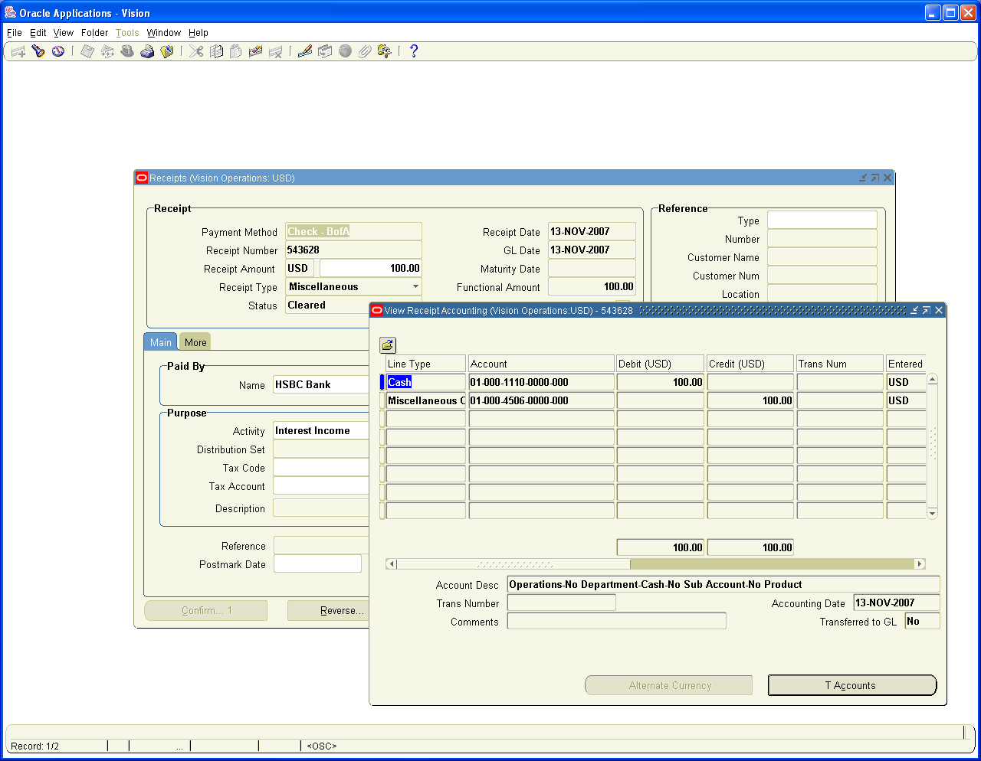

14. Bank charges for the month is 5 USD

Navigation Path: Receivables, Vision operations
Receipts / Receipts

Create a Miscellaneous Receipt with the Negative amount of 5 USD. Then system treats the Transaction as payment to Bank. Only for the Type of Miscellaneous Receipt system will allow you to create Negative Entry.

This is another way you can use Petty cash functionality using Miscellaneous Receipts.

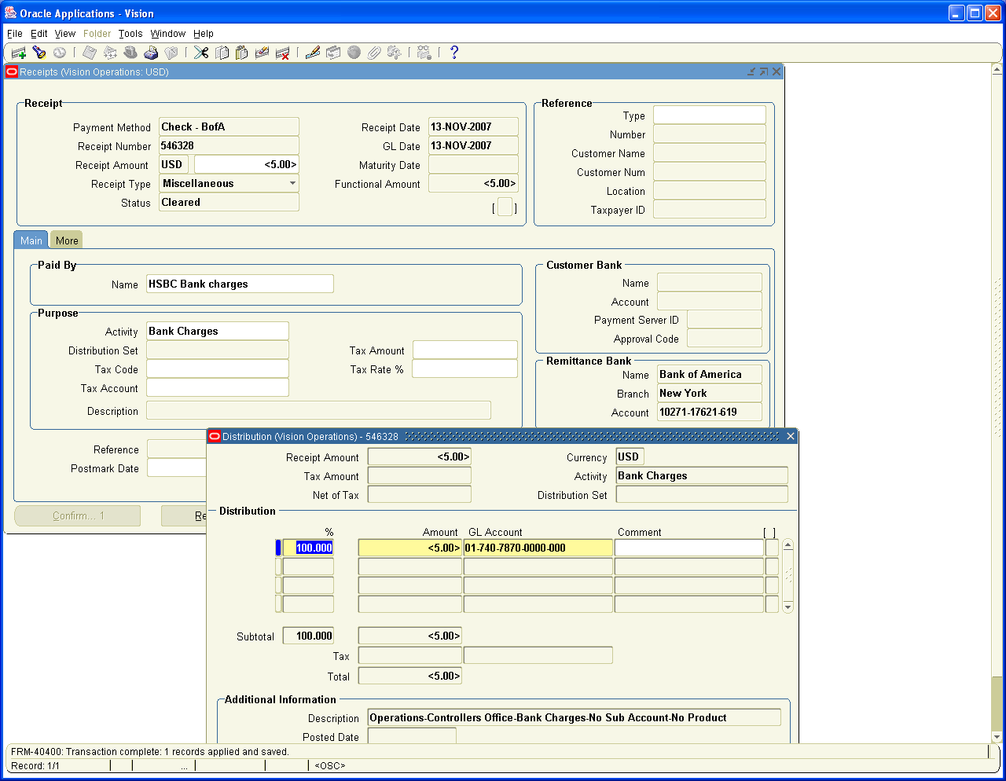

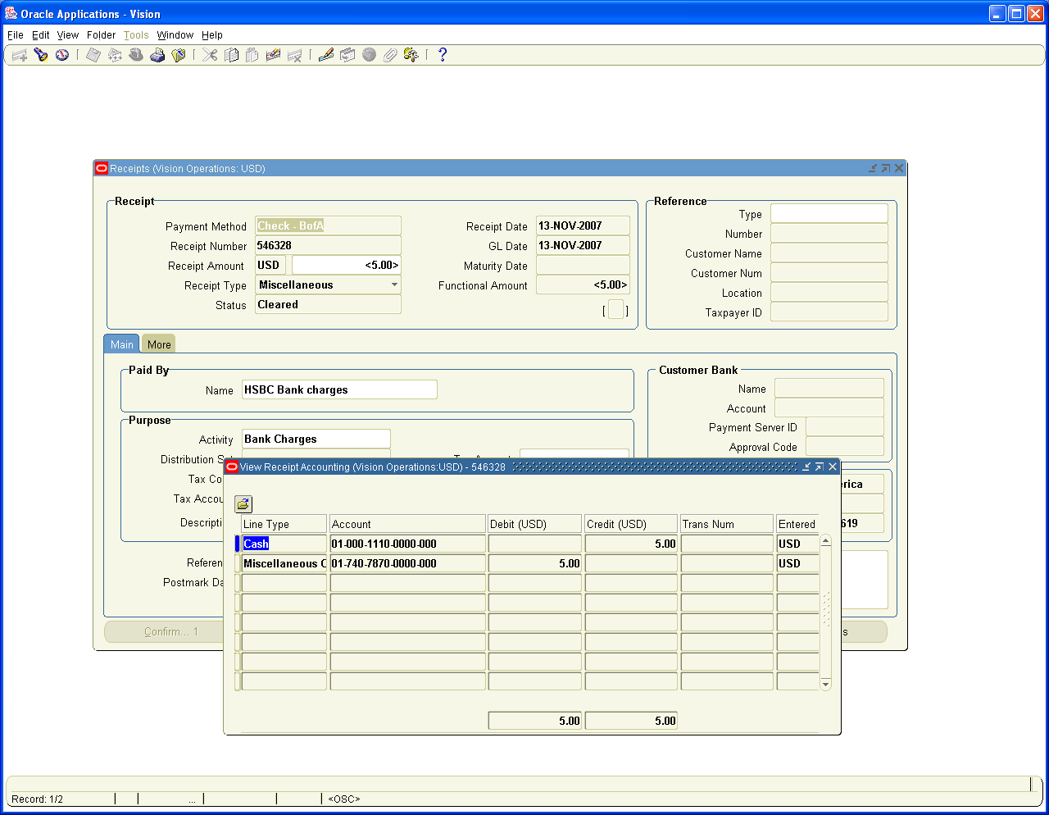

15. Provision for Tax to be made 500 USD

Navigation Path: General Ledger, Vision Operations
Journals / Enter

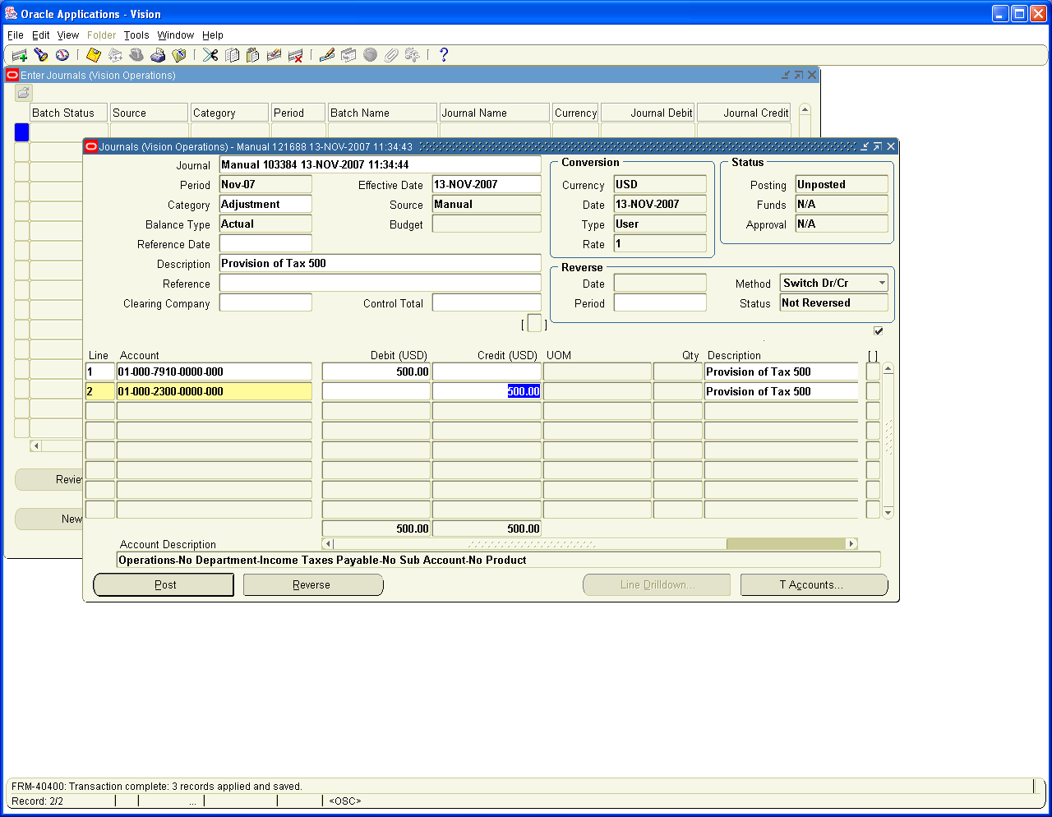

16. Employees Travel Expenses Provision to be made 300 USD

Navigation Path: Payables, Vision Operations
Invoices / Entry / Expense Reports
Enter Employee Expense for 300 USD

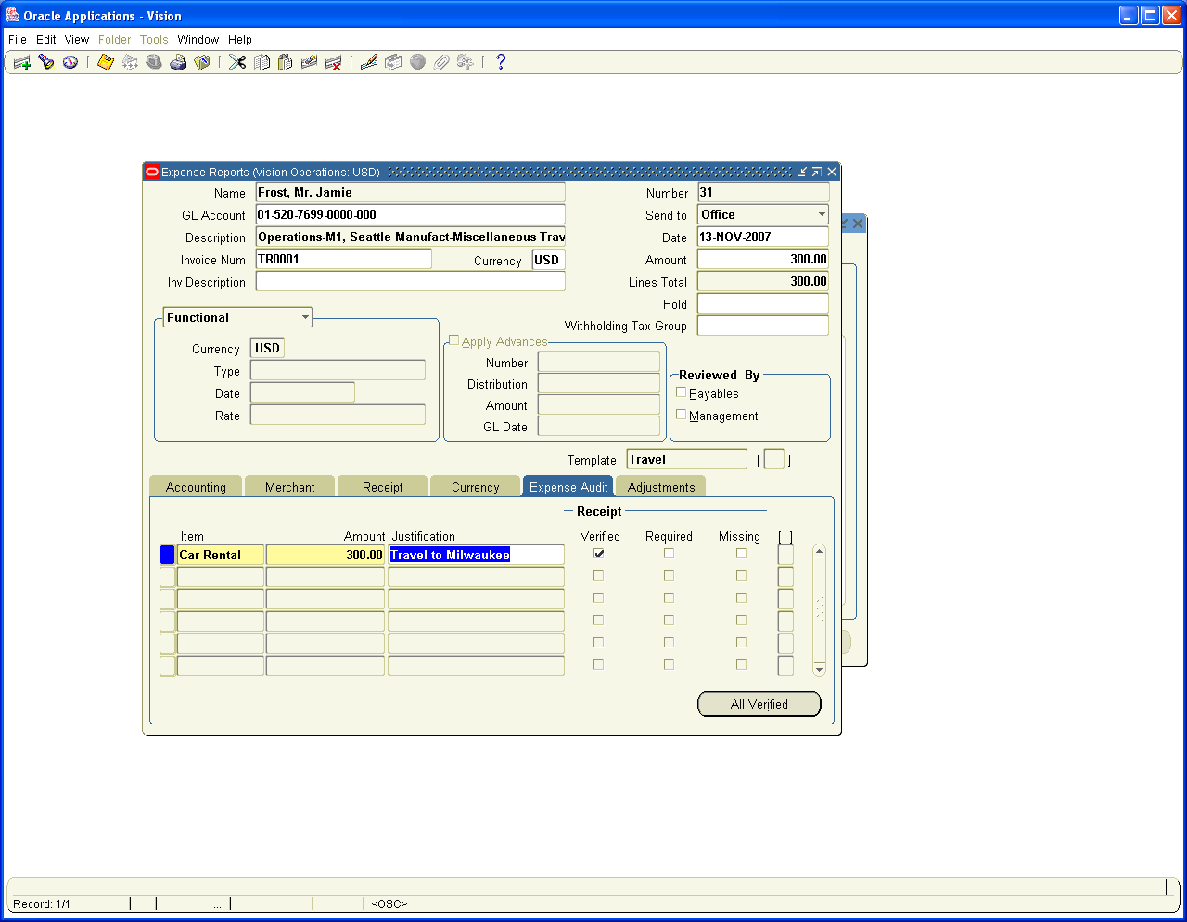

Import the Expense Report as an Invoice through Concurrent Program

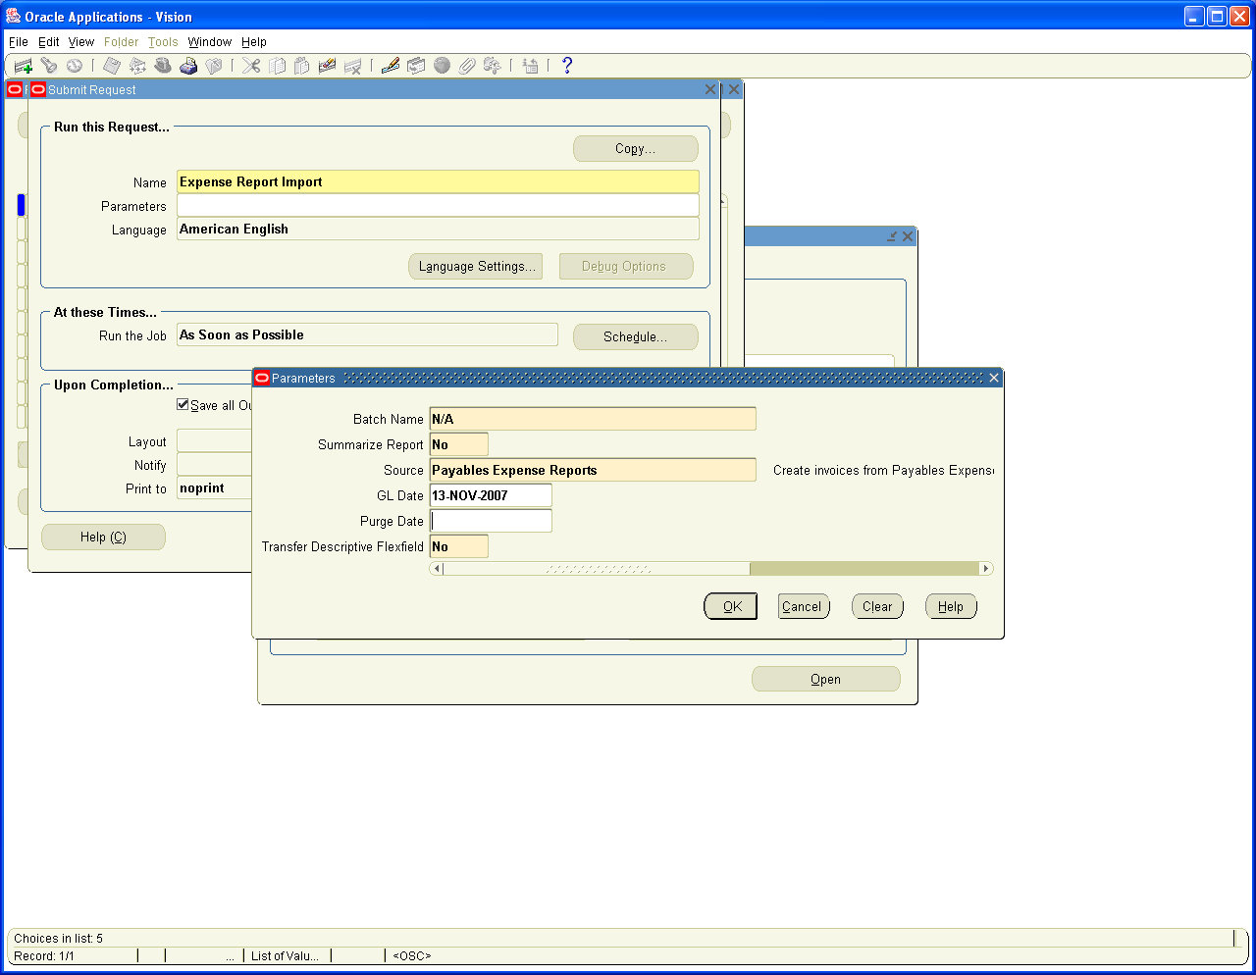

View the Concurrent Request output

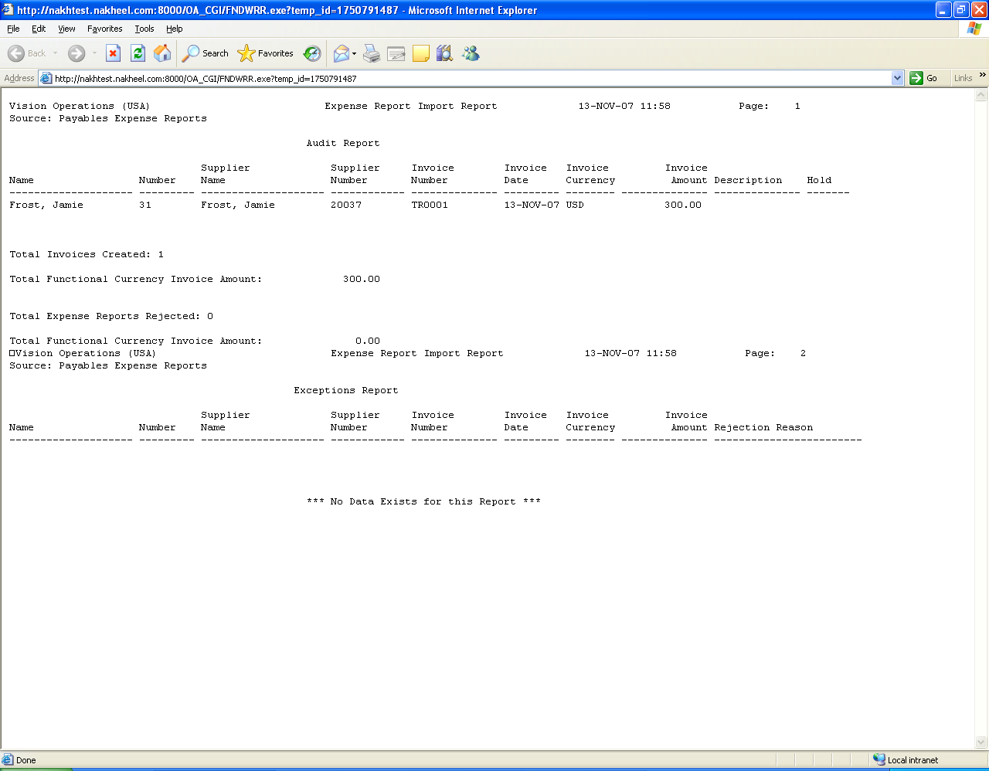

Check the Invoice, Validate and Account for the Same

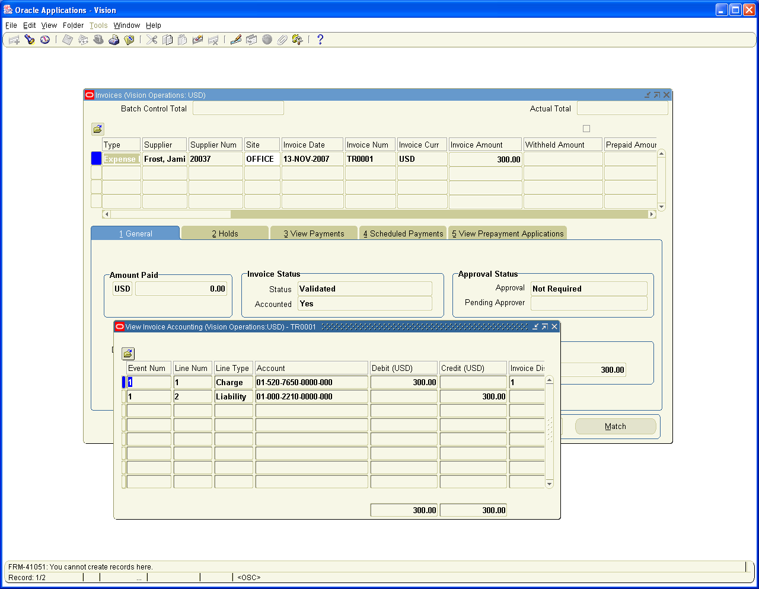

17. Sub Ledger Entries Transfer to General Ledger

We have executed all the Transactions. Now we have to transfer all the Sub ledger Module entries to General Ledger

Modules to be transferred

- Purchasing – It is transferred through a Profile set up called
RCV: Processing Mode: If it is set to Online, it is pushed immediately to GL Interface and we just need to import from GL Interface to GL Journals

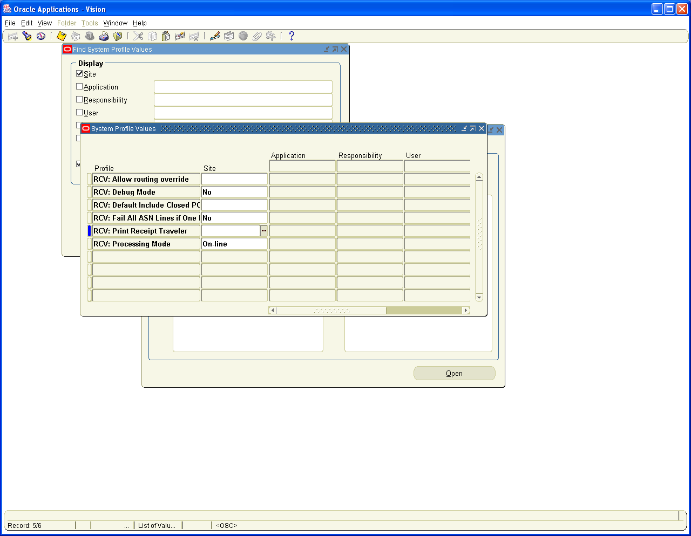

Import the Transactions to GL
Navigation Path: General Ledger, Vision Operations
Journals / Import / Run
Choose the Source as Purchasing

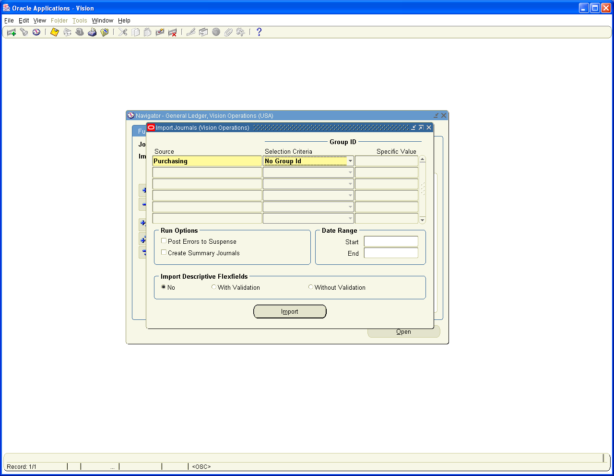

View the Concurrent request Output

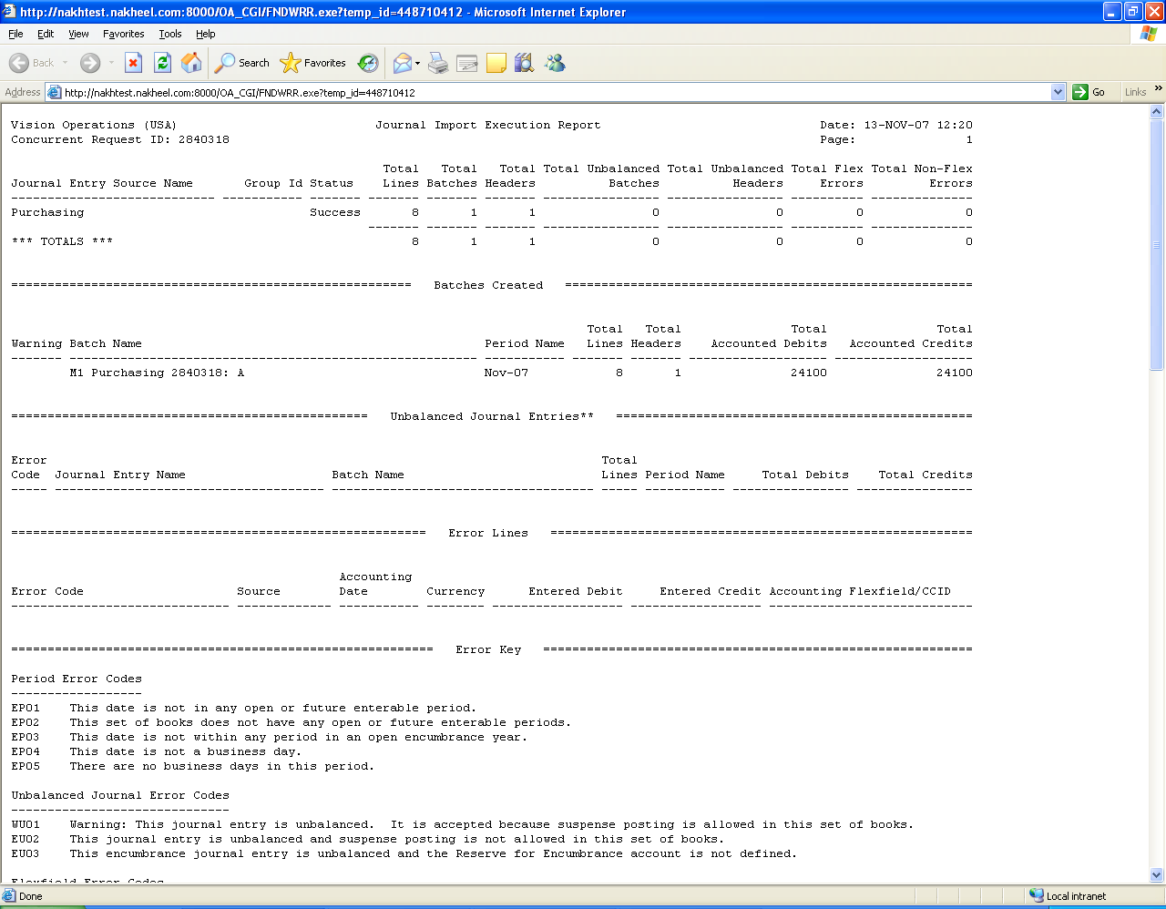

View the Journals in General Ledger Module in Unposted Status

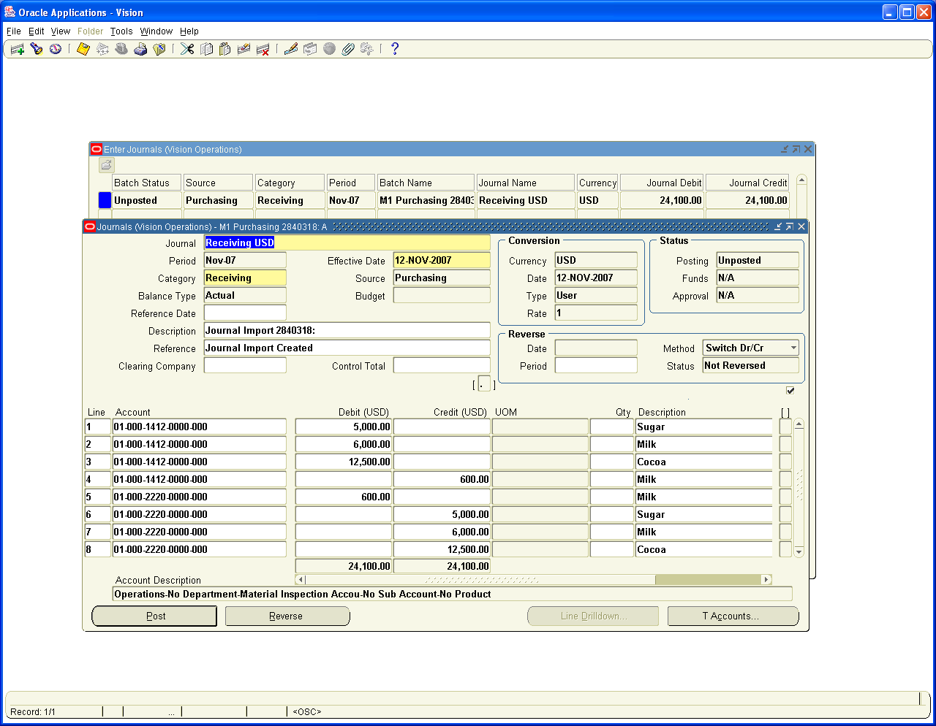

- Inventory: Transfer from Inventory Module

Run the Concurrent Process Transfer Transaction to GL

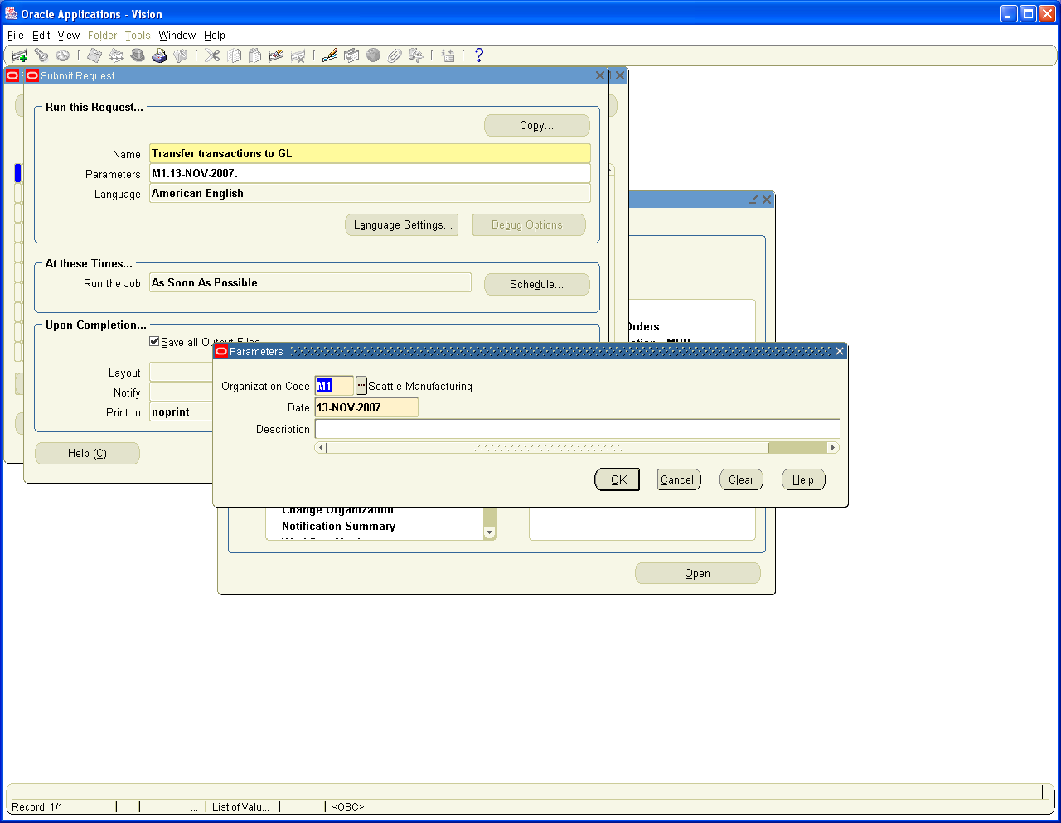

Import the Journals
Navigation Path: General Ledger, Vision Operations
Journals / Import / Run
Choose the Source as Inventory

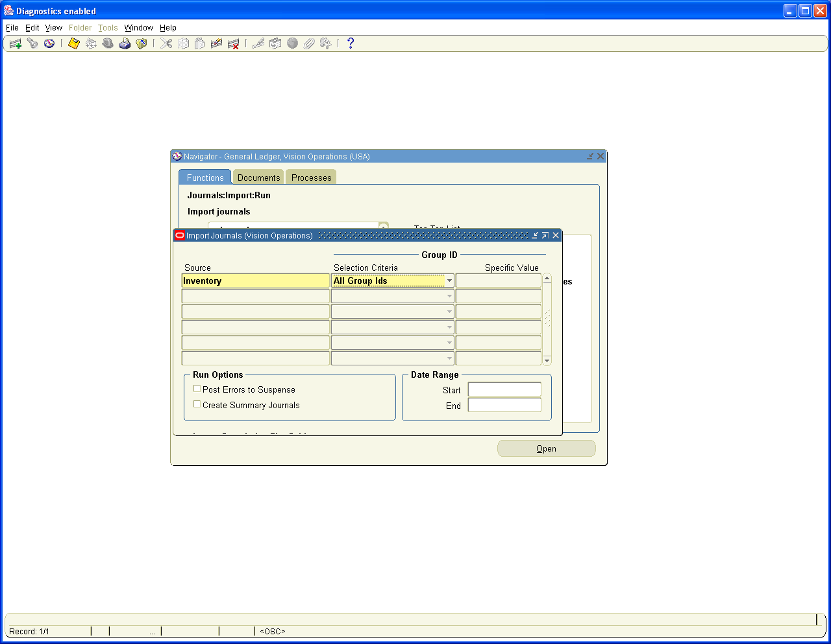

View the Journals created in unposted status

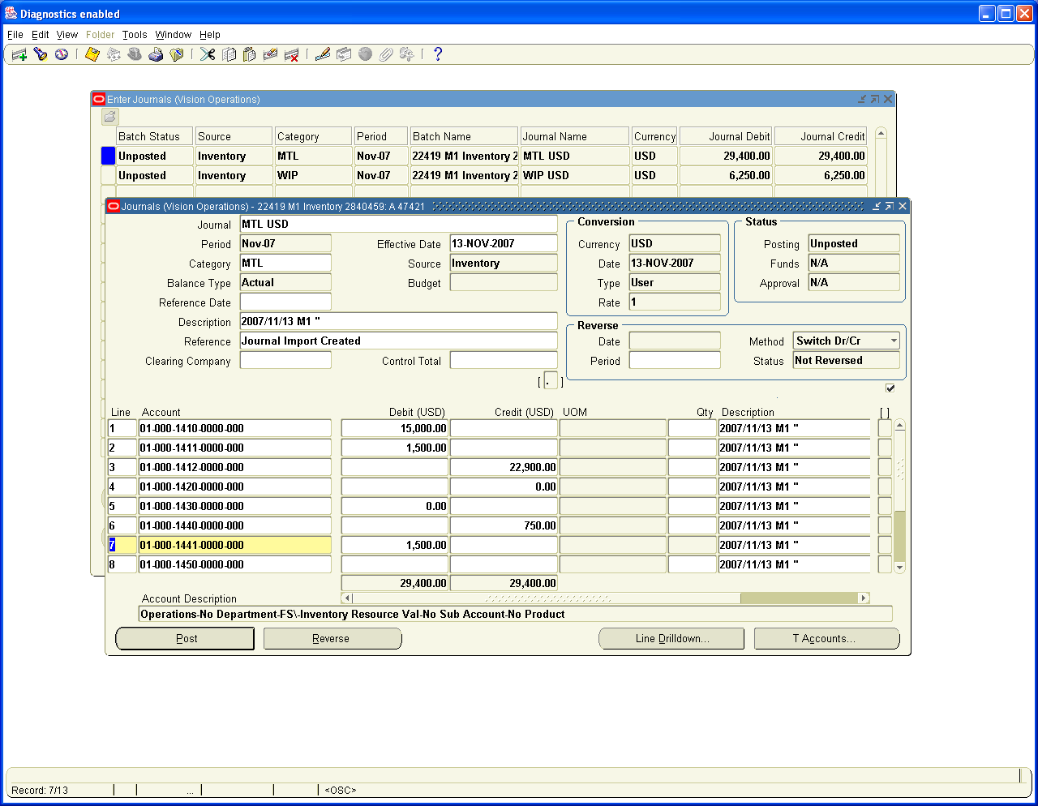

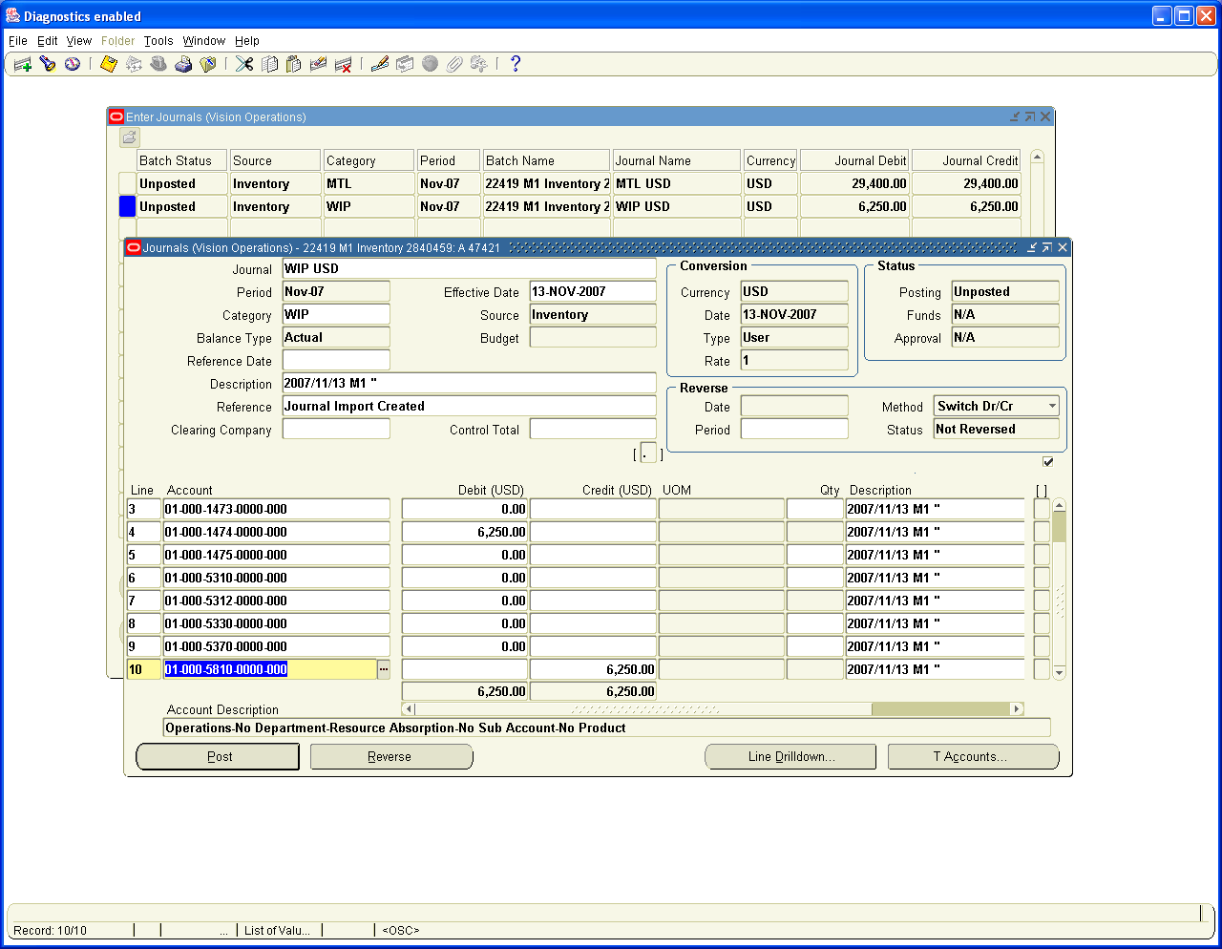

- Manufacturing: – No Accounting Entries are generated in this case from Manufacturing Module in this case
- Order Management: – No Accounting entries are generated from Order management at any point of time. The cost of Good Sold account is debited and Finished Goods Entry is credited in Inventory Module when we do the Ship confirm of Goods in Order management. The Entries are created in Inventory Module and not in Order management Module.
- Accounts Payables:

Navigation Path: Payables, Vision Operations
View / Requests / Simple Request
Choose Payables to General Ledger Concurrent program

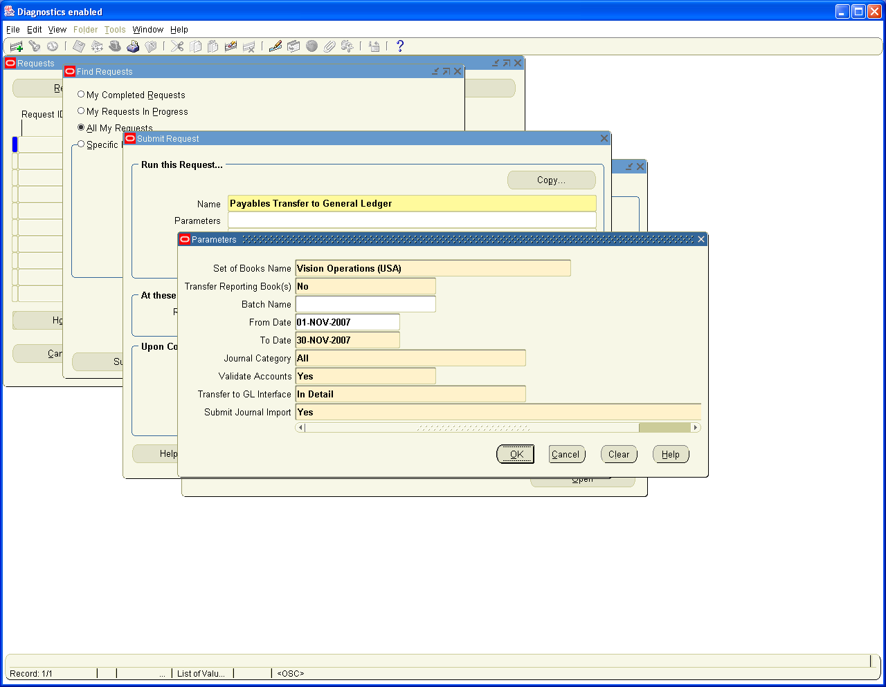

Run the Request it will create unposted Journal Entries in GL as we have set the parameter Submit Journal Import to Yes

View the concurrent Request output

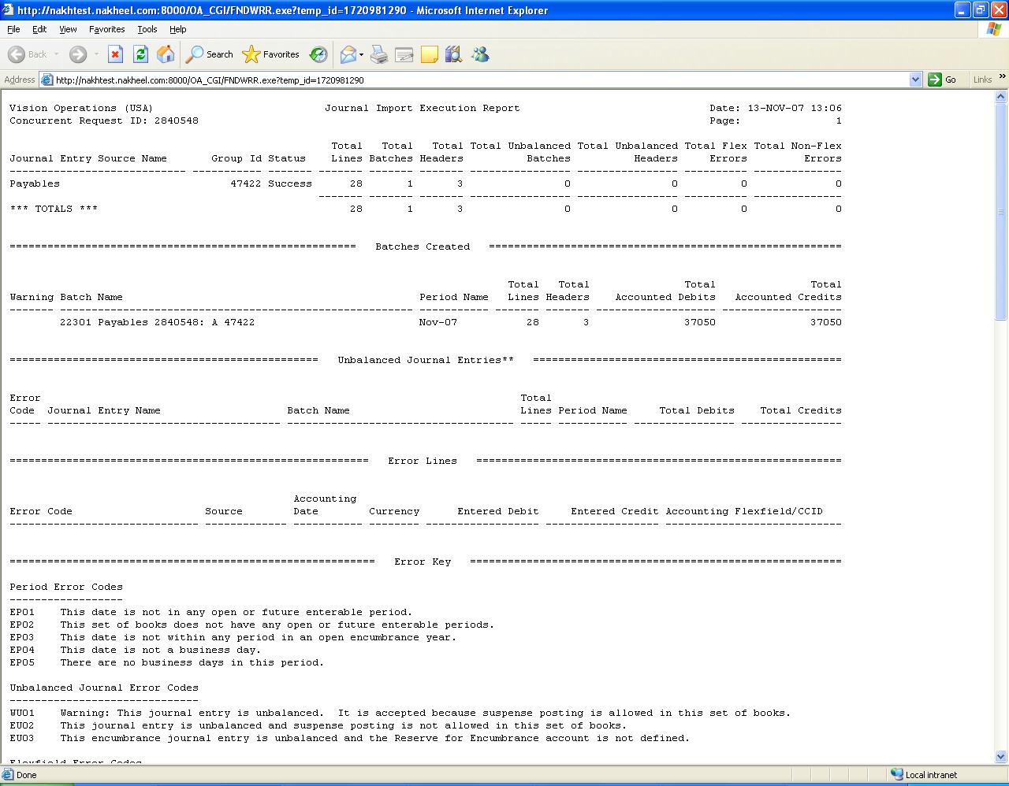

View the Unposted Journals in GL for Purchase Invoices

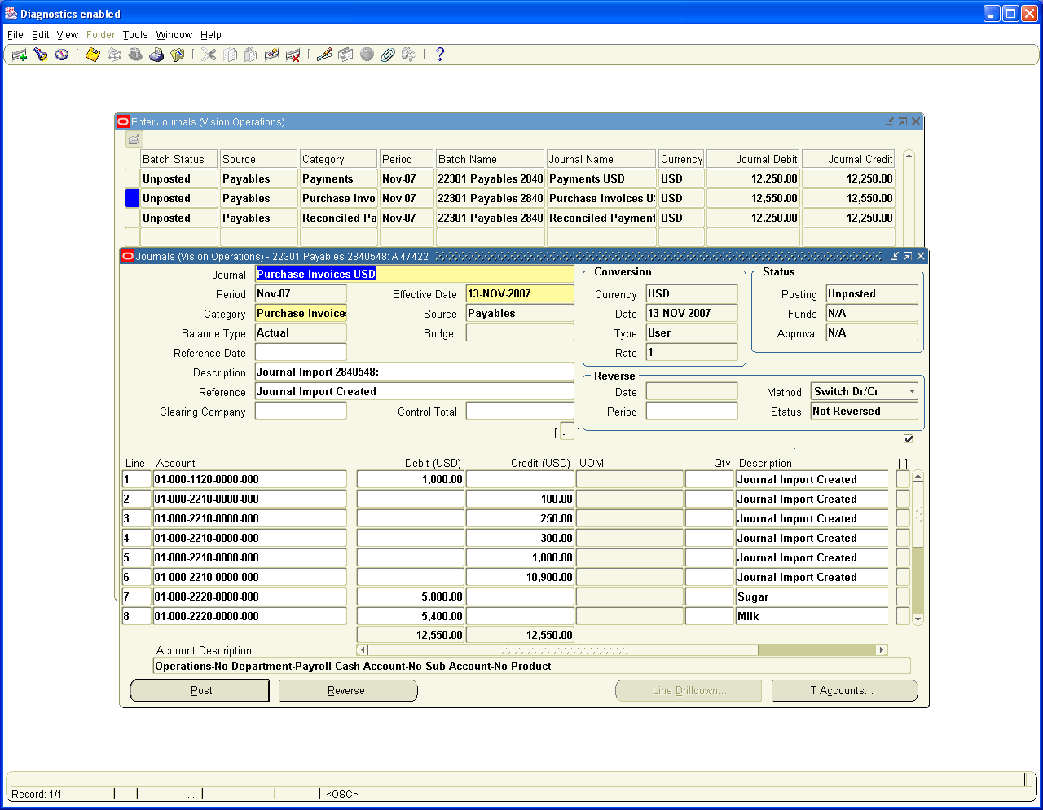

View the Journals created for Payments

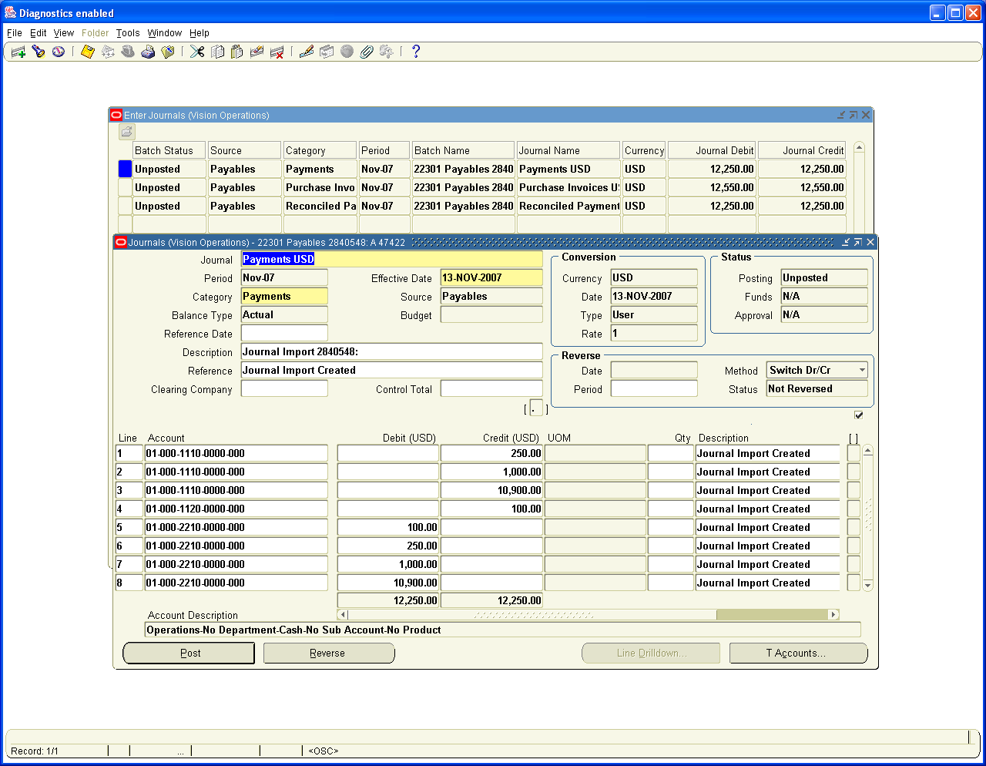

View the Journals created for Reconciliation Entries

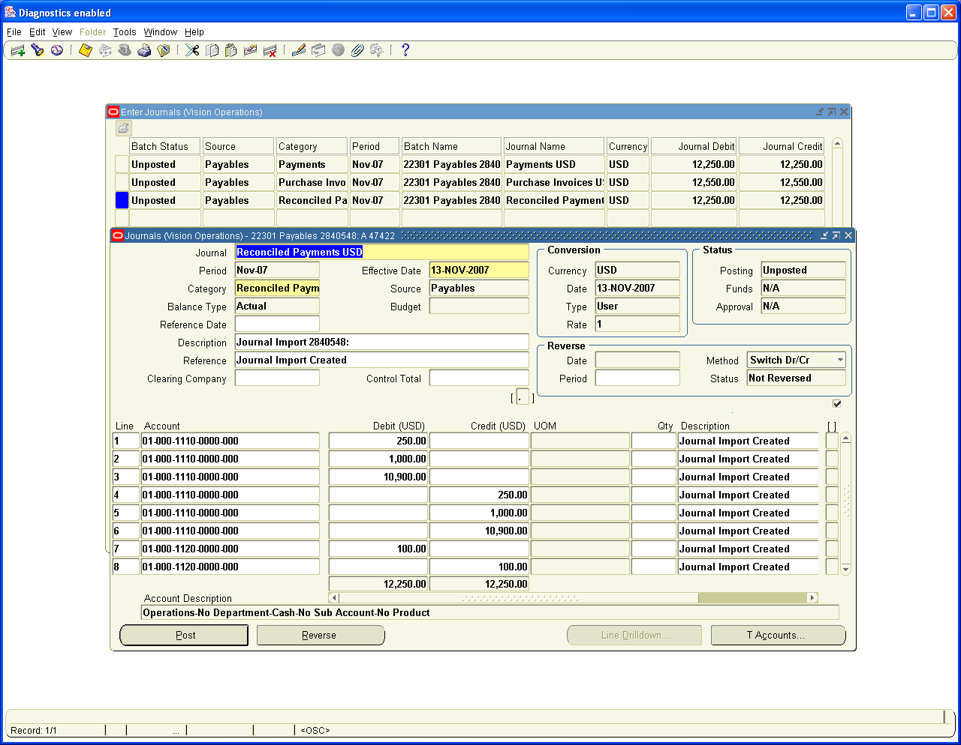

- Accounts Receivables:

Navigation Path: Receivables, Vision Operations
Interfaces / General Ledger
Run General Ledger Transfer Program with the Parameters

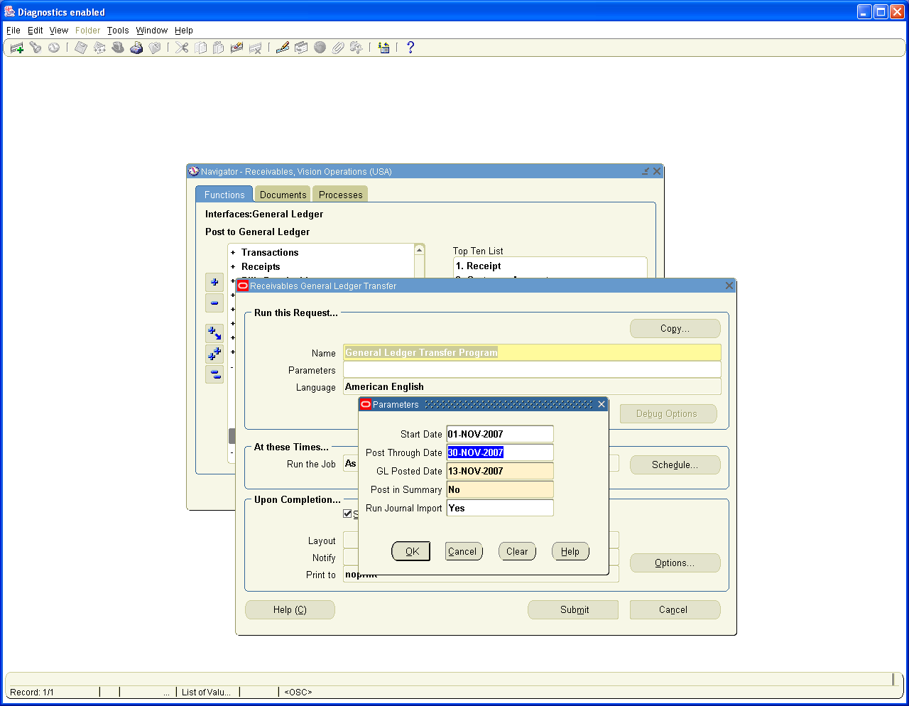

This will create Unposted Journals in GL as we set the Journal Import to Yes

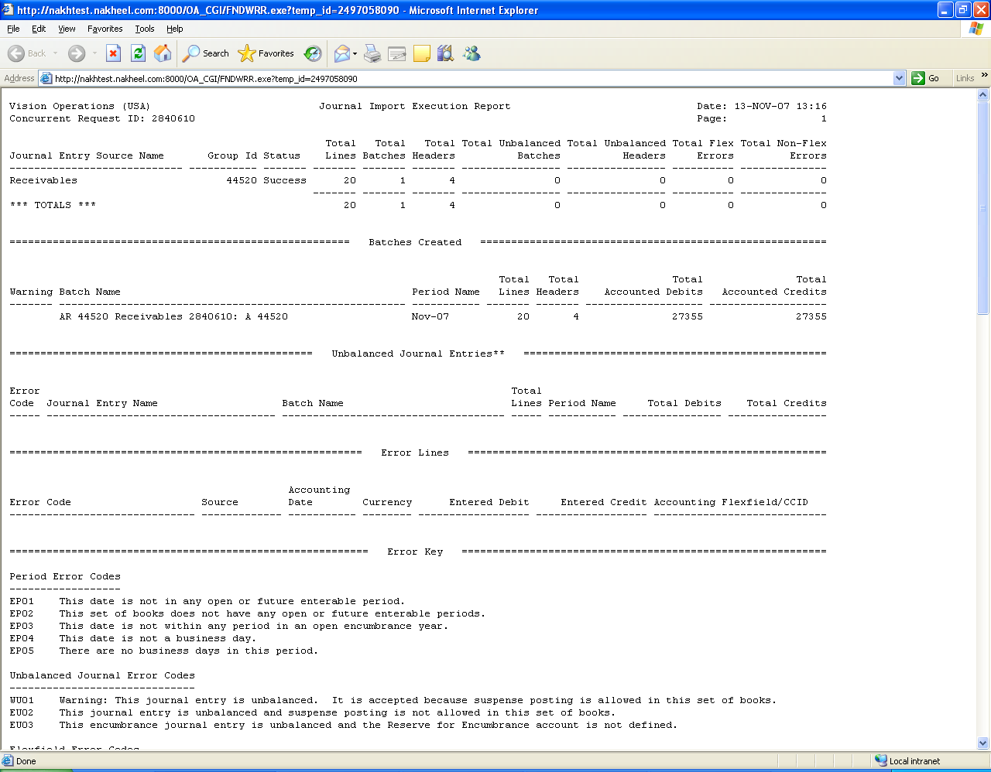

View the Journals created in General Ledger for sales Invoices

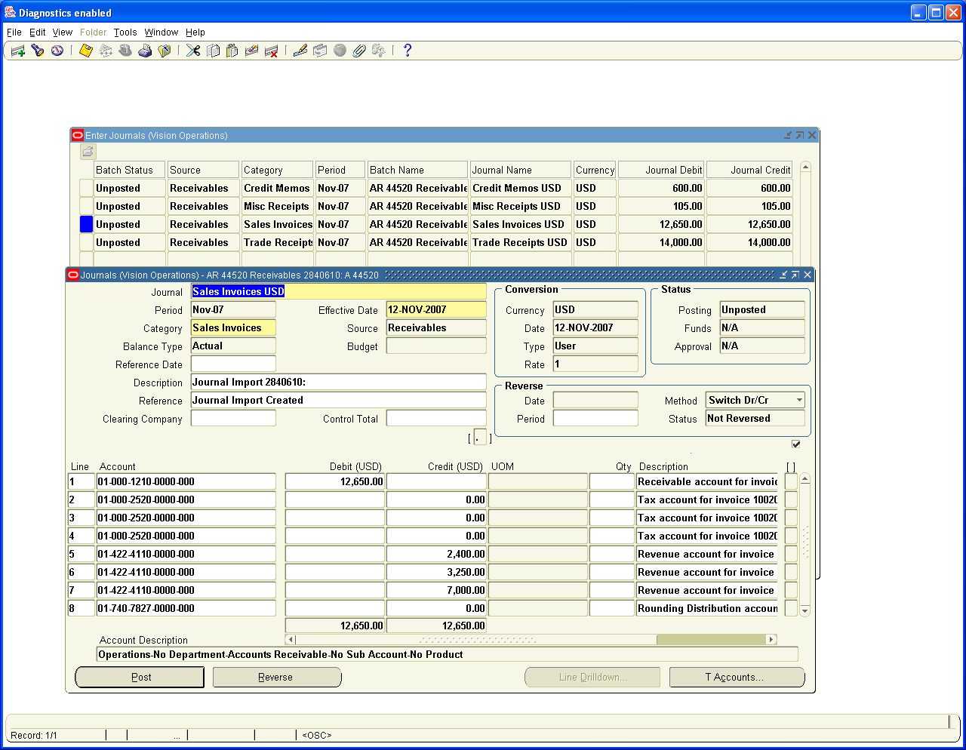

View the Journals created for Receipts

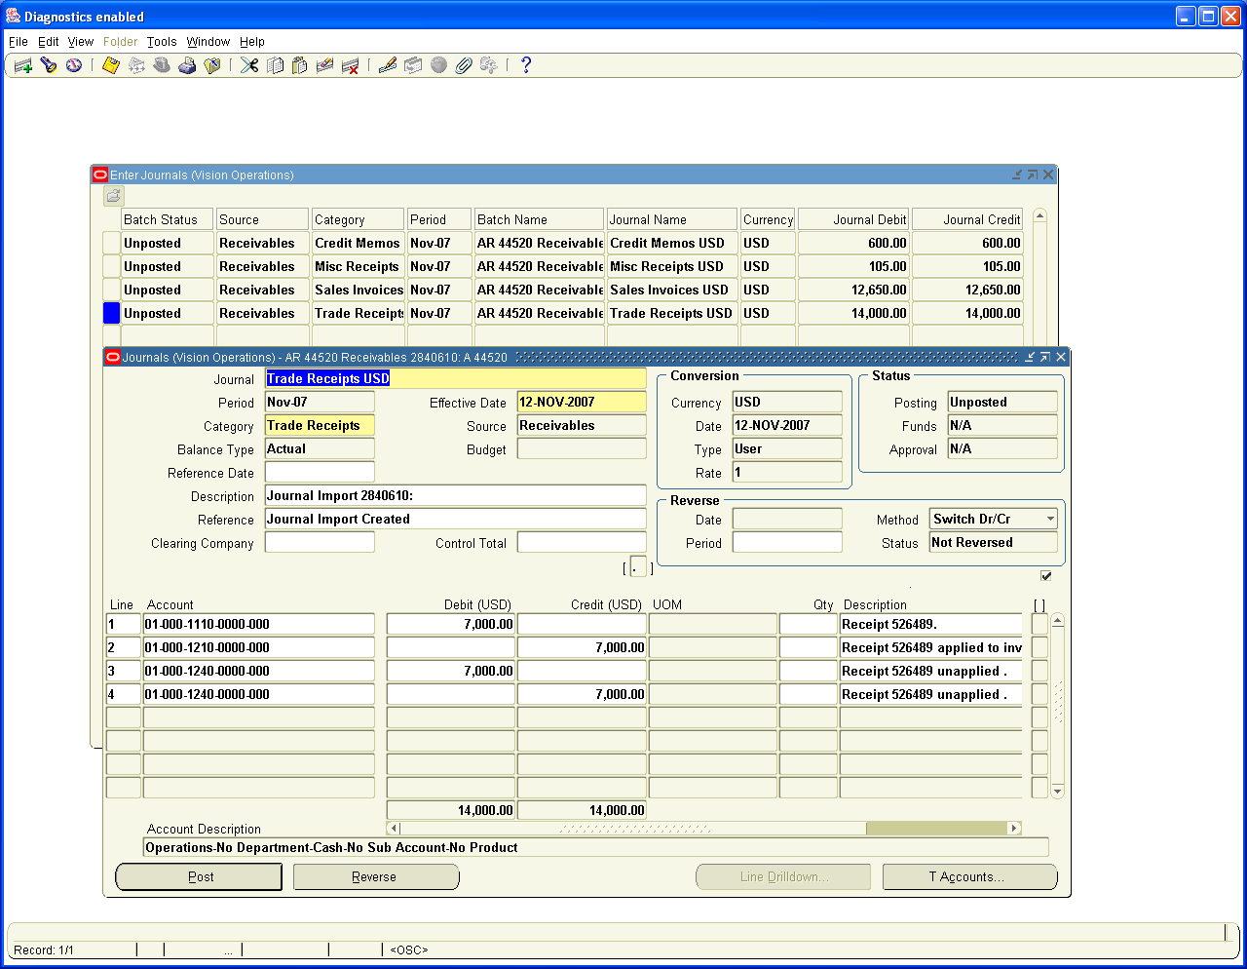

View the Journals created for Credit Memos

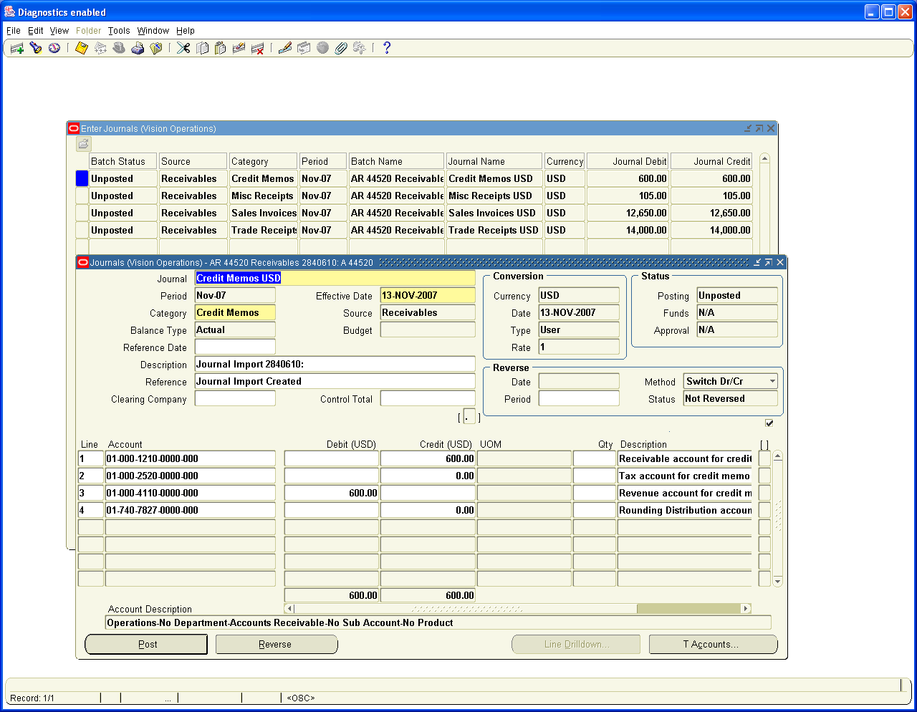

View the Journals created for Miscellaneous Receipts

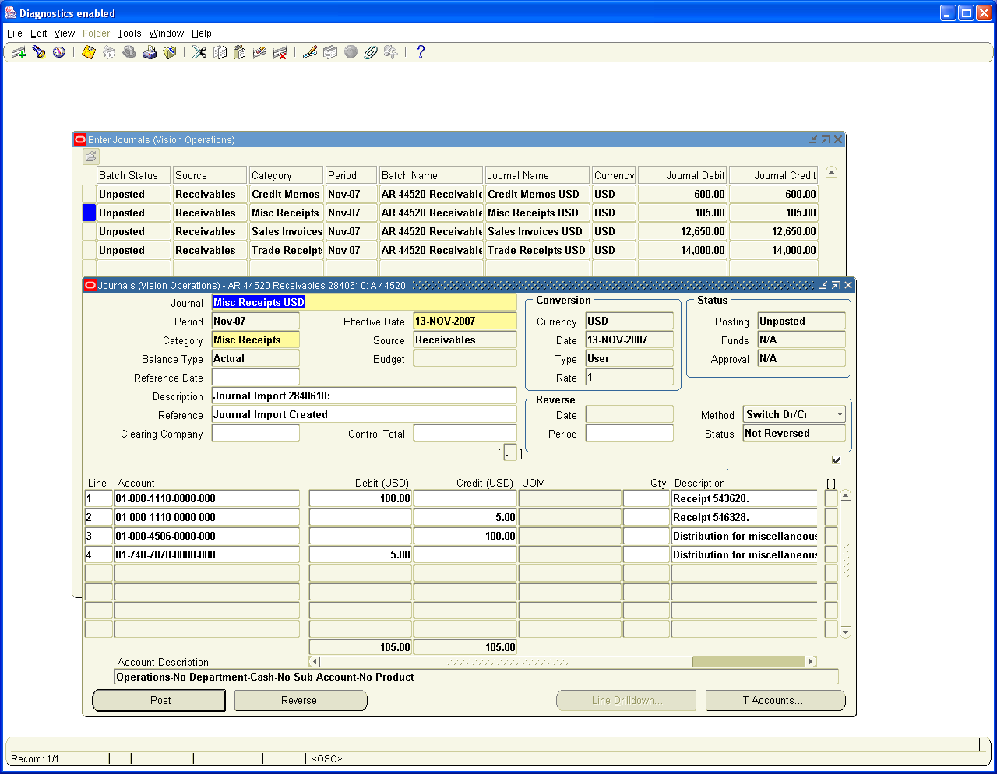

- Cash Management: – No Accounting entries are created in Cash Management. The Reconciliation Payment and Receipt entries are created in Payables and Receivables Module

We have to Post these Journals now to update the General Ledger balances

Let us have a complete view of all unposted Journals

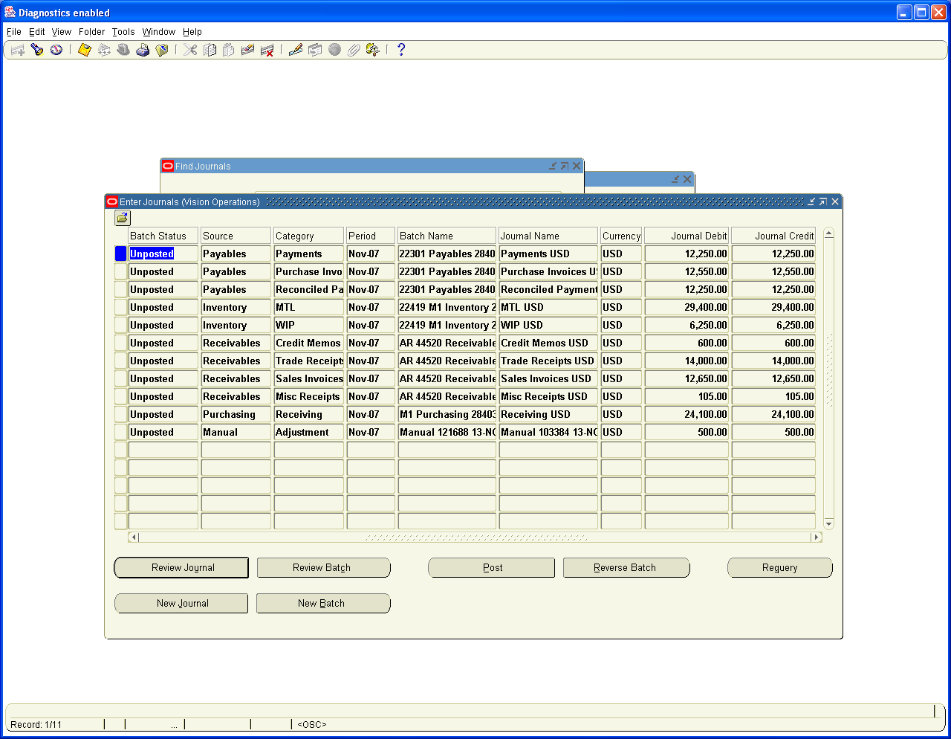

18. Posting in General Ledger

We need to post these Journals to update GL Balances

Navigation Path: General Ledger, Vision Operations
View Requests / Single Request
Run the concurrent Program – Automatic Posting and choose the Parameter Post all Journals.

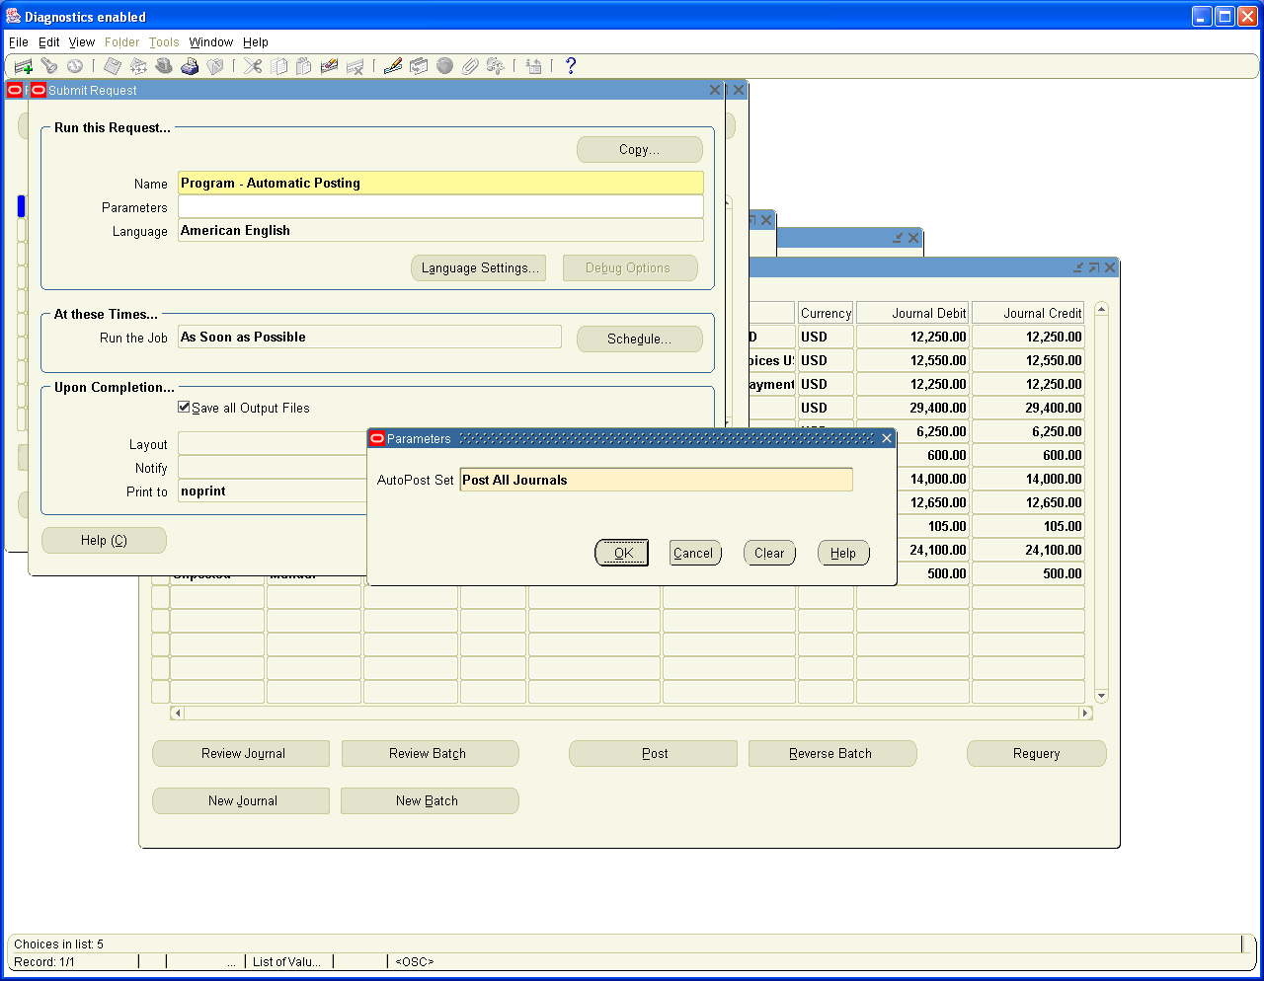

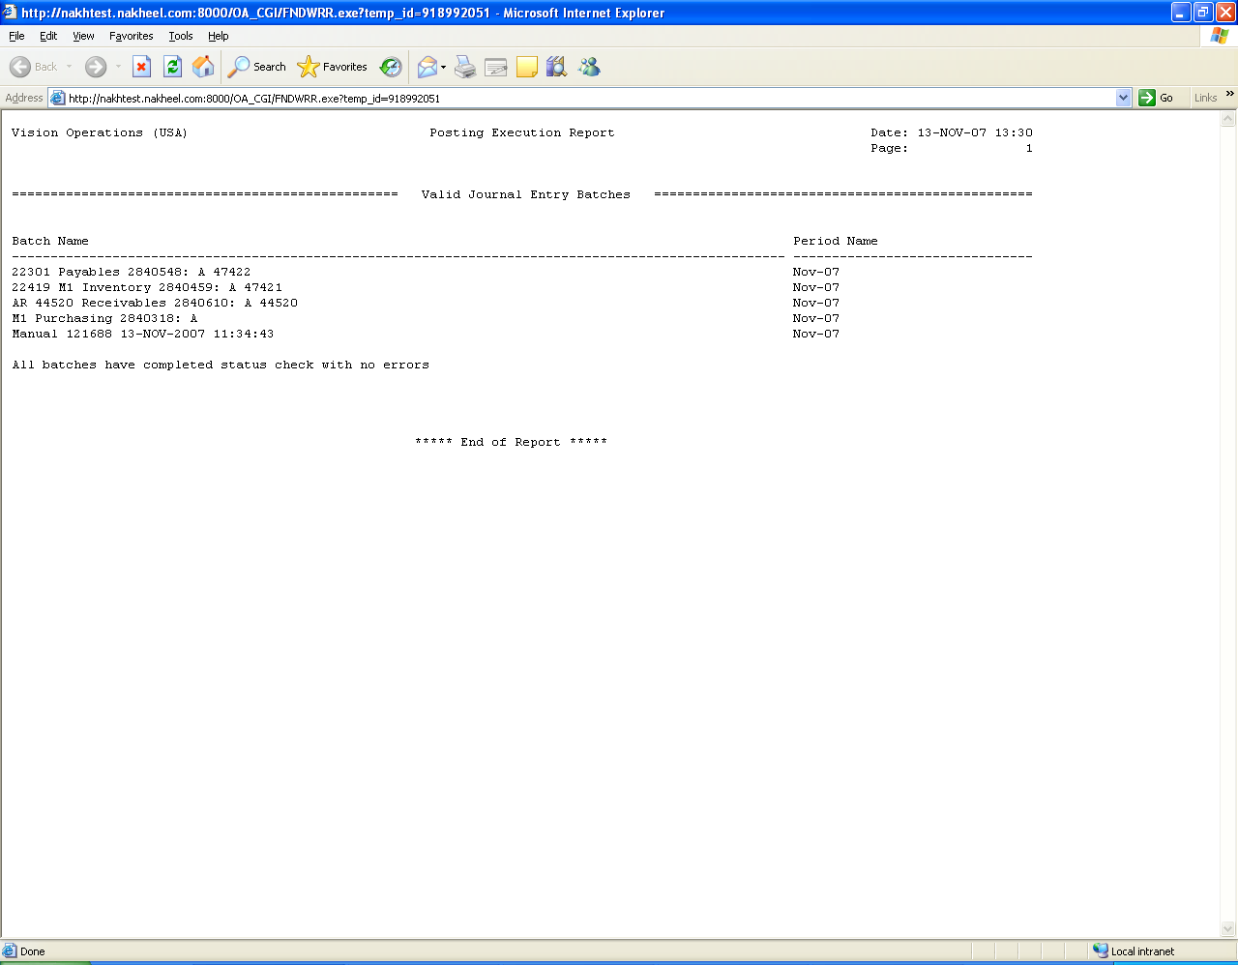

View the Posted Journals

Navigation Path: General Ledger
Journals / Enter / Journals
Query for Period Nov-07 and status as Posted

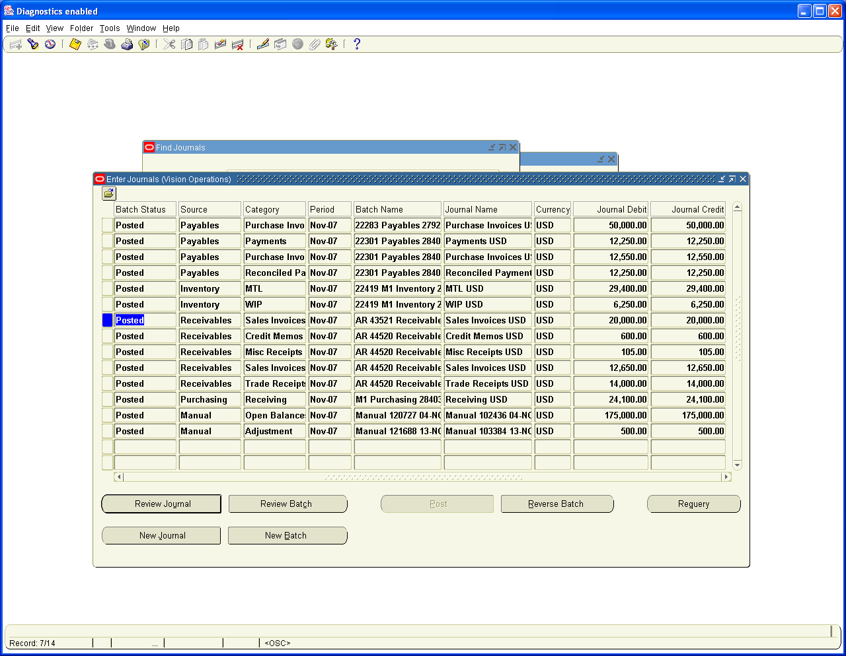

19. Running of Trial Balance, Profit and Loss Account and Balance Sheet

Running the Trial Balance

Navigation Path: General Ledger, Vision Operations

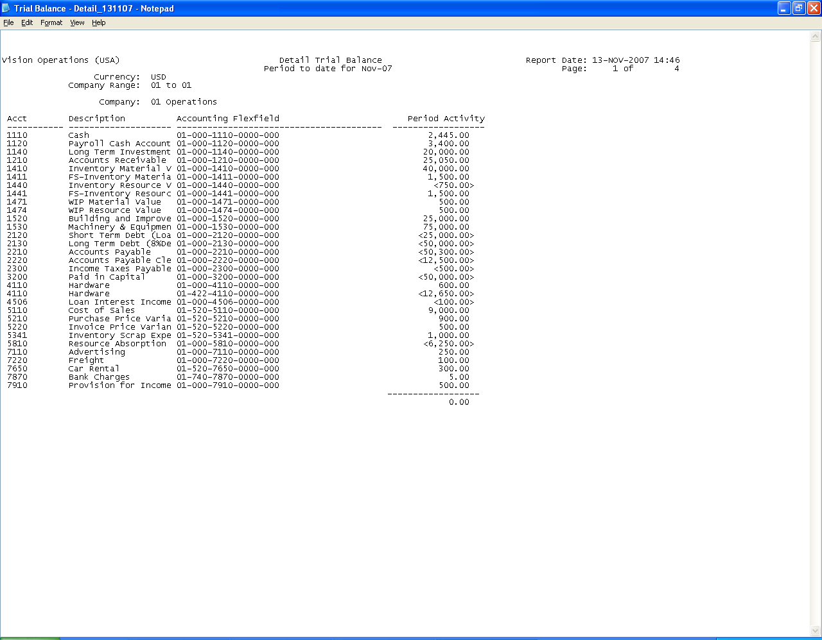

Run the Income and Expenditure Account and Balance Sheet from FSG

Navigation Path: General Ledger, Vision Operations
Reports / Financial

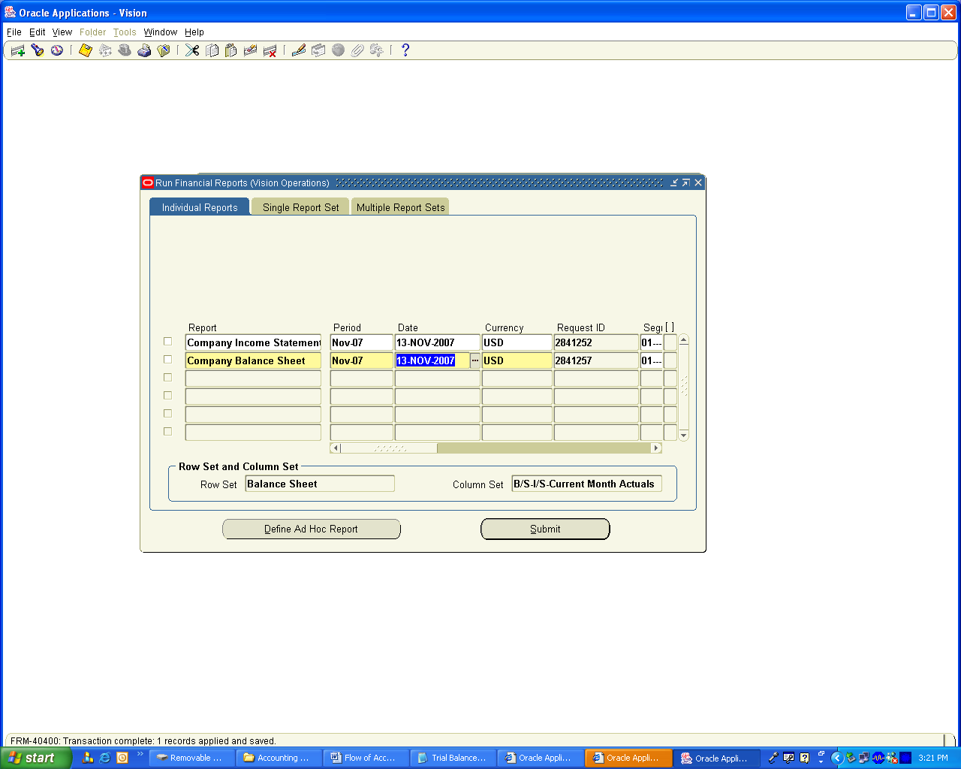

View the Output of the Income and Expenditure Account or Profit and Loss Account

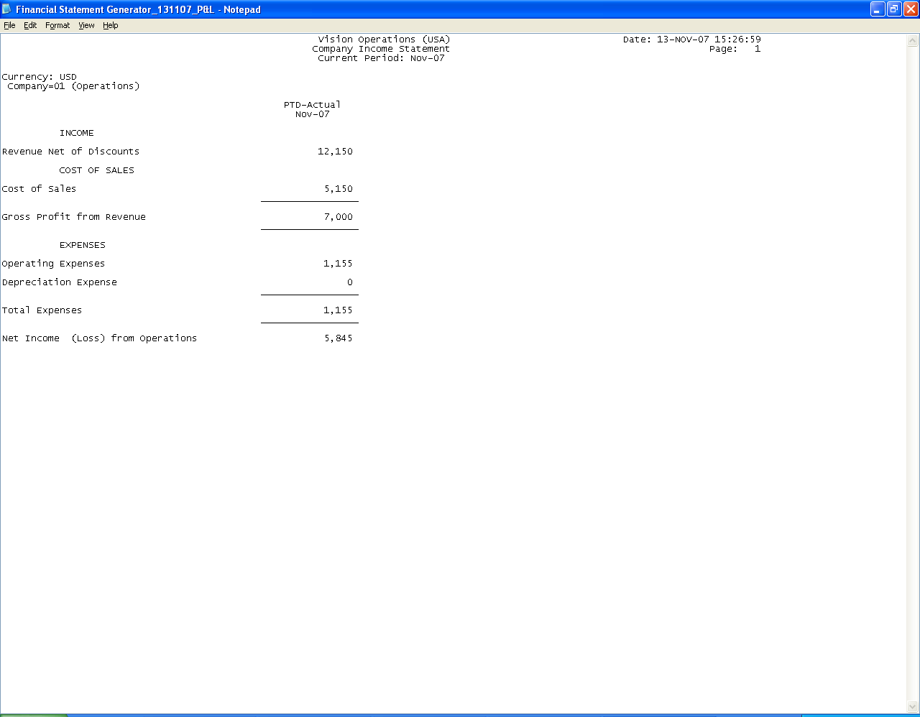

View the output of the Balance Sheet

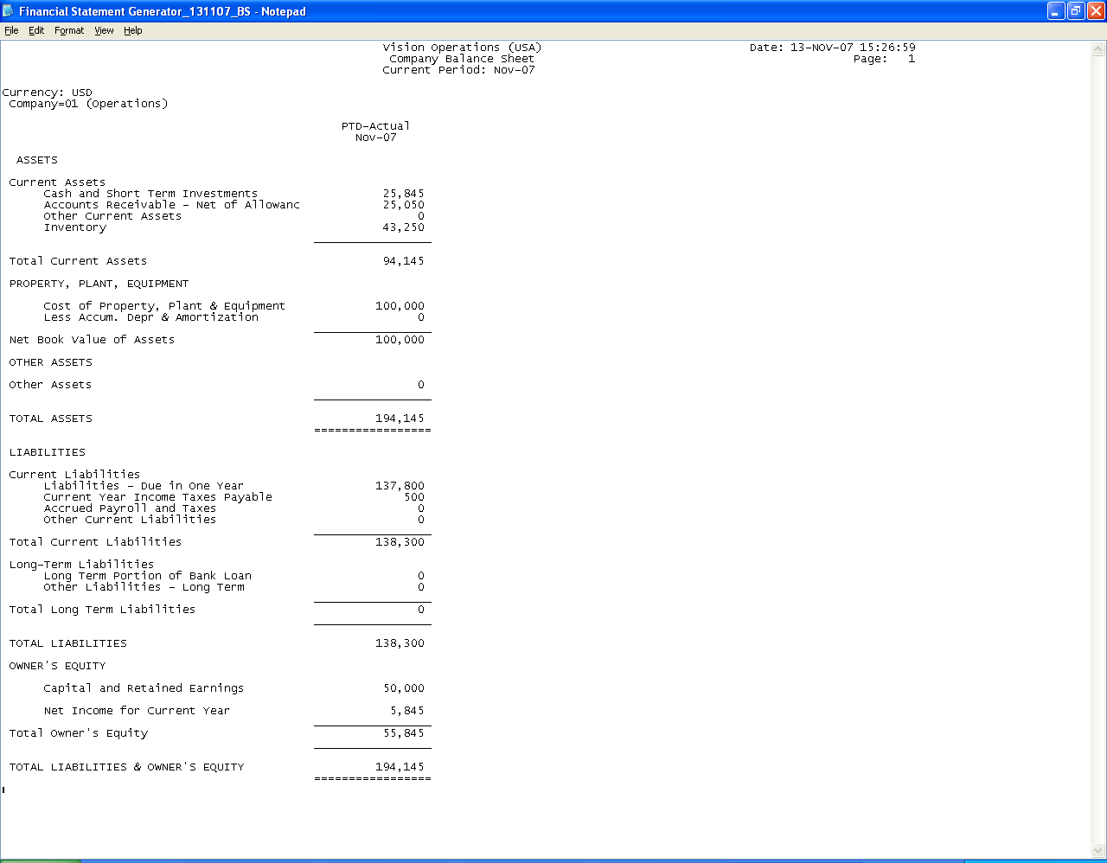

Please review the attached Report Documents which clearly depicts the accounting transactions are created and their Impact in GL with the closing Trial Balance.

Conclusion: The above Document will help you to clearly understand the importance of Accounting and how it is being handled in Oracle Applications. I trust this will help the novice user to expert to understand the concept of Accounting pretty well including Oracle Technical Consultants

"There is a difference between an objective and actions. Unless you understand your objective, you will be wasting your time in actions. Know your objective first " - Swami Vivekananda

Thank You

